

**Software Requirement Specification (SRS)**

Of

**Finance and Accounting module**

For Implementation of

**Campus Management Software**

at

**World Skill Center (WSC)**

**Sustainable Outreach And Universal**

**Leadership (SOUL) Limited**

**Sustainable Outreach And Universal**

**Leadership (SOUL) Limited**

**Table of Content**

A. Abstract 4

B. Introduction 4

C. Definition, Acronyms and Abbreviations 4

D. Overview of the Document 4

E. Scope of Accounting Module 5

F. WSC Finance Accounting Process Flow 5

G. Process Flow Description 6

H. List of Screens and Their Descriptions 7

I. Finance and Account Home Screen 9

1. Accounting Masters 10

1.1 Company 10

1.2 Account (Chart of Accounts) 15

1.3 Fiscal Year 17

1.4 Accounting Period 19

1.5 Finance Book 21

1.6 Bank 22

1.7 Bank Account 24

1.8 Mode of payment 27

2. General Ledger 28

2.1 Journal Entry 28

2.2 General Ledger 34

2.3 Supplier Ledger Summary 36

3. Account Receivable 38

3.1 Payment Entry 38

3.2 Accounts Receivable 45

3.3 Accounts Receivable Summary 48

4. Accounts Payable 51

4.1 Purchase Register 51

4.2 Item Wise Purchase Register 53

4.3 Supplier 55

4.4 Purchase Invoice 59

4.5 Accounts Payable 75

4.6 Accounts Payable Summary 78

5. Reports 80

5.1 Trial Balance for Party 80

5.2 Tax Detail 82

6. Financial Statement 84

6.1 Trial Balance 84

6.2 Balance Sheet 86

6.3 Profit and Loss Statement 88

6.4 Cash Flow 91

6.5 Consolidated Financial Statement 93

7. Bank Statement 95

7.1 Bank Reconciliation Tool 95

7.2 Bank Clearance 98

7.3 Bank Reconciliation Statement 101

7.4 Cost Center 103

7.5 Accounting Dimension 105

8. Taxes 107

8.1 Tax Category 107

8.2 Item Tax Template 109

8.3 Purchase Taxes and Charges Template 110

8.4 Tax Rule 112

8.5 Tax Withholding Category 114

9. SLCM 117

9.1 Fee Structure 117

9.2 Fee Schedule 119

9.3 Fees 122

9.4 Program Enrollment 127

9.5 Student Re registration Tool 134

9.6 Fee Waiver 136

# Abstract

Software Requirements Gathering is one of the first phases of system development. This phase results in the Software Requirements Specification (SRS) document, which must contain a complete, concise, high-quality description of the system being considered.

# Introduction

The World Skill Center (WSC) is a premier advanced skill training institute established by the Government of Odisha, Skill Development and Technical Education Department, through the Odisha Skill Development Authority (OSDA). The WSC will impart advanced skill training in eight trades from engineering and service sectors. WSC caters primarily to induct the best talent from ITIs and Polytechnics and train them to become globally employable in emerging areas such as "Industry 4.0". WSC is housed in a state-of-the-art, 18-storey, air-conditioned building with nearly half a million square feet of space in the heart of capital city of Bhubaneswar.

With the Implementation of campus management software for WSC the goal is to streamline the operations and functions of the campus by integrating various processes, such as admissions, course registration, academic progress tracking, and financial management, HRMS, Procurement and Inventory management, etc into a unified system. The implementation also aims at providing a user-friendly interface for all stakeholders, making it easier for them to access the necessary information and complete their tasks with ease. The modules to be covered during the implementation of the software includes:

|  |  |
| --- | --- |
| Students Management Modules | Infrastructure Management |
| Academic System | Finance and Accounting System |
| Procurement & Inventory Management | Training and Placement |
| Human Resources Management System | Application Integration |

# Definition, Acronyms and Abbreviations

The following table explains the terms and abbreviations used in the document:

|  |  |
| --- | --- |
| **Abbreviation** | **Description** |
| SRS | Software Requirements Specification |
| R | Rename - When a field is Renamed |
| N | New - When a New field is Added |
| D | Delete - When an Existing field is Deleted |
| NA | Not Applicable |

# Overview of the Document

This requirement document provides a detailed overview of the functional requirements of a project. It serves as a communication tool between stakeholders, including developers, project managers, and end-users. The purpose of this requirement document is to define and document the project's objectives, scope, and expectations, and to ensure that all stakeholders have a clear understanding of what the project entails.

This document covers all the functional requirements of the **Finance and Accounting module** of ERP Product. This helps in organizing the Chart of Accounts,opening Account Balances,Taxes,Advance Payments etc.

# Scope of Accounting Module

* Receipt and Payment Entries
* Direct Transfer of Caution Money to Student’s Accounts
* Demand Register
* Caution Money Register
* Bank Reconciliation Statement
* Generation of Cash Book (PL)
* Grants-in-aid Register
* Paid Voucher Register
* Advances Register
* Auditing and Tracking Pendency of Audit paras etc.

# WSC Finance Accounting Process Flow

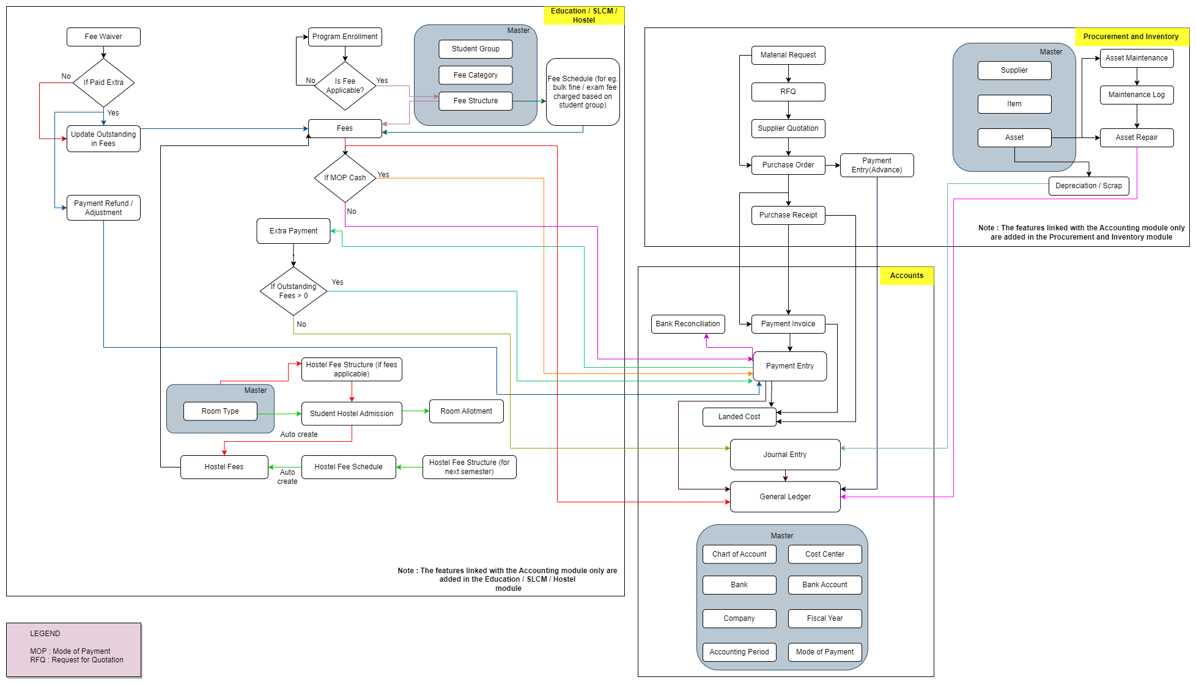

Note : The features linked with the Accounting Module are added in this flowchart

# **Process Flow Description**

**Accounts Masters**

Accounts Master represents the conFigureuration such as Chart of Accounts, Cost center, Bank, Bank Account, Company, Fiscal Year, Accounting Period , Mode of Payment etc.

**SLCM Masters**

Student Group, Fee Category and Fee Structure are the masters which are required for the functioning of the accounts module.

**Procurement and Inventory Masters**

Supplier, Item and Asset are the master which are essential for the accounting processes to be functional with respect to the Material Management module.

**Fee Waiver**

Fee waiver refers to an exemption or reduction of a student's fees that they would normally be required to pay in order to enroll in classes or participate in certain activities.

**Fees**

In this form, Fee Records of the students can be maintained.

**Fee Schedule**

Fee Schedule would help in defining a time-line for the Fee payment of the students, based on the Student Group.

**Payment Invoice**

A Purchase Invoice is a bill you receive from your Suppliers against which you need to make the payment.

**Payment Entry**

Payment Entry is a record indicating that payment has been made for an invoice.

Payment Entry can be made against the following transactions:

1. Sales Invoice
2. Purchase Invoice
3. Sales Order (Advance Payment)
4. Purchase Order (Advance Payment)
5. Expense Claim
6. Internal Transfer

**Bank Reconciliation**

Once all your bank transactions are imported into the application, you can reconcile them with your existing vouchers.

**Journal Entry**

A Journal Entry is an entry made in the general ledger and it indicates the affected accounts.

**General Ledger**

The General Ledger is a detailed report for all transactions posted to each account and for every transaction there is a Credit and Debit account so it lists them all up.

# **List of Screens and Their Descriptions**

|  |  |  |
| --- | --- | --- |
| Prerequisite screens Required for Entrance Exam & Counselling | | |
| **ID** | **Screen Name** | **Description** |
|  | Company | A company is a legal entity made up of an association of people carrying on a commercial or industrial enterprise. |
|  | Chart of Accounts | The Chart of Accounts is the blueprint of the accounts in your organization.Chart of Accounts is a tree view of the names of the Accounts (Ledgers and Groups) that a Company requires to manage its books of accounts.Each of the Accounts of chart of Accounts is Linked to General Ledger. |
|  | Fiscal Year | A Fiscal Year is used to record and report the transactions for the year.It is also known as a financial year or a budget year. It is used for calculating financial statements in businesses and other organizations. The Fiscal Year may or may not be the same as a calendar year. |
|  | Accounting Period | An Accounting period defines a time period in which financial statements are recorded.The selected transactions are only allowed to be created within the defined Accounting Period. |
|  | Finance Book | A Finance Book is a book against which all the accounting entries are booked. |
|  | Bank | A screen where information Bank information is stored , like Bank name,Account name details and address will be there. |
|  | Bank Account | It is a screen where Bank Accounts can be created for a Company as well as other parties like Customers, Suppliers etc. Doing this lets you record all the bank transactions correctly for accounting accuracy. |
|  | Mode of Payment | The Mode of Payment stores the medium through which payments are made or received. |
|  | Journal Entry | A Journal Entry is an entry made in the general ledger and it indicates the affected accounts. |
|  | General Ledger | The General Ledger is a detailed report for all transactions posted to each account and for every transaction there is a Credit and Debit account so it lists them all up. |
|  | Supplier Ledger Summary | This Shows the Ledger by Individual Supplier Wise |
|  | Payment Entry | Payment Entry is a record indicating that payment has been made for an invoice. |
|  | Accounts Receivable | This reports help you to track the outstanding amount of Customers. It also provides ageing analysis i.e. a break-up of outstanding amount based on the period for which the amount is outstanding. |
|  | Accounts Receivable Summary | This reports help you to track the outstanding amount of Customers. It also provides ageing analysis i.e. a break-up of outstanding amount based on the period for which the amount is outstanding. |
|  | Purchase Register | This reports help you to track the outstanding amount of Suppliers with respect to the unique invoice id. |
|  | Item Wise Purchase Register | This reports help you to track the outstanding amount of Suppliers with respect to the individual Items. |
|  | Supplier | Suppliers are companies or individuals who provide you with products or services. |
|  | Purchase Invoice | **A Purchase Invoice is a bill you receive from your Suppliers against which you need to make the payment.** |
|  | Accounts Payable | This report help you to track the outstanding amount of Suppliers.  It also provides ageing analysis i.e. a break-up of outstanding amount based on the period for which the amount is outstanding. |
|  | Accounts Payable Summary | The accounts payable summary is a report that provides an overview of the money owed by the organization to its vendors or suppliers. |
|  | Trial Balance for Party | It is common to review the trial balance for employees, students, and suppliers. This information can be easily accessed for all individuals or for specific individuals. |
|  | Tax Detail | Tax Details report provides an overview of all the taxes applied to transactions.This report shows the Item Tax Template, Taxes and Charges Template and Tax Category linked to various voucher types in the application. |
|  | Trial Balance | A Trial Balance is an accounting report which lists account balances for all Accounts for any given reporting period. A company prepares a trial balance periodically, usually at the end of every reporting period. The general purpose of producing a trial balance is to ensure the entries in a company's bookkeeping system are mathematically correct. The totals of Debit and Credit columns must be same for any given period, to ensure the entries are correct. |
|  | Balance Sheet | A Balance Sheet is the financial statement of a company which states assets, liabilities and equity at a particular point in time.  The Balance Sheet gives more flexibility to analyse your financial position. You can run the report across multiple year to compare values. You can check values for a specific Finance Book or Cost Center. You can also choose any other currency to display the balances. |
|  | Profit and Loss Statement | A Profit and Loss Statement is a financial statement which summarizes all the revenues and expenses in a given period. The report is also known as P&L Statement. |
|  | Cash Flow | A Cash Flow is a financial statement which shows the incoming and outgoing of cash or cash-equivalents for a company. It is used to analyse the liquidity position of the company. |
|  | Consolidated Financial Statement | The report shows a consolidated view of Balance Sheet, Profit and Loss Statement and Cash Flow for a group company, by merging financial statements of all the subsidary companies. It shows balances for all individual company and as well as accumulated balances for a group company. |
|  | Bank Reconciliation Tool | Once all your bank transactions are imported into the application, you can reconcile them with your existing vouchers. The final goal of Bank Reconciliation is to make the difference amount zero (green) by either matching to an existing voucher or creating a new voucher. |
|  | Bank Clearance | This feature is used to manually update clearance date with respect to payment entries which are not reconciled  You can also use this feature to update or rectify clearance date of reconciled transactions |
|  | Bank Reconciliation Statement | The Bank Reconciliation Report provides the difference between the bank balance shown in an organization's bank statement, as provided by the bank against the amount shown in the companies Chart of Accounts. |
|  | Cost Center | A Cost Center is a part of an organization where costs or income can be charged. |
|  | Accounting Dimension | Dimensional accounting means tagging each transaction with appropriate dimensions like Branch, Business Unit, etc. This allows you to maintain each segment separately, thereby limiting the overall maintenance on GL accounts and your Chart of Accounts remains pure. |
|  | Tax Category | A Tax Category allows applying one or more Tax Rules to transactions based on various criteria. |
|  | Item Tax Template | Item Tax Template is useful for item wise taxation. |
|  | Purchase Taxes and Charges Template | Purchase Taxes and Charges may be applied to any item you buy. |
|  | Tax Rule | A Tax Rule automatically applies taxes to transactions based on preset rules. |
|  | Tax Withholding Category | Tax Withholding Category is Tax Deducted at Source. |
|  | Fee Structure | A Fee Structure is a template that can be used while making Fees records or generating them via the Fee Schedule. |
|  | Fee Schedule | Fee Schedule would help in defining a time-line for the Fee payment of the students, based on the Student Group. |
|  | Fees | In this form, Fee Records of the students can be maintained. |
|  | Program Enrollment | Program Enrollment is the record of enrollment of a student in a given program and chosen courses for a particular Academic Term. |
|  | Student Re registration Tool | Student Re registration tool mainly help for enrolling the students into their next semester bulk wise only after the enrollment of first semester. |
|  | Fee Waiver | Fee waiver refers to an exemption or reduction of a student's fees that they would normally be required to pay in order to enroll in classes or participate in certain activities. |

# **Finance and Account Home Screen**

This is the Homepage for the logged in User.

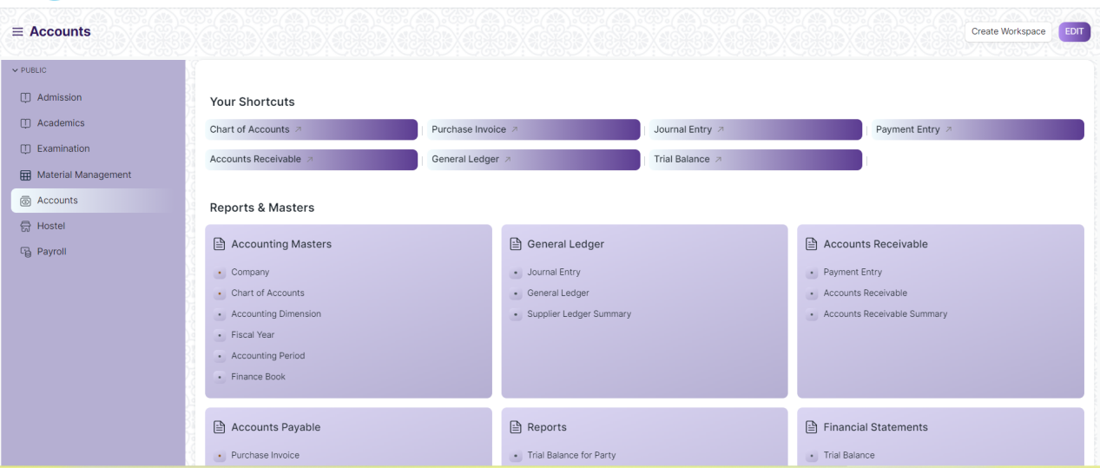

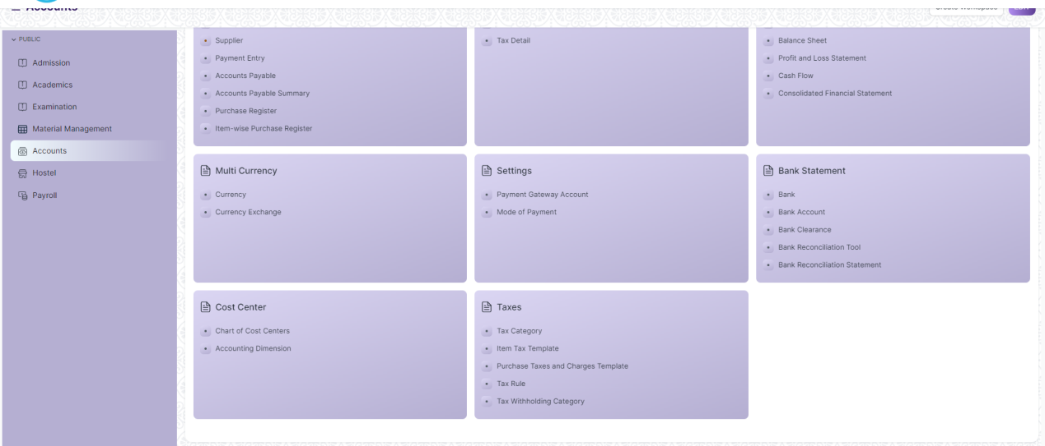

Figure: Home Screen

## Accounting Masters

### Company

**General Description:**

The following table describe overall information about this screen

|  |  |
| --- | --- |
| **Description :** | * A company is a legal entity made up of an association of people carrying on a commercial or industrial enterprise. * A parent company is a larger organization which consists of one or more child companies. A child company is a subsidiary of a parent company. * You can set up multiple companies, the company structure can be parallel, i.e., sister companies, parent-child companies, or a combination of both. |
| **Navigation :** | Home > Accounts > Accounting Masters > Company |
| **Pre-requisites :** | The system should have records in the following screen   1. Default Currency 2. Country |
| **Existing Screen Name** | Company |
| **New Screen Name** | No change |

**Screenshot:**

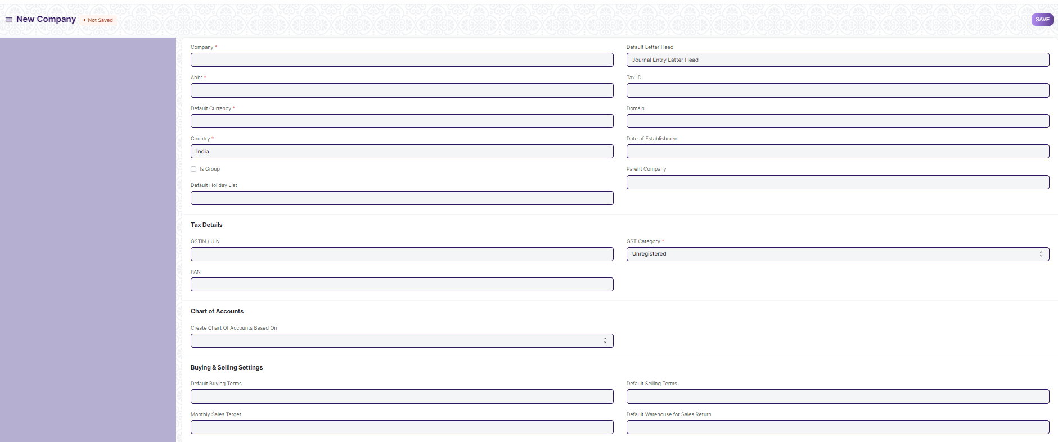

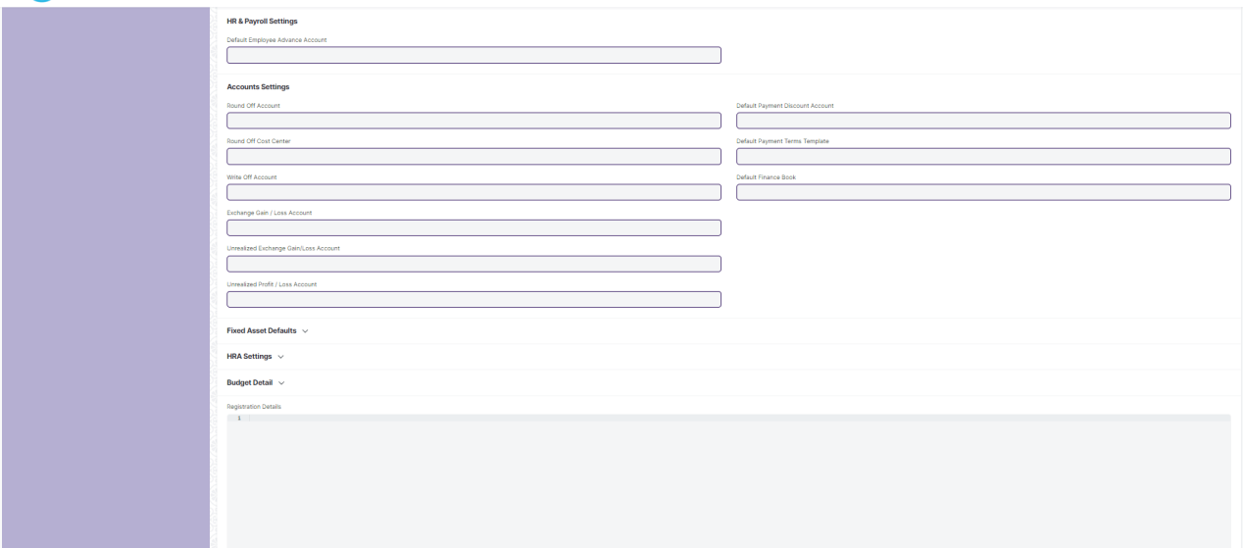

Figure: Company

**Field List:**

The following table describes the UI fields present in this screen :

|  |  |  |  |  |  |  |
| --- | --- | --- | --- | --- | --- | --- |
| **ID** | **Field Name** | **Field Type** | **Mandatory** | **Validation/Action** | **Remarks** | **R/N/D** |
|  | Abbr | Data | Yes |  |  |  |
|  | Default Currency | Link Field | Yes | Links to Currency. | Sets default currency wrt the company |  |
|  | Country | Link Field | Yes | Links to Country. | Sets default countryt wrt the company |  |
|  | Is Group | Checkbox | No |  |  |  |
|  | Default Holiday List | Link Field | No | Links to Holiday List. | Sets default holiday list wrt the company |  |
|  | Default Letter Head | Link Field | No | Links to Letter Head. | Sets default letter head wrt the company |  |
|  | Tax ID | Data | No |  |  |  |
|  | Domain | Data | No |  |  |  |
|  | Date of Establishment | Date | No |  |  |  |
|  | Parent Company | Link Field | No | Links to Parent Company. |  |  |
|  | Company Logo | Attach Image | No |  |  |  |
|  | Date of Incorporation | Date | No |  |  |  |
|  | Phone No | Data | No |  |  |  |
|  | Email | Data | No |  |  |  |
|  | Company Description | Text Editor | No |  |  |  |
|  | Date of Commencement | Date |  |  |  |  |
|  | Fax | Data | No |  |  |  |
|  | Website | Data | No |  |  |  |
|  | Existing Company | Link Field | No |  |  |  |
|  | Create Chart Of Accounts Based On | Dropdown | No | Options: Standard Template, Existing Company |  |  |
|  | Chart Of Accounts Template | Select | No |  |  |  |
|  | Default Buying Terms | Link Field | No | Links to buying terms. | Sets default buying terms wrt the company |  |
|  | Monthly Sales Target | Currency | No |  |  |  |
|  | Total Monthly Sales | Currency | No |  |  |  |
|  | Default Selling Terms | Link Field | No | Links to selling terms. | Sets default selling terms wrt the company |  |
|  | Default Warehouse for Sales Return | Link Field | No | Links to Warehouse for Sales Return  Credit Limit. |  |  |
|  | Credit Limit | Currency | No |  |  |  |
|  | Transactions Annual History | Code | No | Links to Transactions Annual History. |  |  |
|  | Default Cash Account | Link Field | No | Links to Account. | Sets default cash account wrt the company |  |
|  | Default Receivable Account | Link Field | No | Links to Account. | Sets default Receivable account wrt the company |  |
|  | Round Off Account | Link Field | No | Links to Account. |  |  |
|  | Round Off Cost Center | Link Field | No | Links to Account. |  |  |
|  | Write Off Account | Link Field | No | Links to Account. |  |  |
|  | Exchange Gain / Loss Account | Link Field | No | Links to Account. |  |  |
|  | Unrealized Exchange Gain/Loss Account | Link Field | No | Links to Account. |  |  |
|  | Unrealized Profit / Loss Account | Link Field | No | Links to Account. |  |  |
|  | Allow Account Creation Against Child Company | Checkbox | No | Displays depends on if value inserted in Parent Company | If checked account will be created against child company |  |
|  | Default Payable Account | Link Field | No | Links to Account. | Sets default Payable account wrt the company |  |
|  | Default Cost of Goods Sold Account | Link Field | No | Links to Account. | Sets default Cost of Goods Sold account wrt the company |  |
|  | Default Income Account | Link Field | No | Links to Account. | Sets default Income account wrt the company |  |
|  | Default Deferred Revenue Account | Link Field | No | Links to Account. | Sets default Deferred Revenue account wrt the company |  |
|  | Default Deferred Expense Account | Link Field | No | Links to Account. | Sets default Expense account wrt the company |  |
|  | Default Payment Discount Account | Link Field | No | Links to Account. | Sets default Payment Discount account wrt the company |  |
|  | Default Payment Terms Template | Link Field | No | Links to Payment Terms Template. | Sets default Payment Terms Template wrt the company |  |
|  | Default Cost Center | Link Field | No | Links to Cost Center. | Sets default Cost Center wrt the company |  |
|  | Default Finance Book | Link Field | No | Links to Finance Book | Sets default Finance Book wrt the company |  |
|  | Enable Perpetual Inventory | Checkbox | No |  |  |  |
|  | Enable Provisional Accounting For Non Stock Items | Checkbox | No |  |  |  |
|  | Default Inventory Account | Link Field | No | Links to Inventory Account. |  |  |
|  | Stock Adjustment Account | Link Field | No | Links to Adjustment Account. |  |  |
|  | Default In-Transit Warehouse | Link Field | No | Links to In-Transit Warehouse. |  |  |
|  | Stock Received But Not Billed | Link Field | No | Links to Stock Received But Not Billed. |  |  |
|  | Default Provisional Account | Link Field | No | Links to Provisional Account. |  |  |
|  | Expenses Included In Valuation | Link Field | No |  |  |  |
|  | Accumulated Depreciation Account | Link Field | No |  |  |  |
|  | Depreciation Expense Account | Link Field | No |  |  |  |
|  | Series for Asset Depreciation Entry (Journal Entry) | Data | No |  |  |  |
|  | Expenses Included In Asset Valuation | Link Field | No |  |  |  |
|  | Gain/Loss Account on Asset Disposal | Link Field | No |  |  |  |
|  | Asset Depreciation Cost Center | Link Field | No |  |  |  |
|  | Capital Work In Progress Account | Link Field | No |  |  |  |
|  | Asset Received But Not Billed | Link Field | No |  |  |  |
|  | Exception Budget Approver Role | Link Field | No |  |  |  |
|  | Registration Details | Code | No |  |  |  |

**User: Roles & Permission**

The following table describes the users and their roles and permissions for the screens:

|  |  |  |  |  |  |  |  |  |
| --- | --- | --- | --- | --- | --- | --- | --- | --- |
| **ID** | **Role** | **Read** | **Write** | **Create** | **Delete** | **Submit** | **Cancel** | **Amend** |
| 1 | Account User | No | No | No | No | NA | NA | NA |
| 2 | Account Manager | Yes | Yes | Yes | Yes | NA | NA | NA |
| 3 | Accountant Admin | Yes | Yes | Yes | Yes | NA | NA | NA |

### Account (Chart of Accounts)

**General Description :**

The following table describe overall information about this screen

|  |  |
| --- | --- |
| **Description :** | The Chart of Accounts is the blueprint of the accounts in your organization.Chart of Accounts is a tree view of the names of the Accounts (Ledgers and Groups) that a Company requires to manage its books of accounts.Each of the Accounts of chart of Accounts is Link Fielded to General Ledger. |
| **Navigation :** | Home > Accounts > Chart of Accounts |
| **Pre-requisites :** | The system should have records in the following screen   1. Company 2. Parent Account |
| **Existing Screen Name** | Accounts |
| **New Screen Name** | No change |

**Screenshot:**

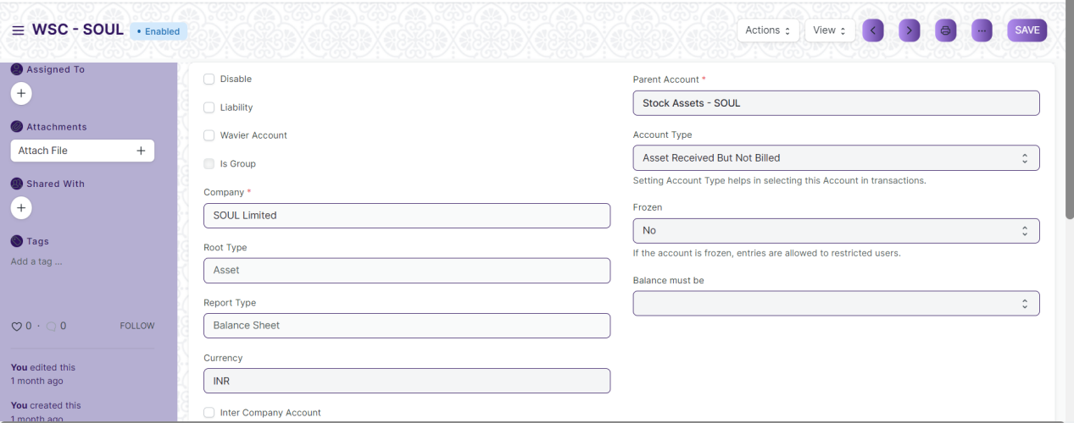

Figure: Chart of Accounts

**Field List:**

The following table describes the UI fields present in this screen:

|  |  |  |  |  |  |  |
| --- | --- | --- | --- | --- | --- | --- |
| **ID** | **Field Name** | **Field Type** | **Mandatory** | **Validation/Action** | **Remarks** | **R/N/D** |
|  | Disable | Checkbox | No | If checked account will be disabled along with the ledger |  |  |
|  | Liability | Checkbox | No | If checked account will be treated as liability |  |  |
|  | Waiver Account | Checkbox | No | If checked account will be treated as waiver account |  |  |
|  | Is Group | Checkbox | No | If checked account will be treated as a group |  |  |
|  | Account Name | Data | Yes |  |  |  |
|  | Account Number | Data | No |  |  |  |
|  | Company | Link Field | Yes | Links to company | By default company will be fetched |  |
|  | Root Type | Select | No |  |  |  |
|  | Report Type | Select | No |  |  |  |
|  | Currency | Link Field | No |  |  |  |
|  | Inter Company Account | Checkbox | No |  |  |  |
|  | Parent Account | Link Field | Yes | Links to Parent Account. |  |  |
|  | Account Type | Select | No |  |  |  |
|  | Rate | Float | No |  |  |  |
|  | Frozen | Select | No |  |  |  |
|  | Balance must be | Select | No |  |  |  |

**User Roles & Permission**

The following table describes the users and their roles and permissions for the screens :

|  |  |  |  |  |  |  |  |  |
| --- | --- | --- | --- | --- | --- | --- | --- | --- |
| **ID** | **Role** | **Read** | **Write** | **Create** | **Delete** | **Submit** | **Cancel** | **Amend** |
| 1 | Account User | No | No | No | No | NA | NA | NA |
| 2 | Account Manager | Yes | Yes | Yes | Yes | NA | NA | NA |
| 3 | Accountant Admin | Yes | Yes | Yes | Yes | NA | NA | NA |

### Fiscal Year

**General Description:**

The following table describe overall information about this screen

|  |  |
| --- | --- |
| **Description :** | **A** Fiscal **Year is used to record and report the transactions for the year.**It is also known as a financial year or a budget year. It is used for calculating financial statements in businesses and other organizations. The Fiscal Year may or may not be the same as a calendar year. |
| **Navigation :** | Home > Accounts > Fiscal Year |
| **Pre-requisites :** | The system should have records in the following screen  1.Company |
| **Existing Screen Name** | Fiscal Year |
| **New Screen Name** | No change |

**Screenshots:**

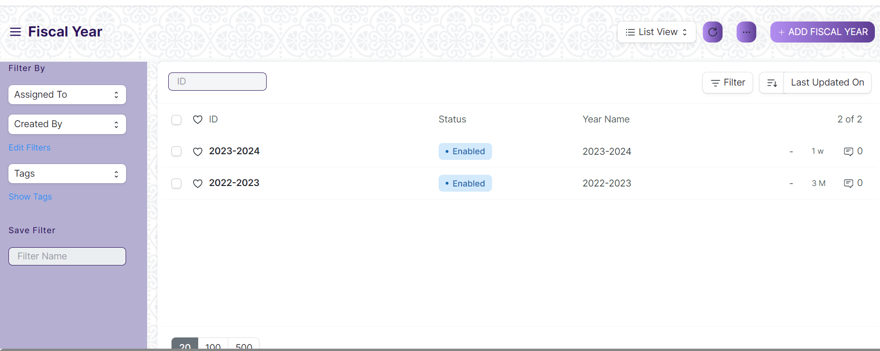

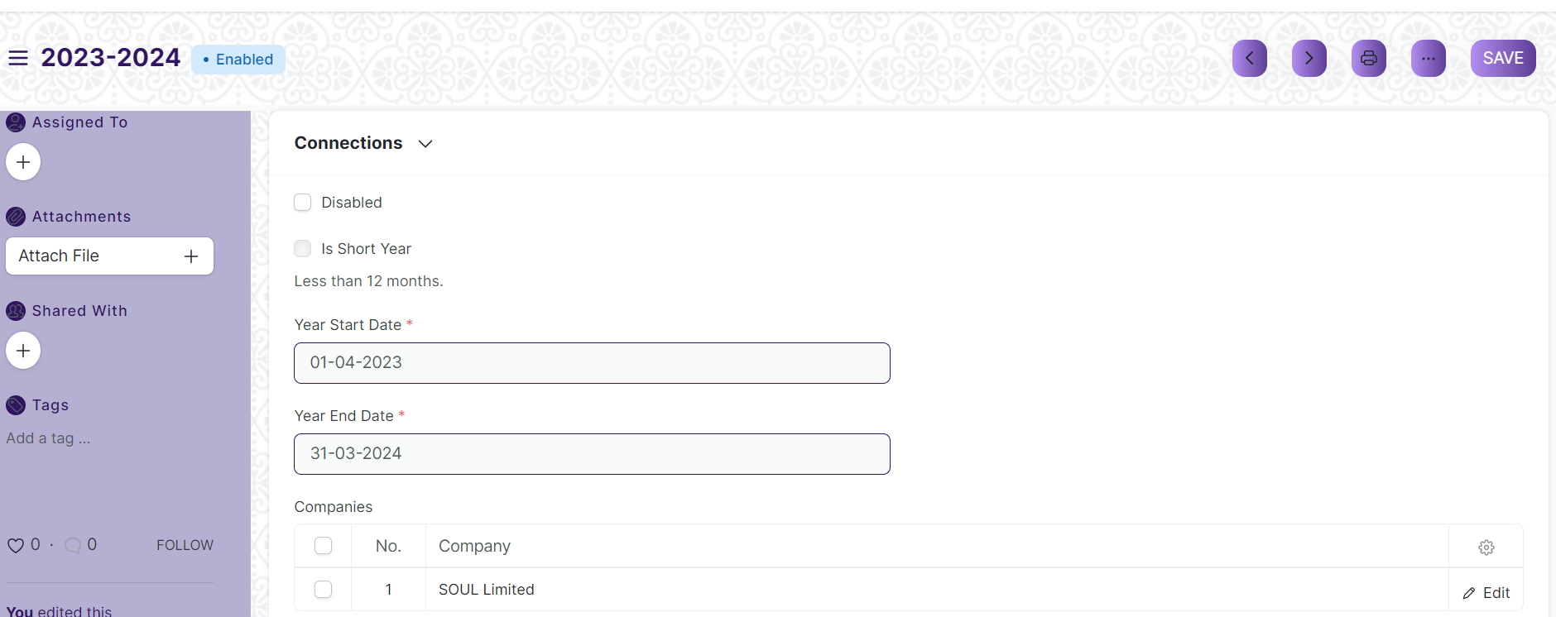

Figure: Fiscal year

**Field List:**

The following table describes the UI fields present in this screen:

|  |  |  |  |  |  |  |
| --- | --- | --- | --- | --- | --- | --- |
| **ID** | **Field Name** | **Field Type** | **Mandatory** | **Validation/Action** | **Remarks** | **R/N/D** |
|  | Disabled | Checkbox | No | If checked fiscal year will be disabled |  |  |
|  | Is Short Year | Checkbox | No |  |  |  |
|  | Year Start Date | Date | Yes | Set the year start date |  |  |
|  | Year End Date | Date | Yes | Set the year end date |  |  |
|  | Companies | Table | Yes |  | For further details regarding table Please check below |  |

|  |  |  |  |  |  |  |
| --- | --- | --- | --- | --- | --- | --- |
| **Company** | | | | | | |
| **ID** | **Field Name** | **Field Type** | **Validation/Action** | **Mandatory** | **Remarks** | **R/N/D** |
| 1 | Company | Link Field |  | No | Default company will be fetched while adding rows |  |

**User: Roles & Permission**

The following table describes the users and their roles and permissions for the screens :

|  |  |  |  |  |  |  |  |  |
| --- | --- | --- | --- | --- | --- | --- | --- | --- |
| **ID** | **Role** | **Read** | **Write** | **Create** | **Delete** | **Submit** | **Cancel** | **Amend** |
| 1 | Account User | No | No | No | No | NA | NA | NA |
| 2 | Account Manager | Yes | Yes | Yes | Yes | NA | NA | NA |
| 3 | Accountant Admin | Yes | Yes | Yes | Yes | NA | NA | NA |

### Accounting Period

**General Description:**

The following table describe overall information about this screen

|  |  |
| --- | --- |
| **Description :** | **An Accounting period defines a time period in which financial statements are recorded.** Accounting Period is a time frame outside which selected submit-table transactions (like Sales/Purchase Invoice, Stock Entry, Payroll Entry, Journal Entry etc) are not allowed to be created. The selected transactions are only allowed to be created within the defined Accounting Period. |
| **Navigation :** | Home > Accounts > Accounting Period |
| **Pre-requisites :** | The system should have records in the following screen   1. Company 2. Closed Documents |
| **Existing Screen Name** | Accounting Period |
| **New Screen Name** | No change |

**Screenshots:**

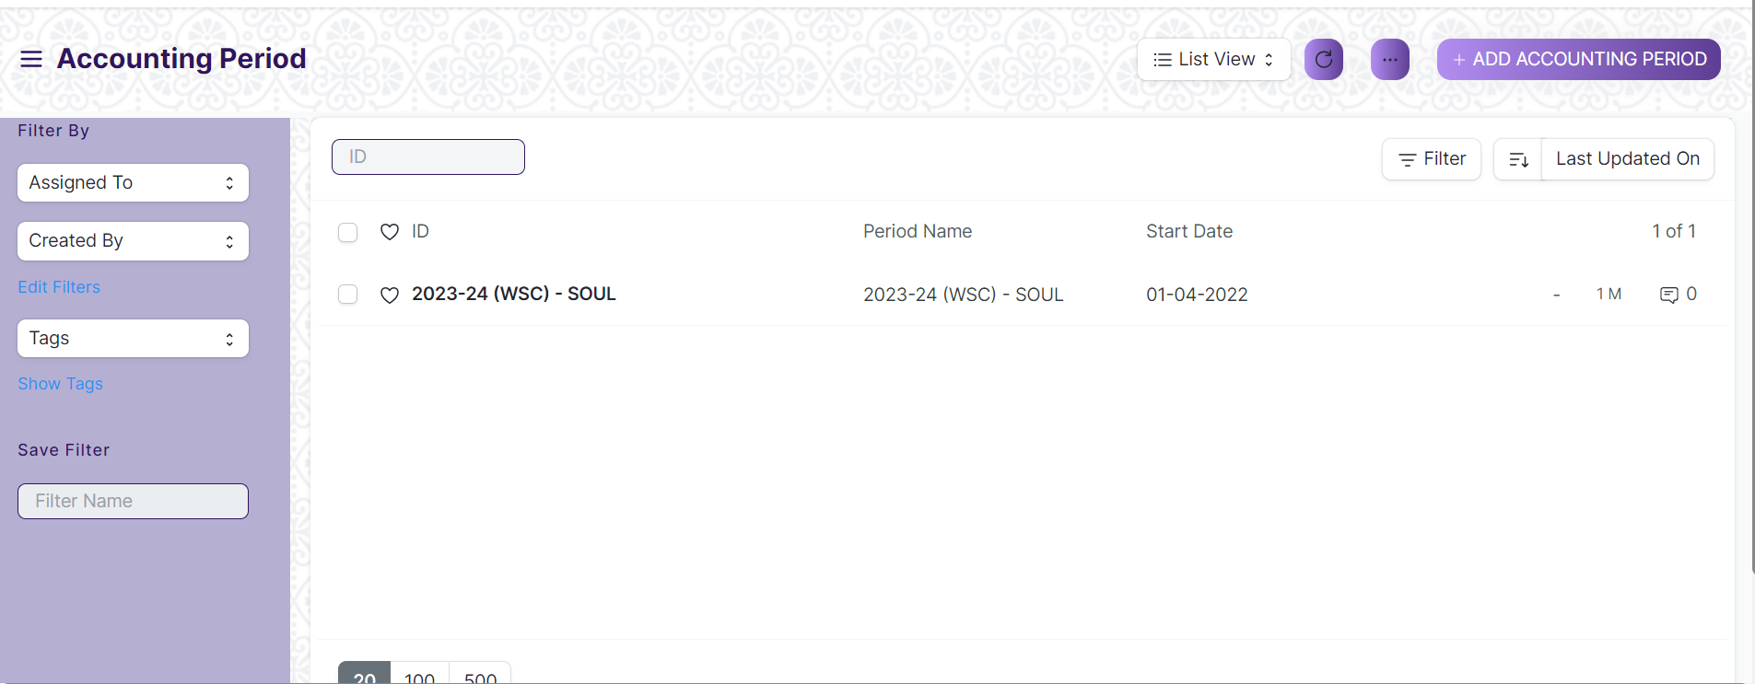

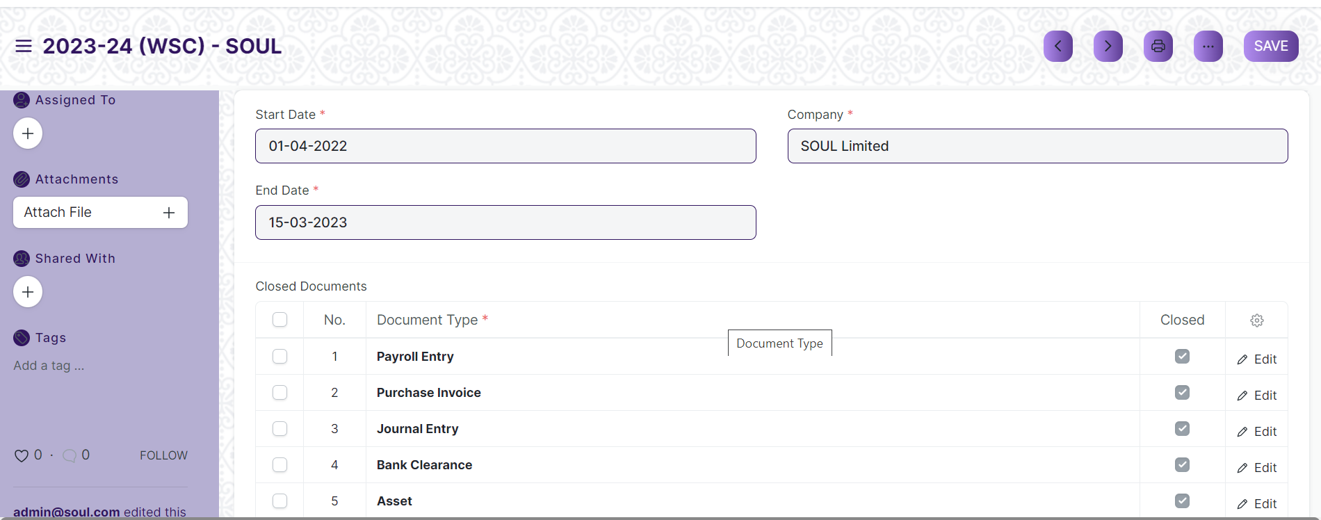

Figure: Accounting Period

**Field List:**

The following table describes the UI fields present in this screen:

|  |  |  |  |  |  |  |
| --- | --- | --- | --- | --- | --- | --- |
| **ID** | **Field Name** | **Field Type** | **Mandatory** | **Validation/Action** | **Remarks** | **R/N/D** |
| 1 | Start Date | Date | Yes | Set the period start date |  |  |
| 2 | End Date | Date | Yes | Set the period end date |  |  |
| 3 | Company | Link Field | Yes | Links to Company Screen . |  |  |
| 4 | Closed Documents | Table | Yes | For further details regarding table Please check below |  |  |

|  |  |  |  |  |  |  |
| --- | --- | --- | --- | --- | --- | --- |
| **Closed Documents** | | | | | | |
| **ID** | **Field Name** | **Field Type** | **Validation/Action** | **Mandatory** | **Remarks** | **R/N/D** |
| 1 | Document Type | Link Field | Links to doc type. | Yes |  |  |
| 2 | Closed | Checkbox |  | No | If checked the corresponding documents will be disabled which means none of the users will be able to create new entries. |  |

**User: Roles & Permission**

The following table describes the users and their roles and permissions for the screens :

|  |  |  |  |  |  |  |  |  |
| --- | --- | --- | --- | --- | --- | --- | --- | --- |
| **ID** | **Role** | **Read** | **Write** | **Create** | **Delete** | **Submit** | **Cancel** | **Amend** |
| 1 | Account User | No | No | No | No | NA | NA | NA |
| 2 | Account Manager | Yes | Yes | Yes | Yes | NA | NA | NA |
| 3 | Accountant Admin | Yes | Yes | Yes | Yes | NA | NA | NA |

### Finance Book

**General Description:**

The following table describe overall information about this screen .

|  |  |
| --- | --- |
| **Description :** | **A Finance Book is a**book**against which all the accounting entries are booked.** |
| **Navigation :** | Home > Accounts > Finance Book |
| **Pre-requisites :** | No Pre-requisite. |
| **Existing Screen Name** | Finance Book |
| **New Screen Name** | No change |

**Screenshots:**

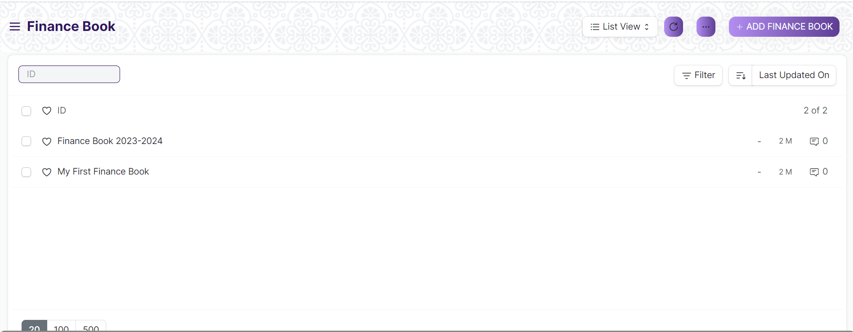

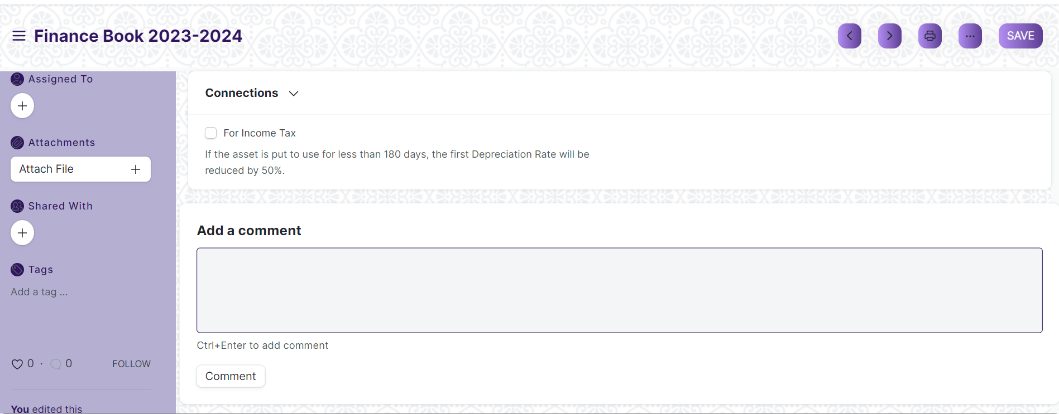

Figure: Finance Book

**Field List:**

The following table describes the UI fields present in this screen:

|  |  |  |  |  |  |  |
| --- | --- | --- | --- | --- | --- | --- |
| **ID** | **Field Name** | **Field Type** | **Mandatory** | **Validation/Action** | **Remarks** | **R/N/D** |
| 1 | Name | Data | No |  |  |  |

**User: Roles & Permission**

The following table describes the users and their roles and permissions for the screens :

|  |  |  |  |  |  |  |  |  |
| --- | --- | --- | --- | --- | --- | --- | --- | --- |
| **ID** | **Role** | **Read** | **Write** | **Create** | **Delete** | **Submit** | **Cancel** | **Amend** |
| 1 | Account User | No | No | No | No | NA | NA | NA |
| 2 | Account Manager | Yes | Yes | Yes | Yes | NA | NA | NA |
| 3 | Accountant Admin | Yes | Yes | Yes | Yes | NA | NA | NA |

### Bank

**General Description:**

The following table describe overall information about this screen

|  |  |
| --- | --- |
| **Description :** | A screen where information Bank information is stored , like Bank name,Account name details and address will be there. |
| **Navigation :** | Home > Accounts > Bank Statement > Bank |
| **Pre-requisites :** | No Pre-requisite. |
| **Existing Screen Name** | Bank |
| **New Screen Name** | No change |

**Screenshots:**

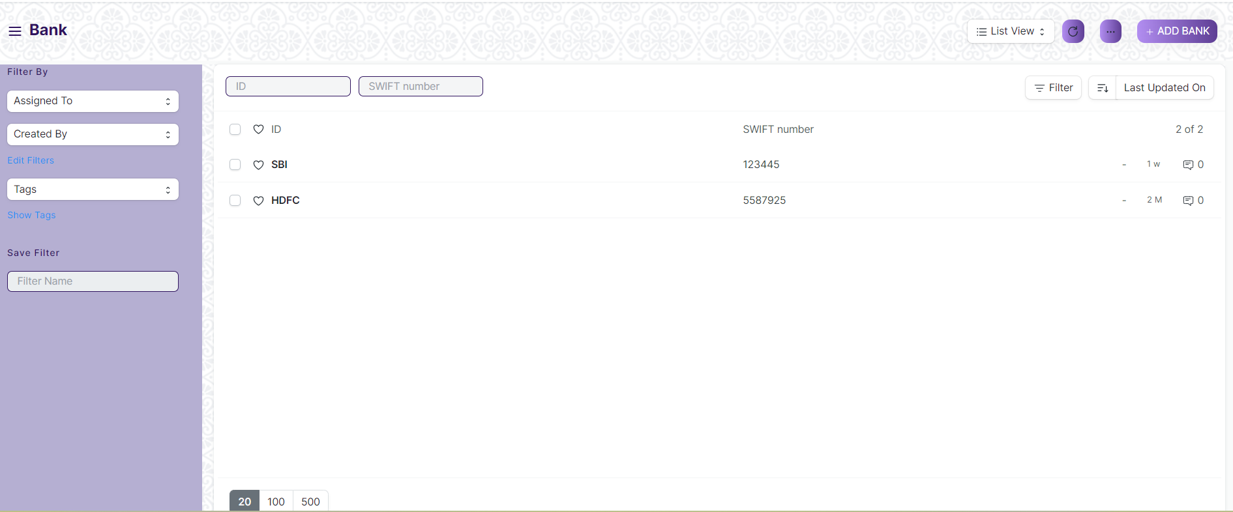

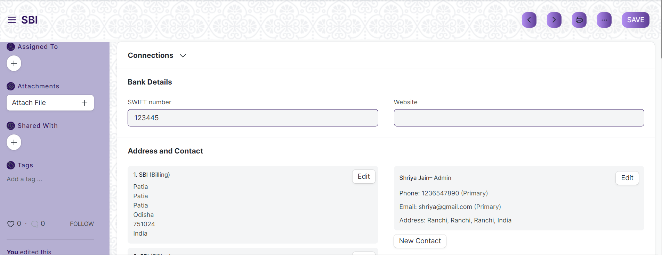

Figure: Bank

**Field List:**

The following table describes the UI fields present in this screen:

|  |  |  |  |  |  |  |
| --- | --- | --- | --- | --- | --- | --- |
| **ID** | **Field Name** | **Field Type** | **Mandatory** | **Validation/Action** | **Remarks** | **R/N/D** |
|  | SWIFT number | Data | No |  |  |  |
|  | Website | Data | No |  |  |  |
|  | Address HTML | HTML | No |  |  |  |
|  | Contact HTML | HTML | No |  |  |  |
|  | Bank Transaction Mapping | Table | No | For further details regarding table Please check below |  |  |
|  | Paid Access Token | Data | No |  |  |  |

|  |  |  |  |  |  |  |
| --- | --- | --- | --- | --- | --- | --- |
| **Bank Transaction Mapping** | | | | | | |
| **ID** | **Field Name** | **Field Type** | **Mandatory** | **Validation/Action** | **Remarks** | **R/N/D** |
| 1 | Field in Bank Transaction | Select | Yes |  |  |  |
| 2 | Column in Bank File | Data | Yes |  |  |  |

**User: Roles & Permission**

The following table describes the users and their roles and permissions for the screens :

|  |  |  |  |  |  |  |  |  |
| --- | --- | --- | --- | --- | --- | --- | --- | --- |
| **ID** | **Role** | **Read** | **Write** | **Create** | **Delete** | **Submit** | **Cancel** | **Amend** |
| 1 | Account User | No | No | No | No | NA | NA | NA |
| 2 | Account Manager | Yes | Yes | Yes | Yes | NA | NA | NA |
| 3 | Accountant Admin | Yes | Yes | Yes | Yes | NA | NA | NA |

### Bank Account

**General Description:**

The following table describe overall information about this screen

|  |  |
| --- | --- |
| **Description :** | It is a screen where Bank Accounts can be created for a Company as well as other parties like Customers, Suppliers etc. Doing this lets you record all the bank transactions correctly for accounting accuracy. |
| **Navigation :** | Home > Accounts > Bank Statement > Bank Account |
| **Pre-requisites** : | The system should have records in the following screen   1. Bank 2. Account Name |
| **Existing Screen Name** | Bank Account |
| **New Screen Name** | No Change |

**Screenshots:**

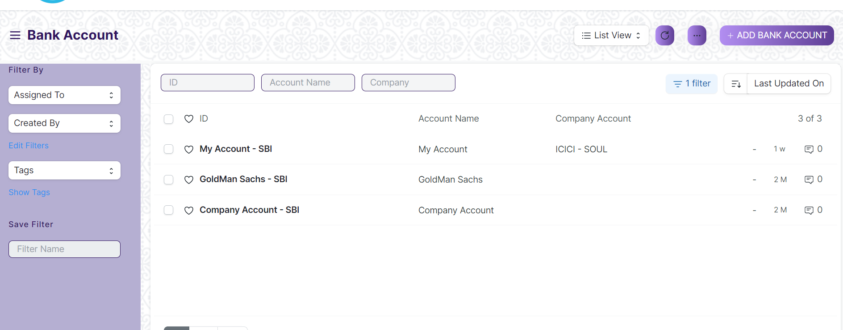

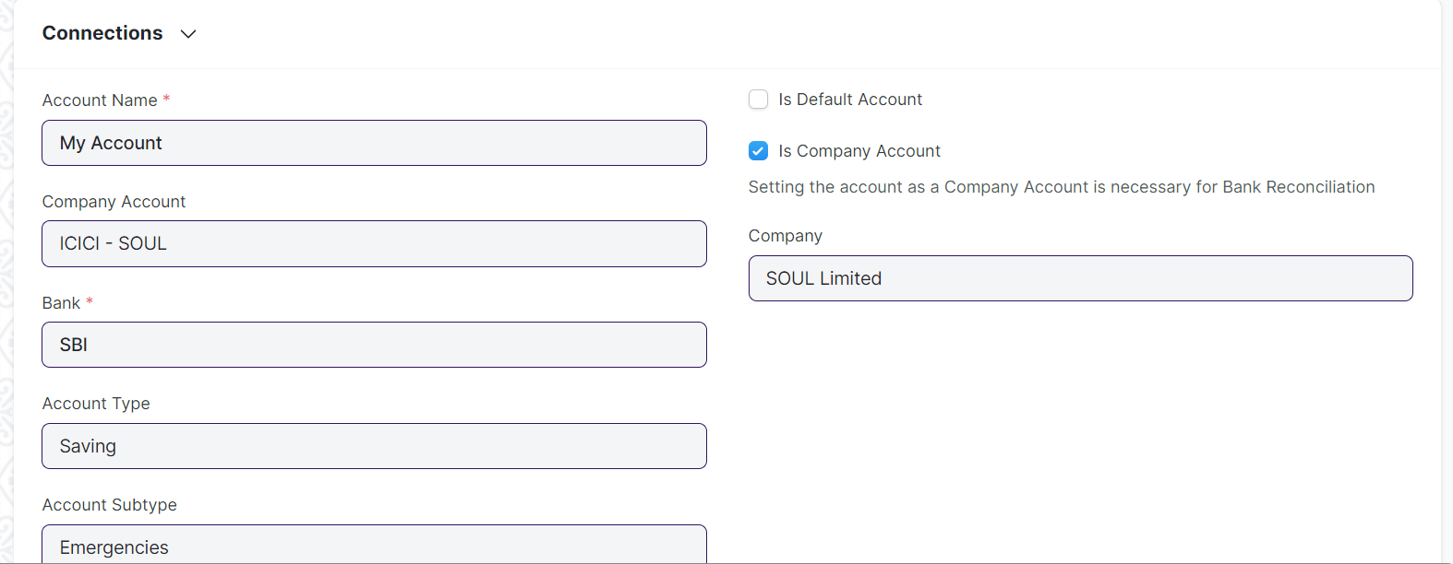

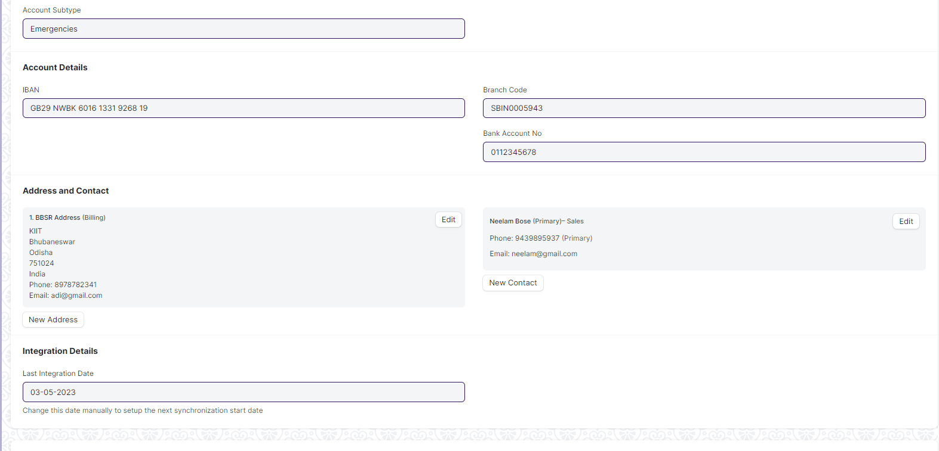

Figure: Bank Account

**Field List:**

The following table describes the UI fields present in this screen:

|  |  |  |  |  |  |  |
| --- | --- | --- | --- | --- | --- | --- |
| **ID** | **Field Name** | **Field Type** | **Mandatory** | **Validation/Action** | **Remarks** | **R/N/D** |
| 1 | Account Name | Data | Yes |  |  |  |
| 2 | Company Account | Link Field | No | Links to Company |  |  |
| 3 | Bank | Link Field | Yes |  |  |  |
| 4 | Account Type | Link Field | No | Links to Account Type Screen |  |  |
| 5 | Account Sub Type | Link Field | No | Links to Account Sub Type. |  |  |
| 6 | Is Default Account | Checkbox | No |  | If checked will set the account as default |  |
| 7 | Is Company Account | Checkbox | No |  |  |  |
| 8 | Company | Link Field | No | Links to Company screen. |  |  |
| 9 | Party Type | Link Field | No | Links to Party Type screen. |  |  |
| 10 | Party | Dynamic Link Field | No | Links to Party screen. |  |  |
| 11 | IBAN | Data | No |  |  |  |
| 12 | Branch Code | Data | No |  |  |  |
| 13 | Bank Account No | Data | No |  |  |  |
| 14 | Address | HTML | No |  |  |  |
| 15 | Contact | HTML | No |  |  |  |
| 16 | Integration ID | Data | No |  |  |  |
| 17 | Last Integration Date | Date | No |  |  |  |
| 18 | Mask | Data | No |  |  |  |

**User: Roles & Permission**

The following table describes the users and their roles and permissions for the screens :

|  |  |  |  |  |  |  |  |  |
| --- | --- | --- | --- | --- | --- | --- | --- | --- |
| **ID** | **Role** | **Read** | **Write** | **Create** | **Delete** | **Submit** | **Cancel** | **Amend** |
| 1 | Account User | No | No | No | No | NA | NA | NA |
| 2 | Account Manager | Yes | Yes | Yes | Yes | NA | NA | NA |
| 3 | Accountant Admin | Yes | Yes | Yes | Yes | NA | NA | NA |

### Mode of payment

**General Description:**

The following table describe overall information about this screen

|  |  |
| --- | --- |
| **Description :** | It is a screen where Bank Accounts can be created for a Company as well as other parties like Customers, Suppliers etc. Doing this lets you record all the bank transactions correctly for accounting accuracy. |
| **Navigation :** | Home > Settings > Mode of payment |
| **Pre-requisites** : | The system should have records in the following screen  1.Mode of Payment Account |
| **Existing Screen Name** | Mode of payment |
| **New Screen Name** | No Change |

**Screenshots:**

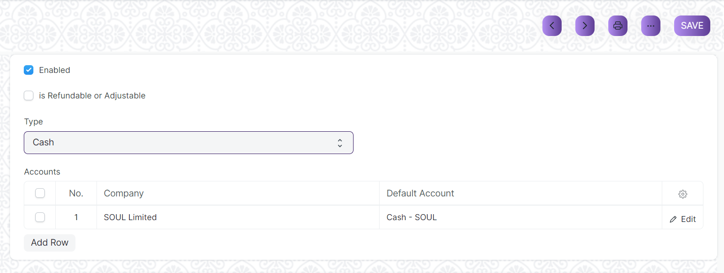

Figure: Mode of payment

**Field List:**

The following table describes the UI fields present in this screen:

|  |  |  |  |  |  |  |
| --- | --- | --- | --- | --- | --- | --- |
| **ID** | **Field Name** | **Field Type** | **Mandatory** | **Validation/Action** | **Remarks** | **R/N/D** |
| 1 | Mode of Payment | Data | Yes |  |  |  |
| 2 | Enable | Check | No | If checked then Mode of payment will be enabled. |  |  |
| 3 | is Refundable or Adjustable | Check | No | If checked then Mode of payment will be refundable or adjustable. |  |  |
| 4 | Type | Select | No |  | There are different types of Mode of Payment such as  -Cash  -Bank  -General  -Phone |  |
| 5 | Mode of Payment Account | Table | Yes |  | The description of the table is given below. |  |

|  |  |  |  |  |  |  |
| --- | --- | --- | --- | --- | --- | --- |
| **Mode of payment Account** | | | | | | |
| **ID** | **Field Name** | **Field Type** | **Validation/Action** | **Mandatory** | **Remarks** | **R/N/D** |
| 1 | Company | Link Field |  | No | Default company will be fetched while adding rows |  |
| 2 | Default Account | Link Field |  | No |  |  |

**User: Roles & Permission**

The following table describes the users and their roles and permissions for the screens :

|  |  |  |  |  |  |  |  |  |
| --- | --- | --- | --- | --- | --- | --- | --- | --- |
| **ID** | **Role** | **Read** | **Write** | **Create** | **Delete** | **Submit** | **Cancel** | **Amend** |
| 1 | Account User | No | No | No | No | NA | NA | NA |
| 2 | Account Manager | Yes | Yes | Yes | Yes | NA | NA | NA |
| 3 | Accountant Admin | Yes | Yes | Yes | Yes | NA | NA | NA |

## General Ledger

### Journal Entry

**General Description**

The following table describes overall information about this screen:

|  |  |
| --- | --- |
| **Description** | A Journal Entry is an entry made in the general ledger and it indicates the affected accounts. |
| **Navigation** | Home > Accounts > General Ledger > Journal Entry |
| **Pre-requisites** | The system should have records in the following screen   1. Company 2. Finance Book 3. Journal Entry Template 4. Account 5. Party Type 6. Party 7. Letter Head 8. Print Heading 9. Mode of Payment |
| **Existing Screen Name** | Journal Entry |
| **New Screen Name** | No change |

**Screenshot**

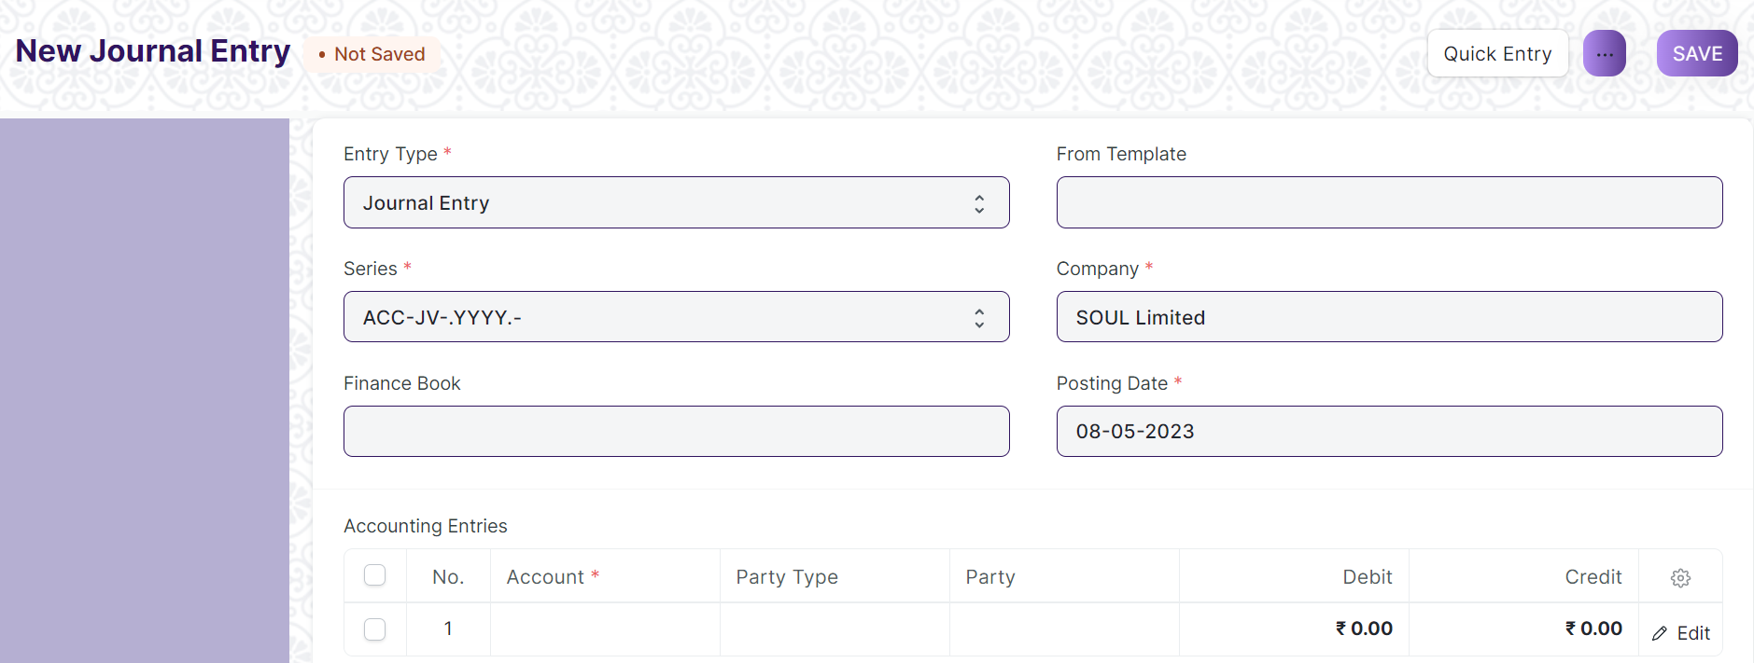Figure: Journal Entry

**Field List**

The following table describes the UI fields present in this screen :

|  |  |  |  |  |  |  |
| --- | --- | --- | --- | --- | --- | --- |
| **ID** | **Field Name** | **Field Type** | **Mandatory** | **Validation/ Action** | **Remarks** | **R/N/D** |
|  | Title | Text |  |  |  |  |
|  | Entry Type | Dropdown | Yes | Options:  Journal Entry  Inter Company Journal Entry  Bank Entry  Cash Entry  Credit Card Entry  Debit Note  Credit Note  Contra Entry  Excise Entry  Write Off Entry  Opening Entry  Depreciation Entry  Exchange Rate Revaluation  Deferred Revenue  Deferred Expense |  |  |
|  | Finance Book | Link Field |  | Link Fields to Finance Book Screen |  |  |
|  | Process Deferred Accounting | Link Field |  | Link Fields to Process Deferred Accounting Screen |  |  |
|  | Reversal Of | Link Field |  | Link Fields to Journal Entry Screen |  |  |
|  | Tax Withholding Category | Link Field |  | Link Fields to Tax Withholding Category Screen |  |  |
|  | From Template | Link Field |  | Link Fields to Journal Entry Template Screen |  |  |
|  | Company | Link Field | Yes | Link Fields to Company Screen |  |  |
|  | Posting Date | Date | Yes |  |  |  |
|  | Apply Tax Withholding Amount | Checkbox |  |  |  |  |
|  | Accounting Entries | Table | Yes | Journal Entry Account |  |  |
|  | Reference Number | Text |  |  |  |  |
|  | Reference Date | Date |  |  |  |  |
|  | User Remark | Small Text |  |  |  |  |
|  | Total Debit | Currency |  |  |  |  |
|  | Total Credit | Currency |  |  |  |  |
|  | Difference (Dr - Cr) | Currency |  |  |  |  |
|  | Make Difference Entry | Button |  |  |  |  |
|  | Multi Currency | Check box |  |  |  |  |
|  | Total Amount Currency | Link Field |  | Link Fields to Currency Screen |  |  |
|  | Total Amount | Currency |  |  |  |  |
|  | Total Amount in Words | Text |  |  |  |  |
|  | Clearance Date | Date |  |  |  |  |
|  | Remark | Small Text |  |  |  |  |
|  | Paid Loan | Text |  |  |  |  |
|  | Bill No | Text |  |  |  |  |
|  | Bill Date | Date |  |  |  |  |
|  | Due Date | Date |  |  |  |  |
|  | Get Outstanding Invoices | Button |  |  |  |  |
|  | Pay To / Recd From | Text |  |  |  |  |
|  | Letter Head | Link Field |  | Link Fields to Letter Head Screen |  |  |
|  | Print Heading | Link Field |  | Link Fields to Print Heading Screen |  |  |
|  | Mode of Payment | Link Field |  | Link Fields to Mode of Payment Screen |  |  |
|  | Payment Order | Link Field |  | Link Fields to Payment Order Screen |  |  |
|  | Is Opening | Dropdown |  | Options  No  Yes |  |  |
|  | Stock Entry | Link Fields |  | Link Fields to Stock Entry Screen |  |  |
|  | Auto Repeat | Link Fields |  | Link Fields to Auto Repeat Screen |  |  |
|  | Quick Entry | | | Action Button | On Click a Popup will open and the user need to enter the Credit account, Debit account, date, etc. |  |
|  | Amount | Text | Yes |  | On Click the Quick Entry Button, this field will visible inside a popup. |  |
|  | Debit Account | Link Field | Yes | Link Field to Account Screen | On Click the Quick Entry Button, this field will visible inside a popup. |  |
|  | Credit Account | Link Field | Yes |  | On Click the Quick Entry Button, this field will visible inside a popup. |  |
|  | Date | Date | Yes |  | On Click the Quick Entry Button, this field will visible inside a popup. |  |
|  | User Remark | Long Text |  |  | On Click the Quick Entry Button, this field will visible inside a popup. |  |
|  | Series | Naming Series | Yes | Create the unique naming series for the records. | On Click the Quick Entry Button, this field will visible inside a popup. |  |
|  | View --> Ledger | | |  | On click the General Ledger Screen will open in report view. |  |
|  | Action --> Reverse Journal Entry | | |  | It Creates another new record when user can do reverse journal entry. |  |

**User: Roles & Permission**

The following table describes the users and their roles and permissions for the screens :

|  |  |  |  |  |  |  |  |  |
| --- | --- | --- | --- | --- | --- | --- | --- | --- |
| **ID** | **Role** | **Read** | **Write** | **Create** | **Delete** | **Submit** | **Cancel** | **Amend** |
| 1 | Accountant Admin | Yes | Yes | Yes | Yes | Yes | Yes | Yes |
| 2 | Account Manager | Yes | Yes | Yes | No | Yes | Yes | Yes |
| 3 | Account User | Yes | Yes | Yes | No | Yes | Yes | Yes |

### 

### General Ledger

**General Description**

The following table describes overall information about this screen:

|  |  |
| --- | --- |
| Description | * The General Ledger is a detailed report for all transactions posted to each account and for every transaction there is a Credit and Debit account so it lists them all up. * The report is based on the table GL Entry and can be filtered by many predefined filters like Account, Cost Centers, Party, Project and Period etc. This helps you to get a full update for all entries posted in a period against any account. * The result can be grouped by Account, Voucher/Transaction and Party with opening and closing balances for each group. * In case of multi-currency accounting, there is also an option to check the amounts in any other currency than the company's base currency. |
| Navigation | Home > Accounts > General Ledger > General Ledger |
| Pre-requisites | The system should have records in the following screen   1. Company 2. Finance Book 3. Account |
| Existing Screen Name | General Ledger |
| New Screen Name | No change |

**Screenshot**

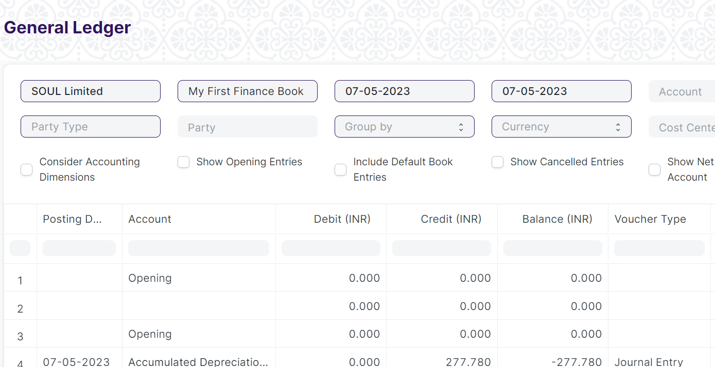

Figure: General Ledger

**Input Filters:**

|  |  |  |  |  |  |  |
| --- | --- | --- | --- | --- | --- | --- |
| **ID** | **Input Fields** | **Field Type** | **Mandatory** | **Validation/ Action** | **Remarks** | **R/N/D** |
|  | Company | Link Field |  | Link Fields to Company Screen |  |  |
|  | Finance Book | Link Field |  | Link Fields to Finance Book Screen |  |  |
|  | From Date | Date |  | From date should be before the To date |  |  |
|  | To Date | Date |  | To date should be after from date |  |  |
|  | Account | Link Field |  | Link Fields to Account Screen |  |  |
|  | Voucher No | Text |  |  |  |  |
|  | Party Type | Link Field |  | Link Fields to Customer, Supplier, Student, Employee Screen |  |  |
|  | Party | Link Field |  | Link fields depends upon the party type |  |  |
|  | Group Name | Dropdown |  | Options:   1. Group by Voucher 2. Group by Voucher (Consolidated) 3. Group by Account 4. Group by Party |  |  |
|  | Currency | Dropdown |  | Options:   1. AED 2. AUD 3. CHF 4. CNY 5. EUR 6. GBP 7. INR 8. JPY 9. USD |  |  |
|  | Cost Center | Link Field |  | Link Fields to Cost Center Master Screen |  |  |
|  | Project | Link Field |  | Link Fields to Project Screen |  |  |
|  | Consider Accounting Dimensions | Check box |  | On Check Accounting Dimensions will be considered. |  |  |
|  | Show Opening Entries | Check box |  | On Check It will show the Opening Entries only. |  |  |
|  | Include Default Book Entries | Check box |  | On Check It includes default book entries |  |  |
|  | Show Cancelled Entries | Check box |  | On Check It will show only Cancelled entries. |  |  |
|  | Show Net Values in Party Account | Check box |  | On Check It shows the net values in Party Account |  |  |

**Actions**

* User will enter the search fields such as: Account, Voucher No, etc. Based on that input, the report will be shown.
* User can add or remove the headers with the help of Add Column or Remove Column button.

**Report Fields**

|  |  |  |
| --- | --- | --- |
| **ID** | **Column Name** | **Description** |
|  | Posting Date | It is the document posting date |
|  | Account | Name of the Account Type |
|  | Debit | Debited Amount |
|  | Credit | Credited Amount |
|  | Balance | Debit - Credit = Balance |
|  | Voucher Type | Different Types of Vouchers like Purchase Receipt, Stock Entry, etc. |
|  | Voucher No | Voucher no. is based on the voucher type. |
|  | Against Account | Different Types of Vouchers like Purchase Receipt, Stock Entry, etc. |
|  | Party Type | Voucher no. is based on the voucher type. |
|  | Party | A specific Supplier, Customer or Student depending on the option you choose for the Party Type. |
|  | Cost Center | It is a part of an organization where costs or income can be charged. |
|  | Project | Name of the Project |
|  | Against Voucher Type | Payment made against a particular voucher type. |
|  | Against Voucher | Payment made against a particular voucher number. |
|  | Supplier Invoice No | Shows the Supplier Invoice Number. |
|  | Remarks | Remarks given w.r.t. the Party Name |

**User: Roles & Permission**

The following table describes the users and their roles and permissions for the screens :

|  |  |  |  |  |  |  |  |  |
| --- | --- | --- | --- | --- | --- | --- | --- | --- |
| **ID** | **Role** | **Read** | **Write** | **Create** | **Delete** | **Submit** | **Cancel** | **Amend** |
| 1 | Accountant Admin | Yes | Yes | NA | NA | NA | NA | NA |
| 2 | Account Manager | Yes | Yes | NA | NA | NA | NA | NA |
| 3 | Account User | Yes | Yes | NA | NA | NA | NA | NA |

### Supplier Ledger Summary

**General Description**

The following table describes overall information about this screen:

|  |  |
| --- | --- |
| Description | This Shows the Ledger by Individual Supplier Wise |
| Navigation | Home > Accounts > General Ledger > Supplier Ledger Summary |
| Pre-requisites | The system should have records in the following screen   1. Company 2. Finance Book 3. Supplier Group 4. Payment Term Template (Optional) |
| Existing Screen Name | Supplier Ledger Summary |
| New Screen Name | No change |

**Screenshot**

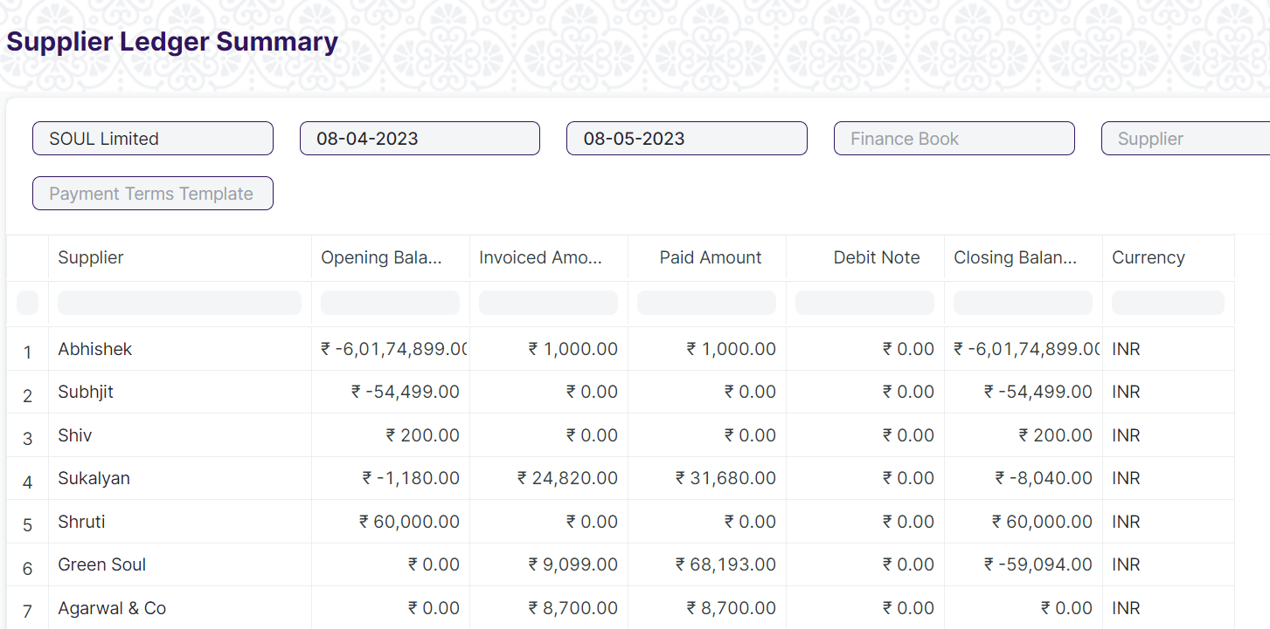

Figure: General Ledger Summary

**Input Filters**

|  |  |  |  |  |  |  |
| --- | --- | --- | --- | --- | --- | --- |
| **ID** | **Input Fields** | **Field Type** | **Mandatory** | **Validation/ Action** | **Remarks** | **R/N/D** |
|  | Company | Link Field |  | Link Field to the Company Screen |  |  |
|  | From Date | Date |  | From date should be before the To date |  |  |
|  | To Date | Date |  | To date should be after from date |  |  |
|  | Finance Book | Link Field |  | Link Fields to Finance Book Screen |  |  |
|  | Supplier | Link Field |  | Link Fields to Supplier Screen |  |  |
|  | Supplier Group | Link Field |  | Link Fields to Supplier Group Screen |  |  |
|  | Payment Terms Template | Link Field |  | Link Fields to Payment Terms Template Screen |  |  |

**Actions**

* User will enter the search fields such as: Finance Book, Supplier, No, etc. Based on that input, the report will be shown.
* A user can add or remove the headers with the help of Add Column or Remove Column button.

**Report Fields**

|  |  |  |
| --- | --- | --- |
| **ID** | **Column Name** | **Description** |
|  | Supplier | Suppliers are companies or individuals who provide you with products or services. |
|  | Opening Balance | Opening Balance of the Supplier. |
|  | Invoiced Amount | It shows the Invoiced amount of the supplier |
|  | Paid Amount | It shows the amount paid by the supplier. |
|  | Debit Note | It is a document send by a buyer to the supplier notifying that a debit has been recorded. |
|  | Closing Balance | It shows the closing balance of the supplier |
|  | Currency | It shows the currency such as INR, USD, etc. |

**User: Roles & Permission**

The following table describes the users and their roles and permissions for the screens :

|  |  |  |  |  |  |  |  |  |
| --- | --- | --- | --- | --- | --- | --- | --- | --- |
| **ID** | **Role** | **Read** | **Write** | **Create** | **Delete** | **Submit** | **Cancel** | **Amend** |
| 1 | Accountant Admin | Yes | Yes | NA | NA | NA | NA | NA |
| 2 | Account Manager | Yes | Yes | NA | NA | NA | NA | NA |
| 3 | Account User | Yes | Yes | NA | NA | NA | NA | NA |

## Account Receivable

### Payment Entry

**General Description**

The following table describes overall information about this screen:

|  |  |
| --- | --- |
| **Description** | Payment Entry is a record indicating that payment has been made for an invoice.  Payment Entry can be made against the following transactions.   1. Sales Invoice 2. Purchase Invoice 3. Sales Order (Advance Payment) 4. Purchase Order (Advance Payment) 5. Expense Claim 6. Internal Transfer |
| **Navigation** | Home > Accounts > Account Receivable > Payment Entry |
| **Pre-requisites** | The system should have records in the following screen   1. Mode of Payment 2. Account |
| **Existing Screen Name** | Payment Entry |
| **New Screen Name** | No change |

**Screenshot**

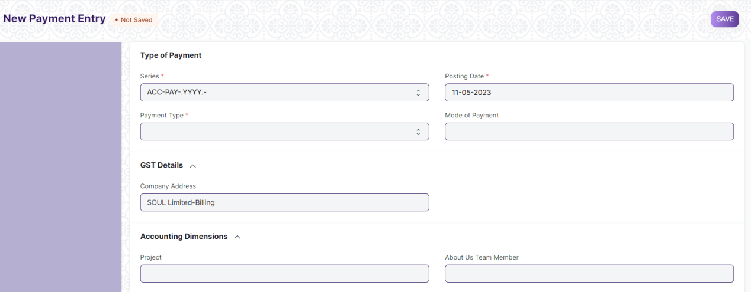

Figure: Payment Entry

**Field List**

The following table describes the UI fields present in this screen :

|  |  |  |  |  |  |  |
| --- | --- | --- | --- | --- | --- | --- |
| **ID** | **Field Name** | **Field Type** | **Mandatory** | **Validation/ Action** | **Remarks** | **R/N/D** |
|  | Payment Type | Dropdown | Yes | Options:  Receive Pay Internal Transfer |  |  |
|  | Payment Order Status | Dropdown |  | Options:  Initiated  Payment Ordered |  |  |
|  | Posting Date | Date | Yes |  |  |  |
|  | Company | Link Field | Yes | Link Field to Company Screen |  |  |
|  | Mode of Payment | Link Field |  | Link Field to Mode of Payment Screen |  |  |
|  | Party Type | Link Field |  | Link Field to Employee, Customer, Student, Share holder, Supplier Screen |  |  |
|  | Party | Dynamic Link |  | On the basis of Party Type selected by the user, Dynamic Link Field will be visible accordingly. |  |  |
|  | Party Name | Text |  | Auto fetched when Party entered |  |  |
|  | Company Bank Account | Link Field |  | Link Field to Account Screen |  |  |
|  | Party Bank Account | Link Field |  | Link Field to Account Screen |  |  |
|  | Contact | Link Field |  | Link Field to Contact Screen |  |  |
|  | Email | Text |  |  |  |  |
|  | Party Balance | Currency |  |  |  |  |
|  | Account Paid From | Link Field | Yes | Link Field to Account Screen | When user entered payment type equal to Internal transfer then only this field will visible. |  |
|  | Paid From Account Type | Text |  |  |  |  |
|  | Account Currency (From) | Link Field | Yes | Link Field to Currency Screen | It will visible When Account Paid From data is entered |  |
|  | Account Balance (From) | Currency |  |  |  |  |
|  | Account Paid To | Link Field | Yes | Link Field to Currency Screen | When user entered payment type equal to Internal transfer then only this field will visible. |  |
|  | Paid To Account Type | Text |  |  |  |  |
|  | Account Currency (To) | Link Field | Yes | Link Field to Currency Screen | It will visible When Account Paid To data is entered |  |
|  | Account Balance (To) | Currency |  |  | It will visible When Account Paid To data is entered |  |
|  | Paid Amount | Currency | Yes |  | It will visible When Account Paid To data is entered |  |
|  | Paid Amount After Tax | Currency |  |  |  |  |
|  | Source Exchange Rate | Float | Yes |  |  |  |
|  | Paid Amount (Company Currency) | Currency | Yes |  |  |  |
|  | Paid Amount After Tax (Company Currency) | Currency |  |  |  |  |
|  | Received Amount | Currency | Yes |  | It will visible When Account Paid To data is entered |  |
|  | Received Amount After Tax | Currency |  |  |  |  |
|  | Target Exchange Rate | Float | Yes |  |  |  |
|  | Received Amount (Company Currency) | Currency | Yes |  |  |  |
|  | Received Amount After Tax (Company Currency) | Currency |  |  |  |  |
|  | Get Outstanding Invoice | Button |  |  |  |  |
|  | **Payment References** | Table |  |  |  |  |
|  | Total Allocated Amount | Currency |  |  |  |  |
|  | Total Allocated Amount (Company Currency) | Currency |  |  |  |  |
|  | Set Exchange Gain / Loss | Button |  |  |  |  |
|  | Unallocated Amount | Currency |  |  |  |  |
|  | Difference Amount (Company Currency) | Currency |  |  |  |  |
|  | Write Off Difference Amount | Button |  |  |  |  |
|  | Purchase Taxes and Charges Template | Link Field |  | Link Field to Purchase Taxes and Charges Template Screen |  |  |
|  | Sales Taxes and Charges Template | Link Field |  | Link Field to Sales Taxes and Charges Template Screen |  |  |
|  | Apply Tax Withholding Amount | Checkbox |  |  |  |  |
|  | Tax Withholding Category | Link Field |  | Link Field to Tax Withholding Category Screen |  |  |
|  | **Advance Taxes and Charges** | Table |  |  |  |  |
|  | Total Taxes and Charges (Company Currency) | Currency |  |  |  |  |
|  | Total Taxes and Charges | Currency |  |  |  |  |
|  | **Payment Deductions or Loss** | Table |  |  |  |  |
|  | Cheque/Reference No | Text |  |  | It will visible When Mode of Payment equals to Cheque |  |
|  | Cheque/Reference Date | Date |  |  | It will visible When Mode of Payment equals to Cheque |  |
|  | Clearance Date | Date |  |  |  |  |
|  | Project | Link Field |  | Link Field to Project Screen |  |  |
|  | Cost Center | Link Field |  | Link Field to Cost Center Screen |  |  |
|  | Status | Dropdown |  | Options:  Draft  Submitted  Cancelled |  |  |
|  | Remarks | Small Text |  |  |  |  |
|  | Letter Head | Link Field |  | Link Field to Company Screen |  |  |
|  | Print Heading | Link Field |  | Link Field to Company Screen |  |  |
|  | Bank | Read Only |  |  |  |  |
|  | Bank Account No | Read Only |  |  |  |  |
|  | Payment Order | Link Field |  | Link Field to Payment Order Screen |  |  |
|  | Auto Repeat | Link Field |  | Link Field to Auto Repeat Screen |  |  |
|  | Title | Text |  |  |  |  |

|  |  |  |  |  |  |  |
| --- | --- | --- | --- | --- | --- | --- |
| **Payment References** | | | | | | |
| **ID** | **Field Name** | **Field Type** | **Mandatory** | **Validation/ Action** | **Remarks** | **R/N/D** |
|  | Type | Link Field | Yes | Link Field to Supplier, Customer, Student, Employee Screen |  |  |
|  | Name | Dynamic Link Field | Yes | Dropdown data will come w.r.t. the Type |  |  |
|  | Due Date | Date |  |  |  |  |
|  | Supplier Invoice No | Text |  |  |  |  |
|  | Payment Term | Link Field |  | Link Field to Payment Term Screen |  |  |
|  | Grand Total | Float |  |  |  |  |
|  | Outstanding | Float |  |  |  |  |
|  | Allocated | Float |  |  |  |  |
|  | Exchange Rate | Float |  |  |  |  |
|  | Exchange Gain/Loss | Currency |  |  |  |  |
| **Advance Taxes and Charges** | | | | | | |
| **ID** | **Field Name** | **Field Type** | **Mandatory** | **Validation/ Action** | **Remarks** | **R/N/D** |
|  | Add Or Deduct | Dropdown | Yes | Option:  Add  Deduct |  |  |
|  | Type | Dropdown | Yes | Option:   1. Actual 2. On Paid Amount 3. On Previous Row Amount 4. On Previous Row Total |  |  |
|  | Account Head | Link Field | Yes | Link Filed to Account Screen |  |  |
|  | Description | Long Text | Yes |  |  |  |
|  | Considered In Paid Amount | Check Box |  | Link Field to Payment Term Screen |  |  |
|  | Cost Center | Link Field |  | Link field to Cost Center Screen |  |  |
|  | Rate | Float |  |  |  |  |
|  | Account Currency | Link Field |  | Link field to Currency Screen |  |  |
|  | Amount | Currency |  |  |  |  |
|  | Total | Currency |  |  |  |  |
|  | Allocated Amount | Currency |  |  |  |  |
| **Payment Deductions or Loss** | | | | | | |
| **ID** | **Field Name** | **Field Type** | **Mandatory** | **Validation/ Action** | **Remarks** | **R/N/D** |
|  | Account | Link Field | Yes | Link Field to Account Screen |  |  |
|  | Cost Center | Link Field | Yes | Link Field to Cost Center Screen |  |  |
|  | Amount | Currency | Yes |  |  |  |
|  | Description | Long Text |  |  |  |  |

**User: Roles & Permission**

The following table describes the users and their roles and permissions for the screens :

|  |  |  |  |  |  |  |  |  |
| --- | --- | --- | --- | --- | --- | --- | --- | --- |
| **ID** | **Role** | **Read** | **Write** | **Create** | **Delete** | **Submit** | **Cancel** | **Amend** |
| 1 | Accountant Admin | Yes | Yes | Yes | Yes | Yes | Yes | Yes |
| 2 | Account Manager | Yes | Yes | Yes | No | Yes | Yes | Yes |
| 3 | Account User | Yes | Yes | Yes | No | Yes | Yes | Yes |

### Accounts Receivable

**General Description**

The following table describes overall information about this screen:

|  |  |
| --- | --- |
| **Description** | This reports help you to track the outstanding amount of Customers. It also provides ageing analysis i.e. a break-up of outstanding amount based on the period for which the amount is outstanding. |
| **Navigation** | Home > Accounts > Account Receivable > Account Receivable |
| **Pre-requisites** | The system should have records in the following screen   1. Company 2. Finance Book 3. Cost Center 4. Customer |
| **Existing Screen Name** | Account Receivable |
| **New Screen Name** | No change |

**Screenshot**

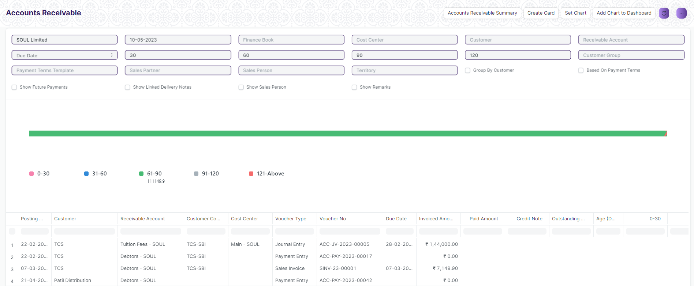

Figure: Account Receivable

**Input Filters**

|  |  |  |  |  |  |  |
| --- | --- | --- | --- | --- | --- | --- |
| **ID** | **Input Fields** | **Field Type** | **Mandatory** | **Validation/ Action** | **Remarks** | **R/N/D** |
|  | Company | Link Field |  |  |  |  |
|  | Posting Date | Date |  | From date should be before the To date |  |  |
|  | Finance Book | Link Field |  | Link Fields to Finance Book Screen |  |  |
|  | Cost Center | Link Field |  | Link Fields to Cost Center Screen |  |  |
|  | Customer | Link Field |  | Link Fields to Customer Screen |  |  |
|  | Receivable Account | Link Field |  | Link Fields to Receivable Account Screen |  |  |
|  | Due Date | Date |  |  |  |  |
|  | Ageing Range 1 | Text |  |  |  |  |
|  | Ageing Range 2 | Text |  |  |  |  |
|  | Ageing Range 3 | Text |  |  |  |  |
|  | Ageing Range 4 | Text |  |  |  |  |
|  | Customer Group | Link Field |  | Link Fields to Customer Group Screen |  |  |
|  | Payment Term Template | Link Field |  | Link Fields to Payment Term Template Screen |  |  |
|  | Sales Partner | Link Field |  | Link Fields to Sales Partner Screen |  |  |
|  | Sales Person | Link Field |  | Link Fields to Sales Person Screen |  |  |
|  | Territory | Link Field |  | Link Fields to Territory Screen |  |  |
|  | Group by Customer | Check box |  | Link Fields to Group by Customer Screen |  |  |
|  | Based on Payment Term | Check box |  |  | On check, data will be visible Based on Payment Term |  |
|  | Show Future Payments | Check box |  |  | On check, it will also show the future payments |  |
|  | Show Linked Delivery Notes | Check box |  |  | On check, It will show the linked delivery notes |  |
|  | Show Sales Person | Check box |  |  | On check, It will show the sales parson details |  |
|  | Show Remarks | Check box |  |  | On check, It will show the remarks. |  |

**Actions**

* User will enter the search fields such as: Finance Book, Posting Date, etc. Based on that input, the report will be shown.
* A user can add or remove the headers with the help of Add Column or Remove Column button.

**Report Fields**

|  |  |  |
| --- | --- | --- |
| **ID** | **Column Name** | **Description** |
|  | Posting Date | It is the document posting date |
|  | Customer | It will show the customer names |
|  | Receivable Account | It shows the receivable account name |
|  | Customer Contact | It shows the customer contact details |
|  | Cost Center | It is a part of an organization where costs or income can be charged. |
|  | Voucher Type | Different Types of Vouchers like Purchase Receipt, Stock Entry, etc. |
|  | Voucher No | Voucher no. is based on the voucher type. |
|  | Due Date | It shows the due date for a particular transaction |
|  | Invoice Amount | It will shows the Invoice amount with respect to the individual customers |
|  | Paid Amount | It will shows the paid amount with respect to the individual customers |
|  | Credit Note | It is a document send by a buyer to the supplier notifying that a credit has been recorded. |
|  | Outstanding Amount | It will shows the outstanding amount with respect to the individual customers |

**User: Roles & Permission**

The following table describes the users and their roles and permissions for the screens :

|  |  |  |  |  |  |  |  |  |
| --- | --- | --- | --- | --- | --- | --- | --- | --- |
| **ID** | **Role** | **Read** | **Write** | **Create** | **Delete** | **Submit** | **Cancel** | **Amend** |
| 1 | Accountant Admin | Yes | Yes | NA | NA | NA | NA | NA |
| 2 | Account Manager | Yes | Yes | NA | NA | NA | NA | NA |
| 3 | Account User | Yes | Yes | NA | NA | NA | NA | NA |

### Accounts Receivable Summary

**General Description**

The following table describes overall information about this screen:

|  |  |
| --- | --- |
| **Description** | * This reports help you to track the outstanding amount of Customers. It also provides ageing analysis i.e. a break-up of outstanding amount based on the period for which the amount is outstanding. * It mainly shows the Receivable Account Details with respect to Individual Supplier Wise |
| **Navigation** | Home > Accounts > Account Receivable > Account Receivable Summary |
| **Pre-requisites** | The system should have records in the following screen   1. Company 2. Finance Book 3. Cost Center 4. Customer |
| **Existing Screen Name** | Account Receivable Summary |
| **New Screen Name** | No change |

**Screenshot**

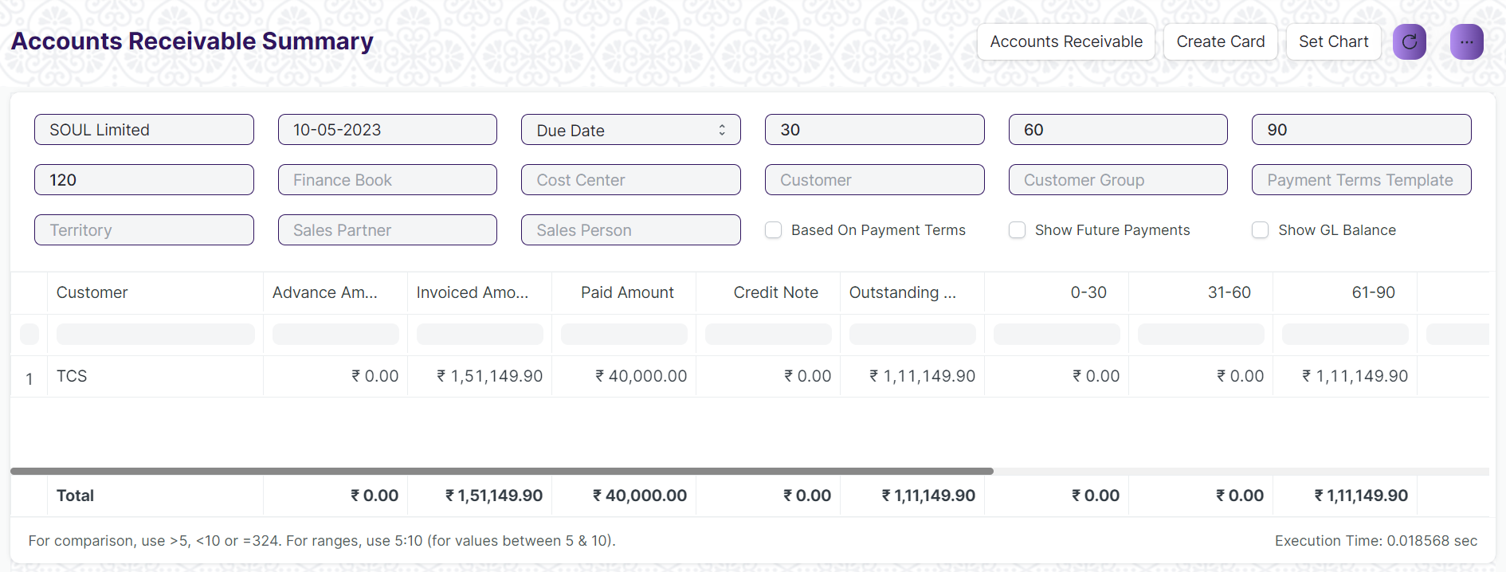Figure: Account Receivable Summary

**Input Filters**

|  |  |  |  |  |  |  |
| --- | --- | --- | --- | --- | --- | --- |
| **ID** | **Input Fields** | **Field Type** | **Mandatory** | **Validation/ Action** | **Remarks** | **R/N/D** |
|  | Company | Link Field |  |  |  |  |
|  | Posting Date | Date |  | From date should be before the To date |  |  |
|  | Ageing Based on | Dropdown |  | Options:  Due Date  Posting Date |  |  |
|  | Finance Book | Link Field |  | Link Fields to Finance Book Screen |  |  |
|  | Cost Center | Link Field |  | Link Fields to Cost Center Screen |  |  |
|  | Customer | Link Field |  | Link Fields to Customer Screen |  |  |
|  | Due Date | Date |  |  |  |  |
|  | Ageing Range 1 | Text |  |  |  |  |
|  | Ageing Range 2 | Text |  |  |  |  |
|  | Ageing Range 3 | Text |  |  |  |  |
|  | Ageing Range 4 | Text |  |  |  |  |
|  | Customer Group | Link Field |  | Link Fields to Customer Group Screen |  |  |
|  | Payment Term Template | Link Field |  | Link Fields to Payment Term Template Screen |  |  |
|  | Sales Partner | Link Field |  | Link Fields to Sales Partner Screen |  |  |
|  | Sales Person | Link Field |  | Link Fields to Sales Person Screen |  |  |
|  | Territory | Link Field |  | Link Fields to Territory Screen |  |  |
|  | Based on Payment Term | Check box |  |  | On check, data will be visible Based on Payment Term |  |
|  | Show Future Payments | Check box |  |  | On check, it will also show the future payments |  |
|  | Show GL Balance | Check box |  |  | On check, It will show the linked delivery notes |  |

**Actions**

* User will enter the search fields such as: Finance Book, Posting Date, etc. Based on that input, the report will be shown.
* A user can add or remove the headers with the help of Add Column or Remove Column button.

**Report Fields**

|  |  |  |
| --- | --- | --- |
| **ID** | **Column Name** | **Description** |
|  | Customer | It will show the customer names |
|  | Advance Amount | It shows the Advance amount with respect to the individual customers |
|  | Invoice Amount | It will shows the Invoice amount with respect to the individual customers |
|  | Paid Amount | It will shows the paid amount with respect to the individual customers |
|  | Credit Note | It is a document send by a buyer to the supplier notifying that a credit has been recorded. |
|  | Outstanding Amount | It will shows the outstanding amount with respect to the individual customers |
|  | Currency | It shows the currency such as INR, USD, etc. |

**User: Roles & Permission**

The following table describes the users and their roles and permissions for the screens :

|  |  |  |  |  |  |  |  |  |
| --- | --- | --- | --- | --- | --- | --- | --- | --- |
| **ID** | **Role** | **Read** | **Write** | **Create** | **Delete** | **Submit** | **Cancel** | **Amend** |
| 1 | Accountant Admin | Yes | Yes | NA | NA | NA | NA | NA |
| 2 | Account Manager | Yes | Yes | NA | NA | NA | NA | NA |
| 3 | Account User | Yes | Yes | NA | NA | NA | NA | NA |

## Accounts Payable

### Purchase Register

**General Description**

The following table describes overall information about this screen:

|  |  |
| --- | --- |
| **Description** | This reports help you to track the outstanding amount of Suppliers with respect to the unique invoice id. |
| **Navigation** | Home > Accounts > Account Payable > Purchase Register |
| **Pre-requisites** | The system should have records in the following screen   1. Company 2. Supplier 3. Cost Center |
| **Existing Screen Name** | Purchase Register |
| **New Screen Name** | No change |

**Screenshot**

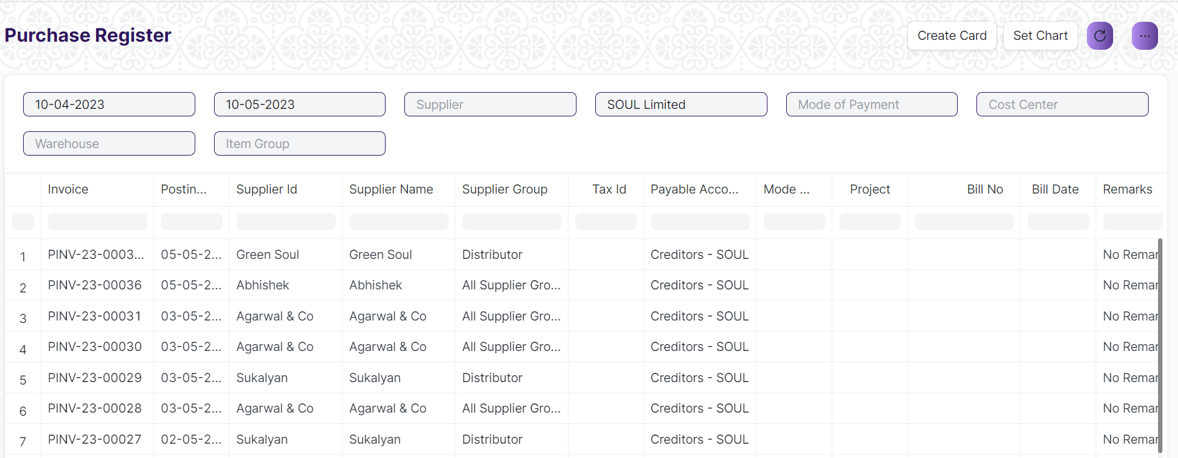

Figure: Purchase Register

**Input Filters**

|  |  |  |  |  |  |  |
| --- | --- | --- | --- | --- | --- | --- |
| **ID** | **Input Fields** | **Field Type** | **Mandatory** | **Validation/ Action** | **Remarks** | **R/N/D** |
|  | Company | Link Field |  |  |  |  |
|  | From Date | Date |  | From date should be before the To date |  |  |
|  | To Date | Date |  | To date should be after the from date |  |  |
|  | Mode of Payment | Link Field |  | Link Fields to Mode of Payment Screen |  |  |
|  | Cost Center | Link Field |  | Link Fields to Cost Center Screen |  |  |
|  | Supplier | Link Field |  | Link Fields to Supplier Screen |  |  |
|  | Warehouse | Link Field |  | Link Fields to Warehouse Screen |  |  |
|  | Item Group | Link Field |  | Link Fields to Item Group Screen |  |  |

**Actions**

* User will enter the search fields such as: Finance Book, Posting Date, etc. Based on that input, the report will be shown.
* A user can add or remove the headers with the help of Add Column or Remove Column button.

**Report Fields**

|  |  |  |
| --- | --- | --- |
| **ID** | **Column Name** | **Description** |
|  | Invoice | It will show the purchase invoice Id |
|  | Posting Date | It is the document posting date |
|  | Supplier Id | It is the Unique Id with respect to individual Suppliers |
|  | Supplier Name | It shows the supplier name with respect to the Supplier Id. |
|  | Supplier Group | It shows the Supplier group which divides different supplier based upon their individual details. It also contains the multiple company & accounts name. |
|  | Tax Id | It is the Unique Id for different type of Taxes. |
|  | Payable Account | It shows the Payable Accounts Name only. |
|  | Mode of Payment | Mode of Payment can be Cash, Online Payment, Cheque, etc. |
|  | Project | It will show the project name with respect to the supplier. |
|  | Bill No | Bill No generate with respect to the different item supplied by individual suppliers. |
|  | Bill Date | Date of Bill generate with respect to the different item supplied by individual suppliers. |
|  | Remarks | Remarks with respect to different invoice number will be shown. |
|  | Purchase Order | It show the purchase order id with respect to the head wise different supplier. |
|  | Purchase Receipt | It show the purchase receipt id with respect to the head wise different supplier. |
|  | Currency | It shows the currency such as INR, USD, etc. |
|  | Net Total | It shows the net total of different Items with respect to the received stock |
|  | Total Tax | It shows the total tax for different Items with respect to the received stock |
|  | Grand Total | It shows the Grand total amount created with respect to the different supplier |
|  | Outstanding Amount | It shows the Grand Outstanding amount created with respect to the different supplier. |

**User: Roles & Permission**

The following table describes the users and their roles and permissions for the screens :

|  |  |  |  |  |  |  |  |  |
| --- | --- | --- | --- | --- | --- | --- | --- | --- |
| **ID** | **Role** | **Read** | **Write** | **Create** | **Delete** | **Submit** | **Cancel** | **Amend** |
| 1 | Accountant Admin | Yes | Yes | NA | NA | NA | NA | NA |
| 2 | Account Manager | Yes | Yes | NA | NA | NA | NA | NA |
| 3 | Account User | Yes | Yes | NA | NA | NA | NA | NA |

### Item Wise Purchase Register

**General Description**

The following table describes overall information about this screen:

|  |  |
| --- | --- |
| **Description** | This reports help you to track the outstanding amount of Suppliers with respect to the individual Items. |
| **Navigation** | Home > Accounts > Account Payable > Item Wise Purchase Register |
| **Pre-requisites** | The system should have records in the following screen   1. Company 2. Supplier 3. Cost Center |
| **Existing Screen Name** | Item Wise Purchase Register |
| **New Screen Name** | No change |

**Screenshot**

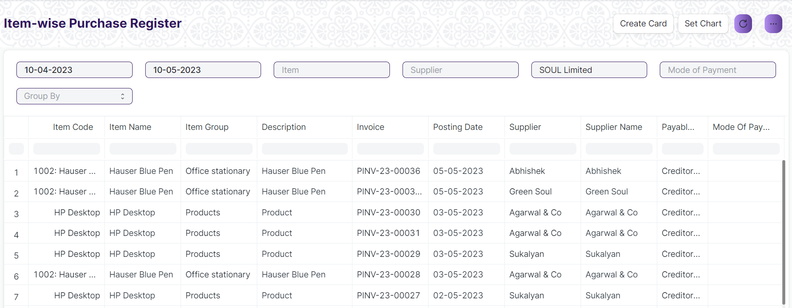Figure: Item Wise Purchase Register

**Input Filters**

|  |  |  |  |  |  |  |
| --- | --- | --- | --- | --- | --- | --- |
| **ID** | **Input Fields** | **Field Type** | **Mandatory** | **Validation/ Action** | **Remarks** | **R/N/D** |
|  | Company | Link Field |  | Link Field to Company Screen |  |  |
|  | From Date | Date |  | From date should be before the To date |  |  |
|  | To Date | Date |  | To date should be after the from date |  |  |
|  | Mode of Payment | Link Field |  | Link Fields to Mode of Payment Screen |  |  |
|  | Cost Center | Link Field |  | Link Fields to Cost Center Screen |  |  |
|  | Supplier | Link Field |  | Link Fields to Supplier Screen |  |  |
|  | Group By | Dropdown |  | Options :   1. Supplier 2. Item Group 3. Item 4. Invoice |  |  |
|  | Item | Link Field |  | Link Fields to Item Screen |  |  |

**Actions**

* User will enter the search fields such as: Item, Posting Date, etc. Based on that input, the report will be shown.
* A user can add or remove the headers with the help of Add Column or Remove Column button.

**Report Fields**

|  |  |  |
| --- | --- | --- |
| **ID** | **Column Name** | **Description** |
|  | Invoice | It will show the purchase invoice Id |
|  | Posting Date | It is the document posting date |
|  | Supplier Id | It is the Unique Id with respect to individual Suppliers |
|  | Supplier Name | It shows the supplier name with respect to the Supplier Id. |
|  | Payable Account | It shows the Payable Accounts Name only. |
|  | Mode of Payment | Mode of Payment can be Cash, Online Payment, Cheque, etc. |
|  | Project | It will show the project name with respect to the supplier. |
|  | Stock Qty | It shows the Supplier wise stock quantity |
|  | Stock UOM | It shows the Stock UOM such as in numbers, in Grams, in KG, in Faraday, etc. |
|  | Purchase Order | It show the purchase order id with respect to the head wise different supplier. |
|  | Purchase Receipt | It show the purchase receipt id with respect to the head wise different supplier. |
|  | Currency | It shows the currency such as INR, USD, etc. |
|  | Total Other Charger | It shows the total other charges of different Items with respect to the individual Supplier. |
|  | Total Tax | It shows the total tax for different Items with respect to the individual Supplier. |
|  | Rate | It shows the rate of an item |
|  | Amount | It shows the amount of an item |
|  | % of Grand Total | It shows the percentage of grand total amount of an item with respect to a particular Supplier |
|  | Company | It shows the Company name from where the supplier and the items belongs to. |

**User: Roles & Permission**

The following table describes the users and their roles and permissions for the screens :

|  |  |  |  |  |  |  |  |  |
| --- | --- | --- | --- | --- | --- | --- | --- | --- |
| **ID** | **Role** | **Read** | **Write** | **Create** | **Delete** | **Submit** | **Cancel** | **Amend** |
| 1 | Accountant Admin | Yes | Yes | NA | NA | NA | NA | NA |
| 2 | Account Manager | Yes | Yes | NA | NA | NA | NA | NA |
| 3 | Account User | Yes | Yes | NA | NA | NA | NA | NA |

### Supplier

**General Description**

The Following table describe overall information about this screen:

|  |  |
| --- | --- |
| **Description :** | Suppliers are companies or individuals who provide you with products or services. |
| **Navigation :** | Home > Accounts > Accounts Payable > Supplier |
| **Pre-requisites :** | 1. Supplier Group 2. Country 3. Billing Currency 4. Bank Account 5. Price List 6. Payment Term 7. Tax Category 8. Tax Withholding Category 9. Company |

**Screenshot**

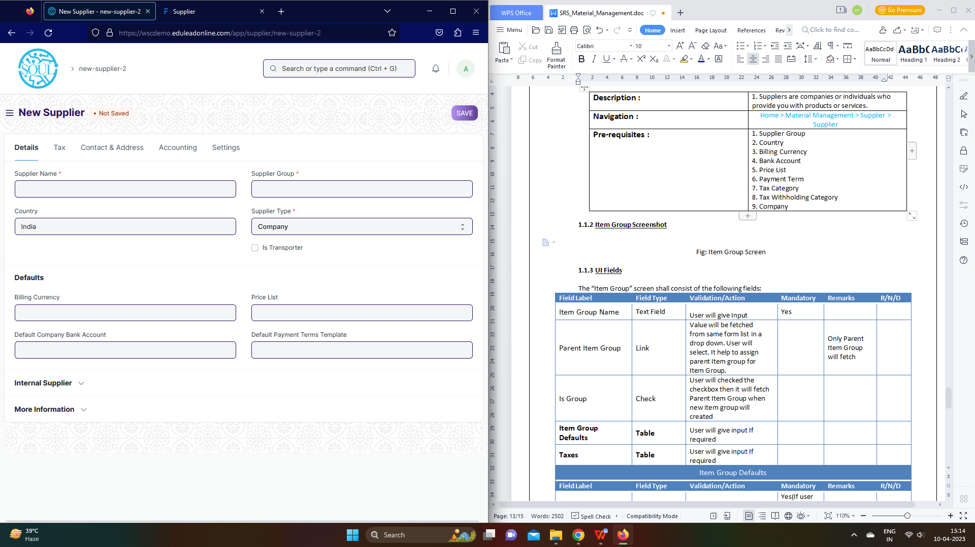

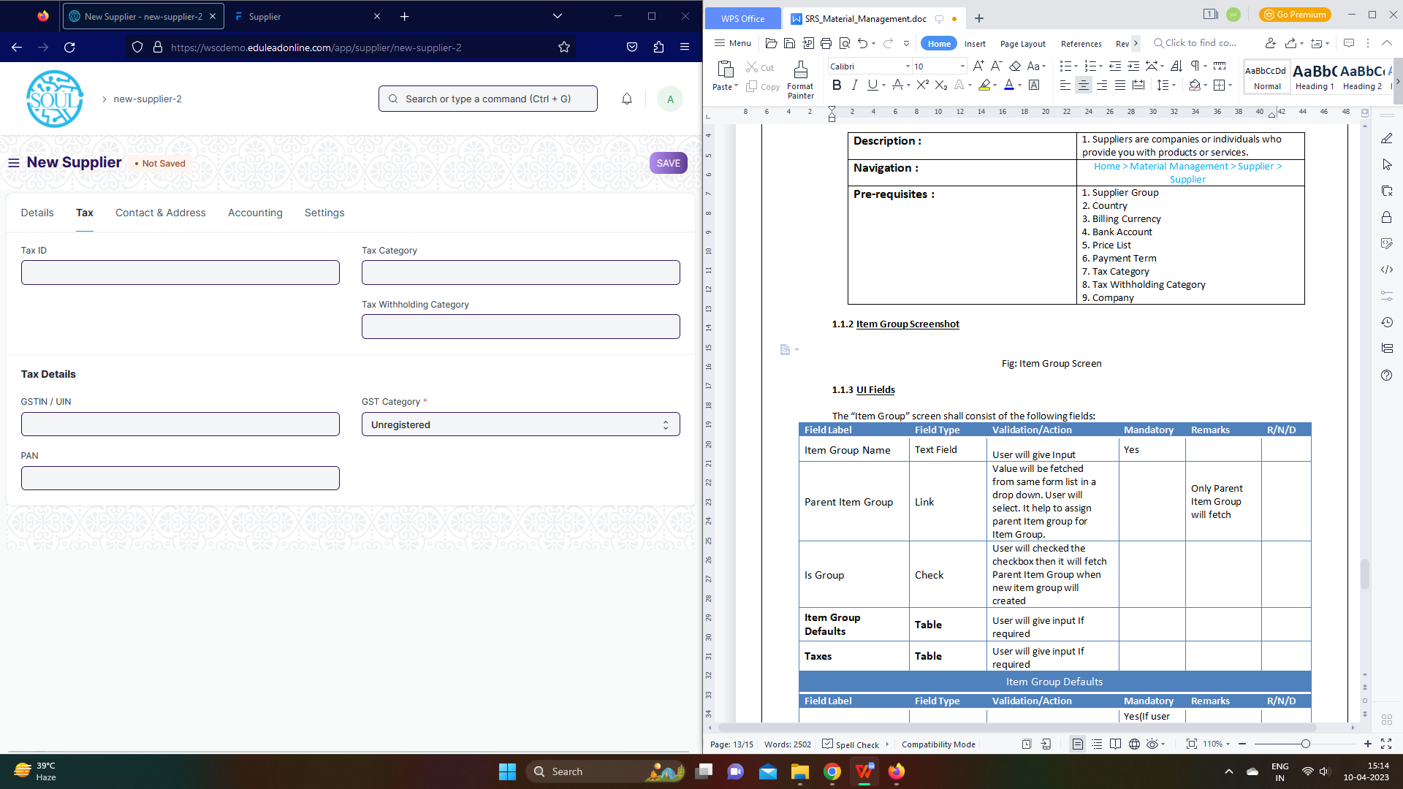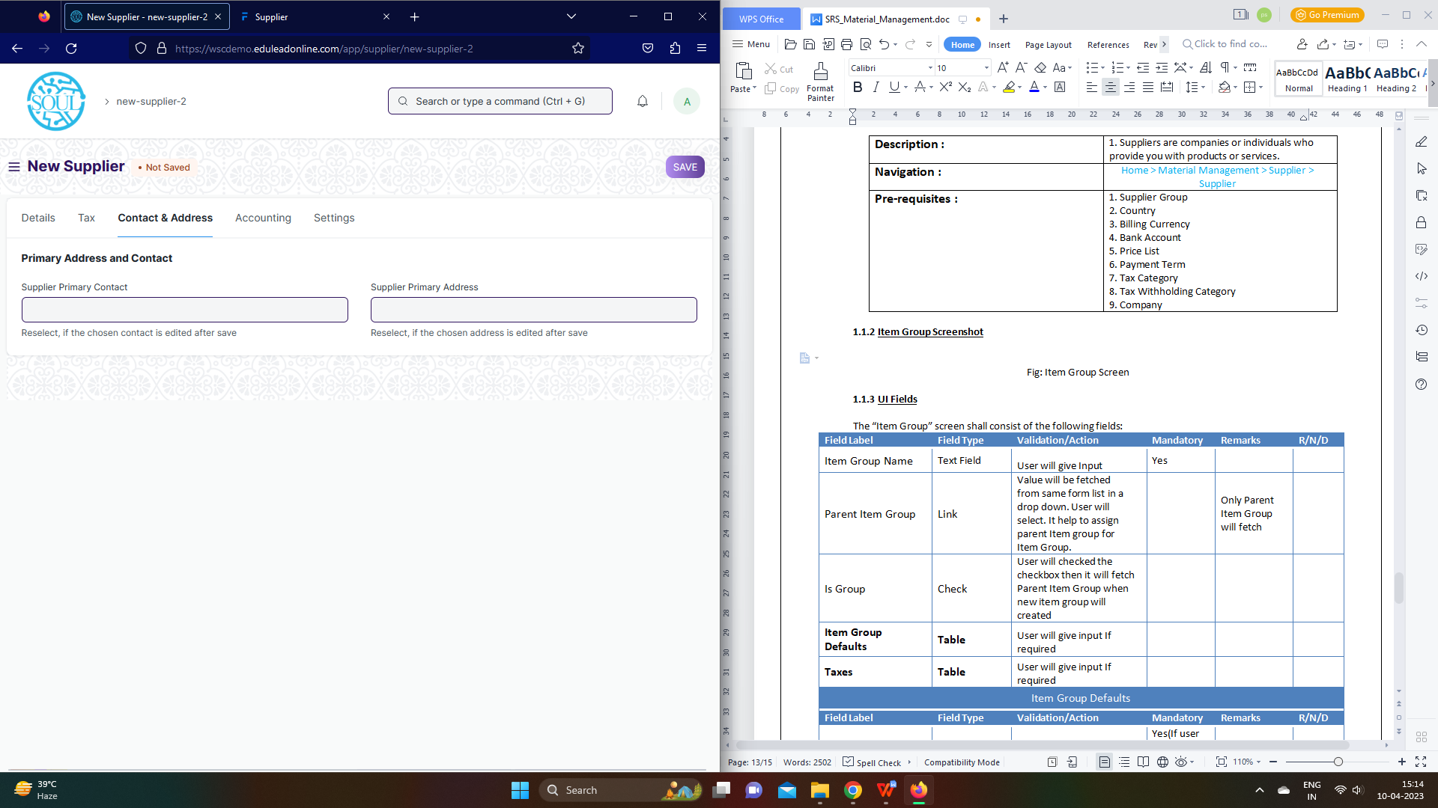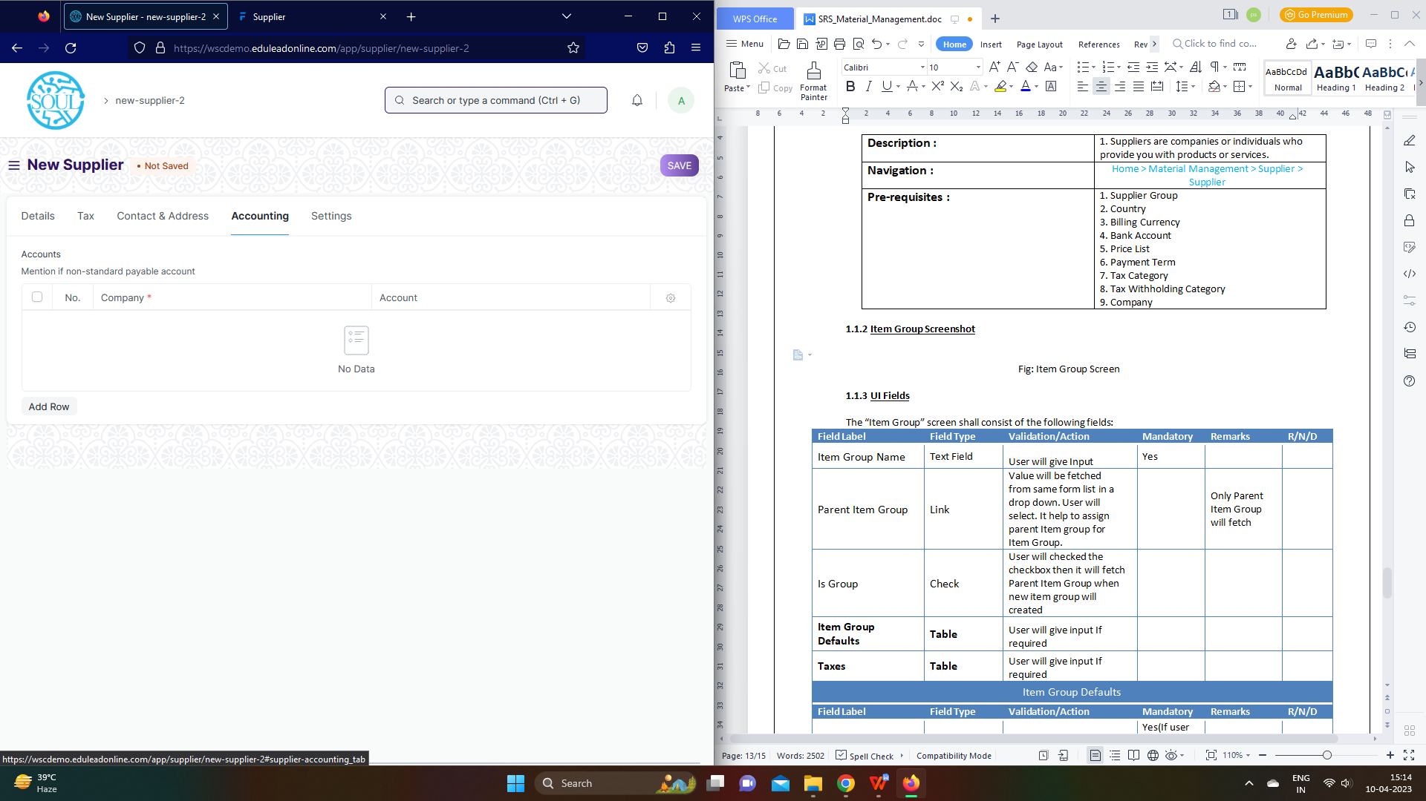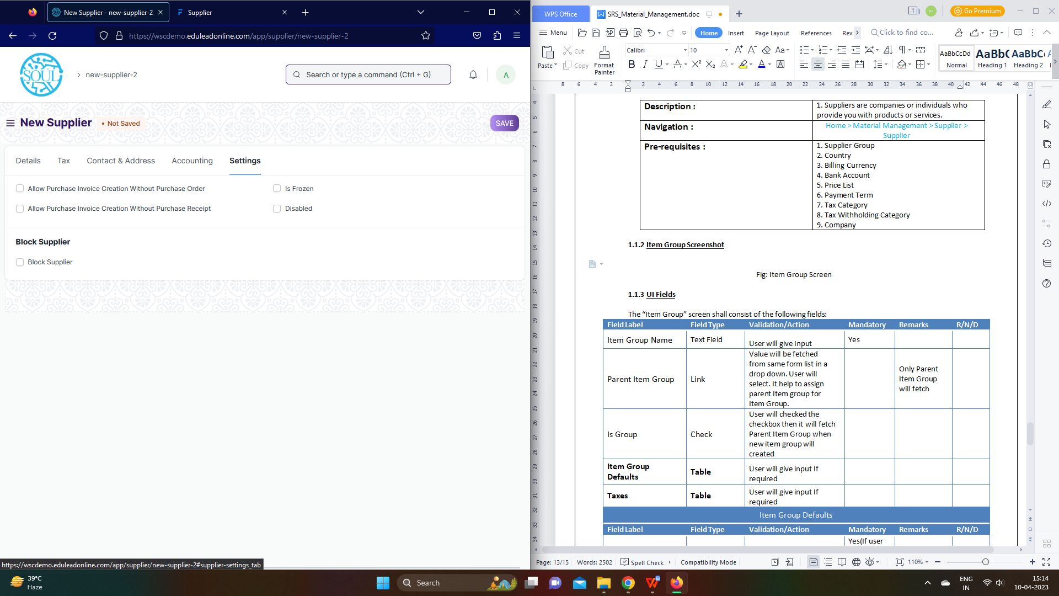

Figure: Supplier

**UI Fields**

The “Supplier” screen shall consist of the following fields:

|  |  |  |  |  |  |  |  |  |  |  |
| --- | --- | --- | --- | --- | --- | --- | --- | --- | --- | --- |
| **ID** | **Field Label** | | **Field Type** | **Validation/ Action** | | | **Mandatory** | **Remarks** | | **R/N/D** |
|  | Supplier Name | | Text Field | User Input | | | Yes |  | |  |
|  | Country | | Link Field | Fetched from Country screen | | |  |  | |  |
|  | Supplier Group | | Link Field | Fetched from Supplier Group screen | | | Yes |  | |  |
|  | Supplier Type | | Drop down | Company/ Individual | | | Yes |  | |  |
|  | Is Transporter | | Checkbox | User Input | | |  |  | |  |
|  | Image | | Attach Image | 1. On attachment a dialogue box will be popup where user can attach the files, take the picture with the help camera and can link any URL.   If photos or images attached then the size will be maximum 200 kb | | |  |  | |  |
|  | Billing Currency | | Link Field | Fetched from Currency screen | | |  |  | |  |
|  | Default Company Bank Account | | Link Field | Fetched from Currency screen | | |  |  | |  |
|  | Price List | | Link Field | Fetched from Price List screen | | |  |  | |  |
|  | Default Payment Terms Template | | Link Field | Fetched from Currency screen | | |  |  | |  |
|  | Is Internal Supplier | | Checkbox | User Input | | |  |  | |  |
|  | Represents Company | | Link Field | Fetched from Company screen | | |  |  | |  |
|  | **Allowed To Transact With** | | **Table** |  | | |  | These table is describe below | |  |
|  | Supplier Details | | Text Field | User Input | | |  |  | |  |
|  | Website | | Text Field | Field | | |  |  | |  |
|  | Print Language | | Link Field | Fetched from Language screen | | |  |  | |  |
|  | Tax ID | | Text Field | User Input | | |  |  | |  |
|  | Tax Category | | Link Field | Fetched from Tax Category screen | | |  |  | |  |
|  | Tax Withholding Category | | Link Field | Fetched from Tax Withholding Category screen | | |  |  | |  |
|  | GSTIN / UIN | | Text Field | User Input | | |  |  | |  |
|  | PAN | | Text Field | User Input | | |  |  | |  |
|  | GST Category | | Drop down | Registered Regular / Registered Composition / Unregistered /  SEZ / Overseas /  Deemed Export /  UIN Holders / Tax Deductor | | | Yes |  | |  |
|  | GST Transporter ID | | Text Field | User Input | | |  |  | |  |
|  | Address HTML | | HTML | User Input | | |  |  | |  |
|  | Contact HTML | | HTML | User Input | | |  |  | |  |
|  | Supplier Primary Contact | | Link Field | Fetched from Contact screen | | |  |  | |  |
|  | Mobile No | | Read Only | Will be fetched based on Contact selection | | |  |  | |  |
|  | Email Id | | Read Only | Will be fetched based on Contact selection | | |  |  | |  |
|  | Supplier Primary Address | | Link Field | Fetched from Address screen | | |  |  | |  |
|  | Primary Address | | Text field | User Input | | |  |  | |  |
|  | **Accounts** | | **Table** |  | | |  | These table is describe below | |  |
|  | Allow Purchase Invoice Creation Without Purchase Order | | Checkbox | User Input | | |  |  | |  |
|  | Allow Purchase Invoice Creation Without Purchase Receipt | | Checkbox | User Input | | |  |  | |  |
|  | Is Frozen | | Checkbox | User Input | | |  |  | |  |
|  | Disabled | | Checkbox | User Input | | |  |  | |  |
|  | Warn RFQs | | Checkbox | User Input | | |  |  | |  |
|  | Warn POs | | Checkbox | User Input | | |  |  | |  |
|  | Prevent RFQs | | Checkbox | User Input | | |  |  | |  |
|  | Prevent POs | | Checkbox | User Input | | |  |  | |  |
|  | Block Supplier | | Checkbox | User Input | | |  |  | |  |
|  | Hold Type | | Drop down | All / Invoices / Payments | | |  |  | |  |
|  | Release Date | | Date | User Input | | |  |  | |  |
|  | View | | Button | Account Ledger: On click of this button you will be able to see the account ledger for suppliers | | |  |  | |  |
|  | Account Payable: On click of this button you will be able to see the payment details for suppliers | | |  |  | |  |
|  | Create | | Bank Account: On click of this button you will be bale to create bank account | | |  | Finance department will be given access to create accounts | |  |
|  | Pricing rule: On click of this button you will be able to see pricing rule for items | | |  | Part of sales module | |  |
|  | Actions | | Get Supplier group details: on click of this button you will see details of supplier group that the supplier is linked to | | |  |  | |  |
|  | **Accounts(Child Table)** | | | | | | | | | |
| **ID** | | **Field Label** | **Field Type** | | **Validation/ Action** | **Mandatory** | | **Remarks** | **R/N/D** | |
| 1. | | Company | Link | | Fetched from Company screen | Yes | |  |  | |
| 2. | | Account | Link | | Fetched from Account screen |  | |  |  | |

**Note:**

1. Fields to be present in supplier form will be shared by WSC Procurement team, So that it will

customized in ERP form and the template could be shared by SOUL Team to WSC for sharing to

their Suppliers which could be used to Import data

**Users: Roles and Permissions**

The following table describes the users and their roles and permissions for the screens :

|  |  |  |  |  |  |  |  |  |  |
| --- | --- | --- | --- | --- | --- | --- | --- | --- | --- |
| **ID** | **Role** | **Select** | **Read** | **Write** | **Create** | **Delete** | **Submit** | **Cancel** | **Amend** |
|  | Accountant Admit | Yes | Yes | Yes | Yes | Yes | Yes | Yes | Yes |
|  | Account Manager | Yes | Yes | Yes | Yes | Yes | Yes | Yes | Yes |
|  | Account User | Yes | Yes | Yes | Yes | Yes | Yes | Yes | Yes |

### Purchase Invoice

**General Description**

|  |  |
| --- | --- |
| **Description :** | **A Purchase Invoice is a bill you receive from your Suppliers against which you need to make the payment.** |
| **Navigation :** | Home > Accounts > Accounts Payable > Purchase Invoice |
| **Pre-requisites :** | 1. Item 2. Supplier 3. Purchase Order 4. Purchase Receipt (Optional) |

**Purchase Invoice Screenshot**

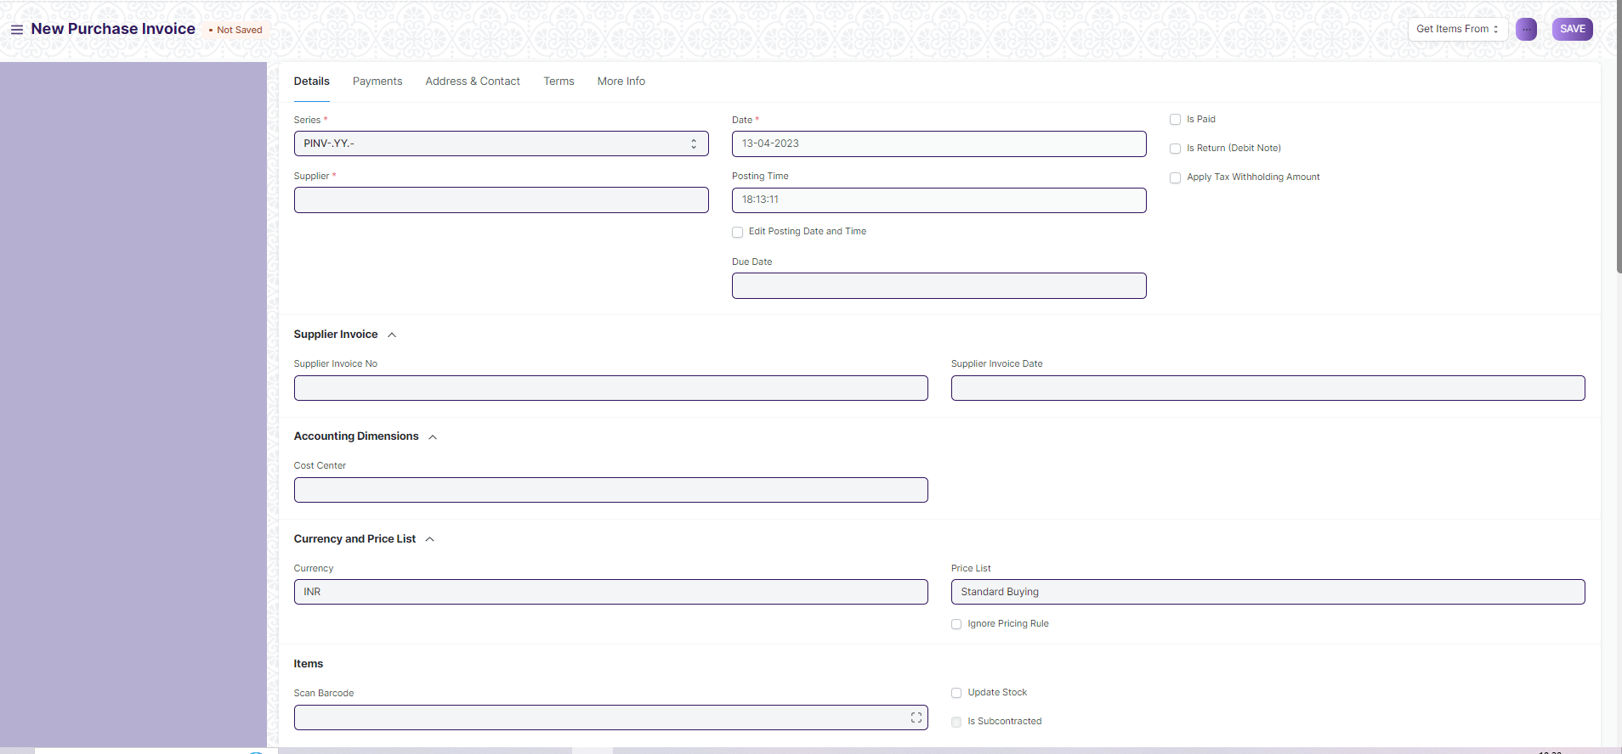

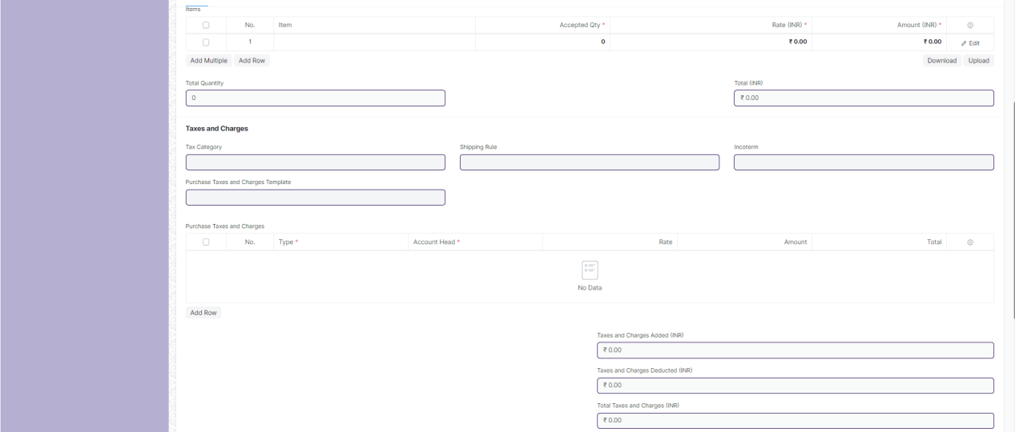

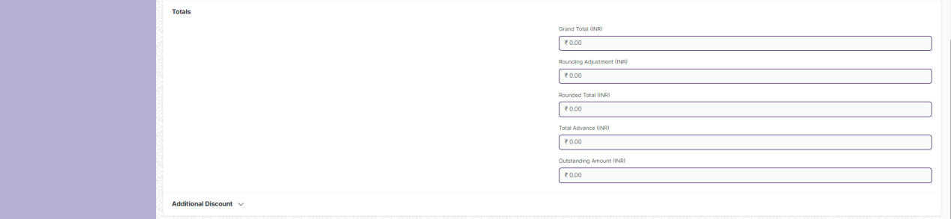

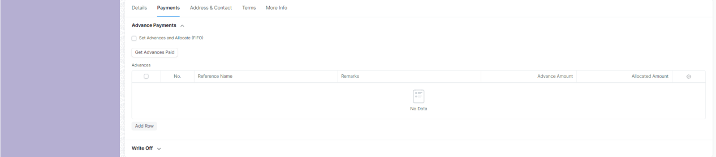

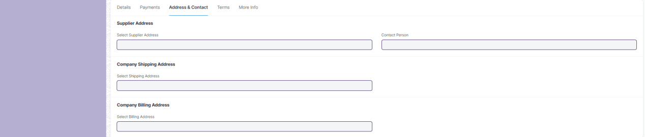

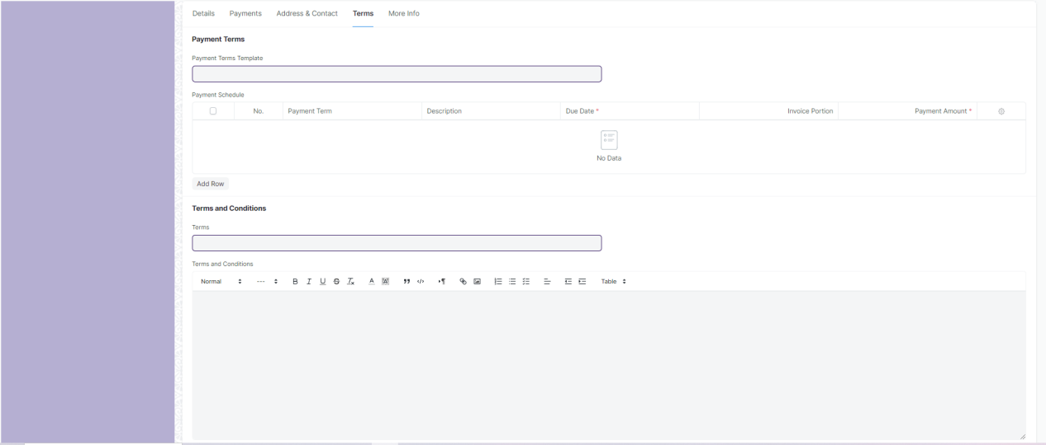

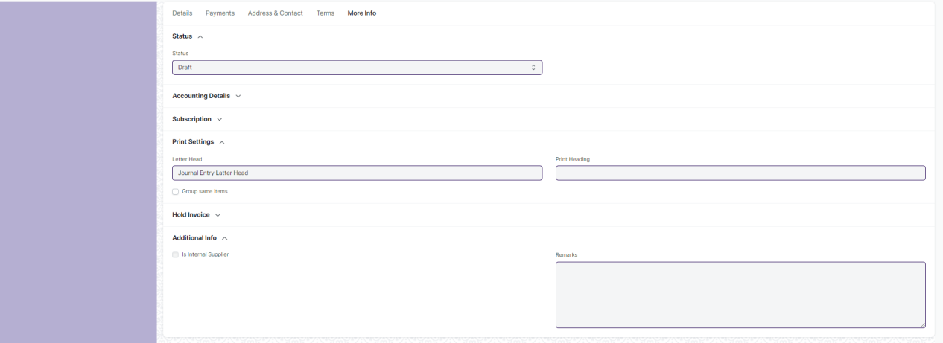

Figure: Purchase Invoice

**UI Fields**

|  |  |  |  |  |  |  |
| --- | --- | --- | --- | --- | --- | --- |
| **ID** | **Field Label** | **Field Type** | **Validation/Action** | **Mandatory** | **Remarks** | **R/N/D** |
|  | Series | Dropdown | * PINV-.YY.- * PRET-.YY.- * ACC-PINV-.YYYY.- * ACC-PINV-RET-.YYYY.-   (“PINV-.YY.-” are default value but user will select any one) | Yes |  |  |
|  | Supplier | Link | Value will fetched from Supplier and user will select any one | Yes |  |  |
|  | Supplier Name | Text List (Read Only) | Value will auto fetch when Supplier field value given |  |  |  |
|  | Tax Id | Read Only | Value will auto fetch when Supplier field value given |  |  |  |
|  | Company | Link | Value will fetched from Company |  |  |  |
|  | Date | Date Picker | Value will auto fetch but user can able to edit If Checked “Edit Posting Date and Time” field | Yes |  |  |
|  | Posting Time | Time | Value will auto fetch but user can able to edit If Checked “Edit Posting Date and Time” field |  |  |  |
|  | Edit Posting Date and Time | Checkbox | If Checked “Edit Posting Date and Time” field then user can edit Date and Posting Time |  |  |  |
|  | Due Date | Date Picker | User will give date |  |  |  |
|  | Is Paid | Checkbox | If checked then Payment is done and Due Date field will be hide |  |  |  |
|  | Is Return (Debit Note) | Checkbox | If Checked, return will applied against purchase Invoice |  |  |  |
|  | Return Against Purchase Invoice | Link (Read Only) | Field will visible when “Is Return” is checked and Value will fetched from Purchase Invoice. User will select any one |  |  |  |
|  | Apply Tax Withholding Amount | Checkbox | If Checked, it applied for Tax Withholding Category |  |  |  |
|  | Tax Withholding Category | Link | Value will fetched from “Tax Withholding Category” and user will select any one |  |  |  |
|  | Supplier Invoice No | Text Field | User will give input |  |  |  |
|  | Supplier Invoice Date | Date Picker | User will give date |  |  |  |
|  | Cost Center | Link | Value will fetched from “Cost Center” and user will select any one |  |  |  |
|  | Currency | Link | Currency will auto fetch but user can able to change |  |  |  |
|  | Exchange Rate | Number | When you select other Country currency then this field will fetch and value will given but user can able to change |  |  |  |
|  | Price List | Link | Value will fetch from Price list |  |  |  |
|  | Price List Currency | Link (Read Only) | Value will fetch from currency when Price List field value are given and Price List form value are given for other country |  |  |  |
|  | Price List Exchange Rate | Number | Field are visible when Price List field value are given and Price List form value are given for other country and User can able to change the value |  |  |  |
|  | Ignore Pricing Rule | Checkbox | If checked then it ignore pricing rule |  |  |  |
|  | Scan Barcode | Number | User will give input. By Reader or camera user will also give input |  |  |  |
|  | Update Stock | Checkbox | If checked, stock will update |  |  |  |
|  | Set Accepted Warehouse | Link | This field will visible if checked update stock. Value will fetched from Warehouse and user will select any one |  |  |  |
|  | Set From Warehouse | Link | If Supplier will be internal then this filed will be visible and value will fetched from Warehouse and user will select any one |  |  |  |
|  | Is Subcontracted | Checkbox (Read Only) | If Checked, Subcontracted is applied |  |  |  |
|  | Rejected Warehouse | Link | Value will fetched from Warehouse and user will select any one |  |  |  |
|  | Supplier Warehouse | Link | If Checked “Is Subcontracted” then this field visible and value will fetched from Warehouse and user will select any one |  |  |  |
|  | **Items** | **Table** |  | Yes | This table is describe below |  |
|  | Total Quantity | Number (Read Only) | Value will fetch according to Item child table field value. |  |  |  |
|  | Total Net Weight | Number (Read Only) | Value will fetch according to Item child table field value. |  |  |  |
|  | Total (Company Currency) | Currency (Read Only) | Value will fetch according to Item child table field value. |  |  |  |
|  | Net Total (Company Currency) | Currency (Read Only) | Value will fetch according to Item child table field value. |  |  |  |
|  | Total | Currency (Read Only) | Value will fetch according to Item child table field value. |  |  |  |
|  | Net Total | Currency (Read Only) | Value will fetch according to Item child table field value. |  |  |  |
|  | Tax Category | Link | Value will fetched from Tax Category and user will select any one |  |  |  |
|  | Purchase Taxes and Charges Template | Link | Value will fetched from Purchase Taxes and Charges Template and user will select any one |  |  |  |
|  | Shipping Rule | Link | Value will fetched from Shipping Rule and user will select any one |  |  |  |
|  | Incoterm | Link | Value will fetched from Incoterm and user will select any one |  |  |  |
|  | Named Place | Text Field | Field will visible when Incoterm value given. User will give input |  |  |  |
|  | **Purchase Taxes and Charges** | **Table** | Value will fetch according to “Purchase Taxes and Charges Template” field value |  | This table is describe below for manual process |  |
|  | Taxes and Charges Added (Company Currency) | Currency (Read Only) | Value will fetch according to “Purchase Taxes and Charges”child table field value. |  |  |  |
|  | Taxes and Charges Deducted (Company Currency) | Currency (Read Only) | Value will fetch according to “Purchase Taxes and Charges”child table field value. |  |  |  |
|  | Total Taxes and Charges (Company Currency) | Currency (Read Only) | Value will fetch according to “Purchase Taxes and Charges”child table field value. |  |  |  |
|  | Taxes and Charges Added | Currency (Read Only) | Value will fetch according to “Purchase Taxes and Charges”child table field value. |  |  |  |
|  | Taxes and Charges Deducted | Currency (Read Only) | Value will fetch according to “Purchase Taxes and Charges”child table field value. |  |  |  |
|  | Total Taxes and Charges | Currency (Read Only) | Value will fetch according to “Purchase Taxes and Charges”child table field value. |  |  |  |
|  | Grand Total (Company Currency) | Currency (Read Only) | Value will fetch automatically according to other field |  |  |  |
|  | Rounding Adjustment (Company Currency) | Currency (Read Only) | Value will fetch automatically according to other field |  |  |  |
|  | Rounded Total (Company Currency) | Currency (Read Only) | Value will fetch automatically according to other field |  |  |  |
|  | In Words (Company Currency) | Text Field (Read Only) | Value will fetch automatically according to Grand Total (Company Currency) field |  |  |  |
|  | Grand Total | Currency (Read Only) | Value will fetch automatically according to other field |  |  |  |
|  | Rounding Adjustment | Currency (Read Only) | Value will fetch automatically according to other field |  |  |  |
|  | Rounded Total | Currency (Read Only) | Value will fetch automatically according to other field |  |  |  |
|  | In Words | Text Field (Read Only) | Value will fetch automatically according to Grand Total field |  |  |  |
|  | Total Advance | Currency (Read Only) | Value will auto fetch when payment is done in advance |  |  |  |
|  | Outstanding Amount | Currency (Read Only) | Value will auto fetch when payment is pending |  |  |  |
|  | Disable Rounded Total | Checkbox | If checked Rounding Adjustment is not applicable |  |  |  |
|  | Apply Additional Discount On | Dropdown | * Grand Total * Net Total   (Grand Total are default value but user can able to change into Net Total) |  |  |  |
|  | Additional Discount Amount (Company Currency) | Currency (Read Only) | Value will auto fetch according to the discount |  |  |  |
|  | Additional Discount Percentage | Number | User will give Input |  |  |  |
|  | Additional Discount Amount | Currency | User will give Input |  |  |  |
|  | **Tax Withheld Vouchers** | **Table (Read Only)** | Value fetched automatically based on the tax templates and tax rules that have been set up in the system. |  | This table is describe below |  |
|  | Taxes and Charges Calculation | Long Text (Read Only) | After all tax calculation value will auto fetch |  |  |  |
|  | **Pricing Rule Detail** | **Table** **(Read Only)** | Auto fetch according to Pricing rule |  | This table is describe below |  |
|  | **Supplied Items** | **Table** | Auto fetch according to Supplied Items |  | This table is describe below |  |
|  | Mode of Payment | Link | If amount is paid value will fetch |  |  |  |
|  | Paid Amount (Company Currency) | Currency (Read Only) | If amount is paid value will fetch |  |  |  |
|  | Clearance Date | Date Picker (Read Only) | If amount is paid value will fetch |  |  |  |
|  | Cash/Bank Account | Link | If amount is paid value will fetch |  |  |  |
|  | Paid Amount | Currency | If amount is paid value will fetch |  |  |  |
|  | Set Advances and Allocate (FIFO) | Checkbox | If checked, then it applied for FIFO and “Get Advances Paid” Button will hide |  |  |  |
|  | Get Advances Paid | Button | When user will click button then value will fetch on Advance Table |  |  |  |
|  | **Advances** | **Table** |  |  | This table is describe below |  |
|  | Write Off Amount | Currency | User will give input |  |  |  |
|  | Write Off Amount (Company Currency) | Currency (Read Only) | Value will auto fetch from write off amount |  |  |  |
|  | Write Off Account | Link | Field will visble when user give value on Write Off Amount and value will fetch from Account and user will select one |  |  |  |
|  | Write Off Cost Center | Link | Field will visble when user give value on Write Off Amount and value will fetch from Cost Center and user will select one |  |  |  |
|  | Select Supplier Address | Link | Value will fetched from Address and user will select any one |  |  |  |
|  | Address | Small Text (Read Only) | Value will fetch when Supplier Address field value given |  |  |  |
|  | Supplier GSTIN | Text Field (Read Only) | After selecting the Supplier, this value will be auto fetch |  |  |  |
|  | GST Category | Text Field (Read Only) | After selecting the Supplier, this value will be auto fetch |  |  |  |
|  | Contact Person | Link | Value will fetched from Contact and user will select any one |  |  |  |
|  | Contact | Small Text (Read Only) | Value will fetch when Contact Person field value given |  |  |  |
|  | Mobile No | Small Text (Read Only) | Value will fetch when Contact Person field value given |  |  |  |
|  | Contact Email | Small Text (Read Only) | Value will fetch when Contact Person field value given |  |  |  |
|  | Select Shipping Address | Link | After selecting the Supplier, this value will be auto fetch but user can able to edit |  |  |  |
|  | Shipping Address | Small Text (Read Only) | After selecting the Supplier, this value will be auto fetch |  |  |  |
|  | Select Billing Address | Link | After selecting the Supplier, this value will be auto fetch but user can able to edit |  |  |  |
|  | Billing Address | Small Text (Read Only) | After selecting the Supplier, this value will be auto fetch |  |  |  |
|  | Company GSTIN | Text Field (Read Only) | After selecting the Supplier, this value will be auto fetch |  |  |  |
|  | Place of Supply | Text Field (Read Only) | After selecting the Supplier, this value will be auto fetch |  |  |  |
|  | Payment Terms Template | Link | After selecting the Supplier, this value will be auto fetch but user can able to edit |  |  |  |
|  | **Payment Schedule** | **Table** | Value will fetch according to “Payment Terms Template” field value |  | This table is describe below for manual process |  |
|  | Terms | Link | Value will fetched from “Terms and Conditions” and user will select any one |  |  |  |
|  | Terms and Conditions | Text Editor | Value will fetch when “Terms and Conditions” field value given and User can able to edit |  |  |  |
|  | Status | Dropdown | * Draft * Return * Debit Note Issued * Submitted * Paid * Partly Paid * Unpaid * Overdue * Cancelled * Internal Transfer   (It will auto fetch according to the form condition) |  |  |  |
|  | Credit To | Link | Value will fetched from Account and user will select any one | Yes |  |  |
|  | Is Opening Entry | Dropdown | * Yes * No   (User will select one) |  |  |  |
|  | Unrealized Profit / Loss Account | Link | User will give input if supplier is internal |  |  |  |
|  | Auto Repeat | Link (Read Only) | Auto Repeat the Purchase Invoice at specified intervals.(After submitting the form it will visible) |  |  |  |
|  | Update Auto Repeat Reference | Button | When value are present in Auto Repeat field then this button are visible. User will click and update Auto Repeat |  |  |  |
|  | From Date | Date Picker | User will give date |  |  |  |
|  | To Date | Date Picker | User will give date |  |  |  |
|  | Letter Head | Link | Value will fetched from Letter Head and user will select any one |  |  |  |
|  | Group same items | Checkbox | If checked then grouped same item |  |  |  |
|  | Print Heading | Link | Value will fetched from Print Heading and user will select any one |  |  |  |
|  | Print Language | Text Field (Read Only) | Value will auto fetch when give supplier name In supplier field |  |  |  |
|  | Hold Invoice | Checkbox | If Checked, Invoice will be on hold. |  |  |  |
|  | Release Date | Date Picker | When Hold Invoice is checked then this field will visible and user will give date |  |  |  |
|  | Reason For Putting On Hold | Small Text | When Hold Invoice is checked then this field will visible and user will give input |  |  |  |
|  | Is Internal Supplier | Checkbox (Read Only) | If checked then supplier will be internal |  |  |  |
|  | Represents Company | Link | Value will auto fetch from Company |  |  |  |
|  | Inter Company Invoice Reference | Link (Read Only) | Value will auto fetch from Company |  |  |  |
|  | Remarks | Small Text | User will give input |  |  |  |
|  | Create | Button | Purchase receipt: On click of this button you will be able to create Purchase receipt |  |  |  |
|  | Return/ Debit note: On click of this button you can create return or debit note |  |  |  |
|  | Subscription: Subscription: On click of this button you can create subscription for the Purchase receipt |  |  |  |
|  | View | Button | Accounting Ledger: On click of this button you will be able to see Accounting Ledger |  |  |  |
|  | **Items** | | | | | |
| ID | **Field Label** | **Field Type** | **Validation/Action** | **Mandatory** | **Remarks** | **R/N/D** |
|  | Item | Link | Value will fetched from Item and user will select any one |  |  |  |
|  | Product Bundle | Link (Read Only) | Value will auto fetch from Product Bundle according to the Item |  |  |  |
|  | Item Name | Text Field | Value will fetch when user will give Item Code field input but user can edit | Yes |  |  |
|  | Description | Text Editor | Value will fetch when user will give Item Code field input but user can edit |  |  |  |
|  | HSN/SAC | Text Field | Value will fetch when user will give Item Code field input but user can edit |  |  |  |
|  | Is Nil Rated or Exempted | Checkbox | Tax is not applicable if checked |  | Tax is applicable for all item | D |
|  | Is Non GST | Checkbox | If checked, For an item that is not covered under GST |  |  |  |
|  | Item Group | Link (Read Only) | Value will fetch when user will give Item Code field input |  |  |  |
|  | Image View | Image | Image will fetch when user will give Item Code field input |  |  |  |
|  | Received Qty | Number (Read Only) | Value will fetch when user will give Item Code field input |  |  |  |
|  | Accepted Qty | Number | Value will fetch when user will give Item Code field input | Yes |  |  |
|  | Rejected Qty | Number | Value will fetch when user will give Item Code field input |  |  |  |
|  | UOM | Link Field | Value will fetch when user will give Item Code field input but user can edit | Yes |  |  |
|  | UOM Conversion Factor | Number (Read Only) | Value will fetch when user will give UOM field input but user can edit | Yes |  |  |
|  | Stock UOM | Link (Read Only) | Value will fetch when user will give UOM field input |  |  |  |
|  | Accepted Qty in Stock UOM | Number (Read Only) | Value will fetch when user will give UOM field input | Yes |  |  |
|  | Price List Rate | Currency (Read Only) | Value will fetch when user will give Item Code field input but user can edit |  |  |  |
|  | Price List Rate (Company Currency) | Currency (Read Only) | Value will fetch when user will give Item Code field input |  |  |  |
|  | Margin Type | Dropdown | * Percentage * Amount   (User will select one) |  |  |  |
|  | Margin Rate or Amount | Number | Field will visible when user will give input to Margin Type field |  |  |  |
|  | Rate With Margin | Currency (Read Only) | Field will visible when user will give input to Margin Rate or Amount field |  |  |  |
|  | Discount on Price List Rate (%) | Percent | User will give Input |  |  |  |
|  | Discount Amount | Currency | User will give Input |  |  |  |
|  | Rate With Margin (Company Currency) | Currency (Read Only) | Field will visible when user will give input to Margin Type field |  |  |  |
|  | Rate | Currency | Value will fetch when user will give Item Code field input but user can edit | Yes |  |  |
|  | Amount | Currency (Read Only) | Value will fetch when user will give Item Code field input | Yes |  |  |
|  | Item Tax Template | Link Field | Value will fetched from Item Tax Template and user will select any one |  |  |  |
|  | Rate (Company Currency) | Currency (Read Only) | Value will fetch when user will give Item Tax Template field input | Yes |  |  |
|  | Amount (Company Currency) | Currency (Read Only) | Value will fetch when user will give Item Tax Template field input | Yes |  |  |
|  | Rate of Stock UOM | Currency (Read Only) | Value will fetch when user will give Item Tax Template field input |  |  |  |
|  | Is Free Item | Checkbox (Read Only) | If Checked, Item will be free of cost |  |  |  |
|  | Apply TDS | Checkbox | If Checked, TDS will applied for that item |  |  |  |
|  | Net Rate | Currency (Read Only) | Value will fetch when user will give Item Code field input |  |  |  |
|  | Net Amount | Currency (Read Only) | Value will fetch when user will give Item Code field input |  |  |  |
|  | Net Rate (Company Currency) | Currency (Read Only) | Value will fetch when user will give Item Code field input |  |  |  |
|  | Net Amount (Company Currency) | Currency (Read Only) | Value will fetch when user will give Item Code field input |  |  |  |
|  | Landed Cost Voucher Amount | Currency (Read Only) | Value will fetch when user will give Item Code field input |  |  |  |
|  | Accepted Warehouse | Link Field | Value will fetched from Warehouse and user will select any one |  |  |  |
|  | Quality Inspection | Link Field | Value will fetched from Quality Inspection and user will select any one |  |  |  |
|  | Serial No | Text | User will give input |  |  |  |
|  | Rejected Warehouse | Link Field | Value will fetched from Warehouse and user will select any one |  |  |  |
|  | Batch No | Link Field | Value will fetch when user will give Item Code field input But user can able to change |  |  |  |
|  | Rejected Serial No | Text | User will give input |  |  |  |
|  | Manufacturer | Link Field |  |  | It is for a Manufacture module | D |
|  | Manufacturer Part Number | Text Field |  |  | It is for a Manufacture module | D |
|  | Expense Head | Link Field | Value will fetched from Account and user will select any one |  |  |  |
|  | Asset Location | Link Field | Value will fetched from Location and user will select any one |  |  |  |
|  | Asset Category | Link (Read Only) | Value will fetch when user will give Item Code field input |  |  |  |
|  | Deferred Expense Account | Link Field | This field will visible when Enable Deferred Expense Checked, User will give input |  |  |  |
|  | Service Stop Date | Date Picker | This field will visible when Enable Deferred Expense Checked, User will give date |  |  |  |
|  | Enable Deferred Expense | Checkbox | If Checked, then applied for deferred expense |  |  |  |
|  | Service Start Date | Date Picker | This field will visible when Enable Deferred Expense Checked, User will give date |  |  |  |
|  | Service End Date | Date Picker | This field will visible when Enable Deferred Expense Checked, User will give date |  |  |  |
|  | Allow Zero Valuation Rate | Checkbox | If Checked, valuation will be zero |  |  |  |
|  | BOM | Link (Read Only) |  |  | It is for a Manufacture module | D |
|  | Include Exploded Items | Checkbox (Read Only) | Value will fetch when user will give Item Code field input |  |  |  |
|  | Purchase Invoice Item | Text Field (Read Only) | Value will fetch when user will give Item Code field input |  |  |  |
|  | Purchase Order | Link (Read Only) | Value will fetch when user will give Item Code field input |  |  |  |
|  | Purchase Receipt | Link (Read Only) | Value will fetch when user will give Item Code field input |  |  |  |
|  | Sales Invoice Item | Text Field (Read Only) | Value will fetch when user will give Item Code field input |  |  |  |
|  | Weight Per Unit | Number | User will give Input |  |  |  |
|  | Total Weight | Number (Read Only) | Value will fetch when user will give Item Code field input |  |  |  |
|  | Weight UOM | Link Field | Value will fetched from Account and user will select any one |  |  |  |
|  | Address | Link Field | Value will fetched from Address and user will select any one |  |  |  |
|  | Article | Link Field | Value will fetched from Article and user will select any one |  |  |  |
|  | Project | Link Field | Value will fetched from Project and user will select any one |  |  |  |
|  | About Us Team Member | Link Field |  |  | It’s not link with any form, Value will not fetch from anywhere | D |
|  | Cost Center | Link Field | Value will fetched from Cost Center and user will select any one |  |  |  |
|  | Page Break | Checkbox | If checked then Page Break will create a page break just before this item when printing |  |  |  |
|  | **Purchase Taxes and Charges** | | | | | |
|  | **Field Label** | **Field Type** | **Validation/Action** | **Mandatory** | **Remarks** | **R/N/D** |
|  | Consider Tax or Charge for | Dropdown | * Valuation and Total * Valuation * Total   (“Total” are default value but user can able to change into “Valuation and Total”  or “Valuation”) | Yes |  |  |
|  | Add or Deduct | Dropdown | * Add * Deduct   (“Add” are default value but user can able to change into “Deduct”) | Yes |  |  |
|  | Type | Dropdown | * Actual * On Net Total * On Previous Row Amount * On Previous Row Total * On Item Quantity   (“On Net Total”are default value but user can able to change into other) | Yes |  |  |
|  | Reference Row # | Text Field | If tax is based on "Previous Row Total" User can select the row number which will be taken as a base for this calculation |  |  |  |
|  | Is this Tax included in Basic Rate? | Checkbox | If checked, the tax amount will be considered as already included in the Print Rate / Print Amount |  |  |  |
|  | Considered In Paid Amount | Checkbox | If checked, considered in paid amount |  |  |  |
|  | Account Head | Link Field | Value will fetched from Account and user will select any one | Yes |  |  |
|  | Description | Long Text | Value will auto fetch when we give value in Account Head field but user can edit | Yes |  |  |
|  | Rate | Number | Value will auto fetch when we give value in Account Head field but user can edit |  |  |  |
|  | Address | Link Field | Value will fetched from Address and user will select any one |  |  |  |
|  | Article | Link Field | Value will fetched from Article and user will select any one |  |  |  |
|  | Cost Center | Link Field | Value will auto fetch when we give value in Account Head field but user can edit |  |  |  |
|  | About Us Team Member | Link Field |  |  | It’s not link with any form,  Value will not fetch from anywhere | D |
|  | Account Currency | Link Field(Read Only) | Value will auto fetch when we give value in Account Head field |  |  |  |
|  | Amount | Currency | Value will auto fetch when we give value in Account Head field but user can edit |  |  |  |
|  | Tax Amount After Discount Amount | Currency (Read Only) | Value will auto fetch when we give value in Account Head field but user can edit |  |  |  |
|  | Total | Currency (Read Only) | Value will auto fetch when we give value in Account Head field but user can edit |  |  |  |
|  | Amount (Company Currency) | Currency (Read Only) | Value will auto fetch when we give value in Account Head field but user can edit |  |  |  |
|  | Tax Amount After Discount Amount | Currency (Read Only) | Value will auto fetch when we give value in Account Head field but user can edit |  |  |  |
|  | **Tax Withheld Vouchers** | | | | | |
|  | **Field Label** | **Field Type** | **Validation/Action** | **Mandatory** | **Remarks** | **R/N/D** |
|  | Voucher Type | Link Field | Value fetched automatically based on the tax templates and tax rules that have been set up in the system. |  |  |  |
|  | Voucher Name | Link Field | Value fetched automatically based on the tax templates and tax rules that have been set up in the system. |  |  |  |
|  | Taxable Amount | Currency | Value fetched automatically based on the tax templates and tax rules that have been set up in the system. |  |  |  |
|  | **Pricing Rule Detail** | | | | | |
|  | **Field Label** | **Field Type** | **Validation/Action** | **Mandatory** | **Remarks** | **R/N/D** |
|  | Pricing Rule | Link Field | Value will auto fetch from Pricing Rule if it is applicable for account |  |  |  |
|  | Item Code | Text Field | Value will auto fetch according Pricing Rule |  |  |  |
|  | Rule Applied | Checkbox | If Checked, rule will applied for account pricing |  |  |  |
|  | **Supplied Items** | | | | | |
|  | **Field Label** | **Field Type** | **Validation/Action** | **Mandatory** | **Remarks** | **R/N/D** |
|  | Item Code | Link Field | Value auto fetch When transfer Material to Supplier |  |  |  |
|  | Raw Material Item Code | Link Field | Value auto fetch When transfer Material to Supplier |  |  |  |
|  | Stock Uom | Link Field | Value auto fetch When transfer Material to Supplier |  |  |  |
|  | Reserve Warehouse | Link Field | Value auto fetch When transfer Material to Supplier |  |  |  |
|  | BOM Detail No | Text Field |  |  | It is for a Manufacture module | D |
|  | Reference Name | Text Field | Value auto fetch When transfer Material to Supplier |  |  |  |
|  | Rate | Currency | Value auto fetch When transfer Material to Supplier |  |  |  |
|  | Amount | Currency | Value auto fetch When transfer Material to Supplier |  |  |  |
|  | Required Qty | Number | Value auto fetch When transfer Material to Supplier |  |  |  |
|  | Supplied Qty | Number | Value auto fetch When transfer Material to Supplier |  |  |  |
|  | Consumed Qty | Number | Value auto fetch When transfer Material to Supplier |  |  |  |
|  | Returned Qty | Number | Value auto fetch When transfer Material to Supplier |  |  |  |
|  | **Advances** | | | | | |
|  | **Field Label** | **Field Type** | **Validation/Action** | **Mandatory** | **Remarks** | **R/N/D** |
|  | Reference Type | Link Field(Read Only) | When user click “Get Advances Paid” button then value will fetch |  |  |  |
|  | Reference Name | Link Field(Read Only) | When user click “Get Advances Paid” button then value will fetch |  |  |  |
|  | Remarks | Text (Read Only) | When user will click “Get Advances Paid” button then value will fetch |  |  |  |
|  | Advance Amount | Currency (Read Only) | When user will click “Get Advances Paid” button then value will fetch |  |  |  |
|  | Allocated Amount | Currency | When user will click “Get Advances Paid” button then value will fetch but user can edit |  |  |  |
|  | Exchange Gain/Loss | Currency (Read Only) | When user will click “Get Advances Paid” button then value will fetch |  |  |  |
|  | Reference Exchange Rate | Number (Read Only) | When user will click “Get Advances Paid” button then value will fetch |  |  |  |
|  | **Payment Schedule** | | | | | |
|  | **Field Label** | **Field Type** | **Validation/Action** | **Mandatory** | **Remarks** | **R/N/D** |
|  | Payment Term | Link Field | Value will fetched from Payment Term and user will select any one |  |  |  |
|  | Description | Small Text | Value will give input |  |  |  |
|  | Due Date | Date Picker | Value will auto fetch when user give input in Payment Term field but user can able to edit | Yes |  |  |
|  | Mode of Payment | Link Field | Value will auto fetch when user give input in Payment Term field but user can able to edit |  |  |  |
|  | Invoice Portion | Percent | Value will auto fetch when user give input in Payment Term field but user can able to edit |  |  |  |
|  | Discount Type | Select | * Percentage * Amount   (Percentage Is default value but user can change into Amount) |  |  |  |
|  | Discount Date | Date Picker | Value will auto fetch when user give input in Discount field but user can able to edit |  |  |  |
|  | Discount | Number | User will give Input |  |  |  |
|  | Payment Amount | Currency | Value will auto fetch when user give input in Payment Term field but user can able to edit | Yes |  |  |
|  | Outstanding | Currency (Read Only) | Value will auto fetch when user give input in Payment Term field |  |  |  |
|  | Paid Amount | Currency | Value will auto fetch when user give input in Payment Term field but user can able to edit |  |  |  |
|  | Discounted Amount | Currency (Read Only) | Value will auto fetch according to the discount |  |  |  |
|  | Payment Amount (Company Currency) | Currency | Value will auto fetch when user give input in Payment Term field but user can able to edit |  |  |  |

The “Purchase Invoice” screen shall consist of the following fields:

**Users: Roles and Permissions**

The following table describes the users and their roles and permissions for the screens :

|  |  |  |  |  |  |  |  |  |  |
| --- | --- | --- | --- | --- | --- | --- | --- | --- | --- |
| **ID** | **Role** | **Select** | **Read** | **Write** | **Create** | **Delete** | **Submit** | **Cancel** | **Amend** |
|  | Accountant Admin | Yes | Yes | Yes | Yes | Yes | Yes | Yes | Yes |
|  | Account User | Yes | Yes | Yes | Yes | Yes | Yes | Yes | Yes |
|  | Account Manager | Yes | Yes | Yes | Yes | Yes | Yes | Yes | Yes |

### Accounts Payable

**General Description**

The following table describes overall information about this screen:

|  |  |
| --- | --- |
| Description | This report help you to track the outstanding amount of Suppliers.  It also provides ageing analysis i.e. a break-up of outstanding amount based on the period for which the amount is outstanding. |
| Navigation | Home > Accounts > Accounts Payable > Accounts Payable |
| Pre-requisites | The system should have records in the following screen   1. Company 2. GL Entries 3. Payment Entries 4. Purchase Invoice |
| Existing Screen Name | Accounts Payable |
| New Screen Name | No change |

**Screenshot**

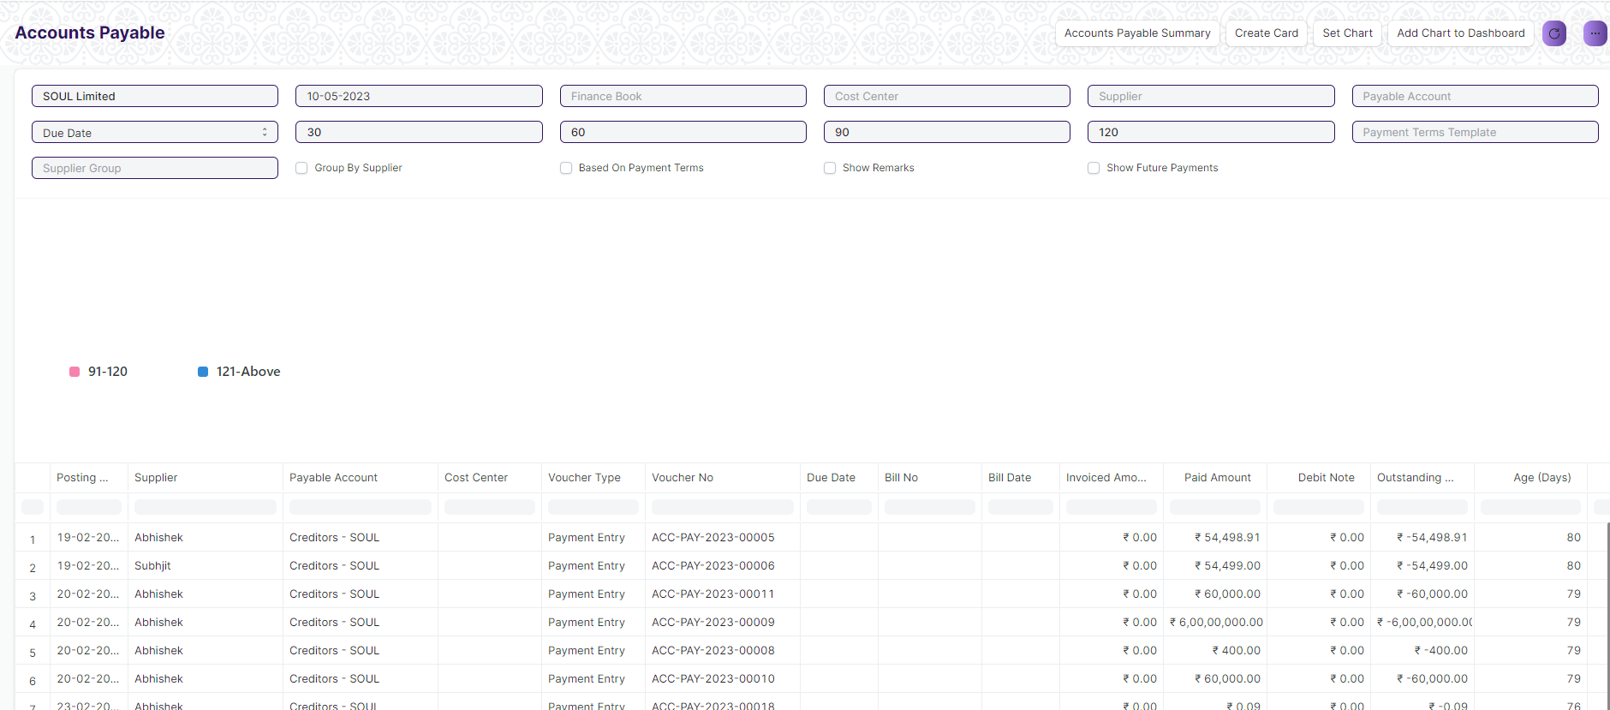

Figure: Accounts Payable Screen

**Input Filters**

|  |  |  |  |  |  |  |
| --- | --- | --- | --- | --- | --- | --- |
| **ID** | **Input Fields** | **Field Type** | **Mandatory** | **Validation/ Action** | **Remarks** | **R/N/D** |
| 1 | Company | Link Field |  |  | Default Company will be fetched |  |
| 2 | Posting Date | Date |  |  | Today’s date will be auto-fetched |  |
| 3 | Finance Book | Link Field |  |  |  |  |
| 4 | Cost Center | Link Field |  |  |  |  |
| 5 | Supplier | Link Field |  |  |  |  |
| 6 | Payable Account | Link Field |  |  |  |  |
| 7 | Ageing Based On | Dropdown |  |  | Options: Posting Date, Due Date, Supplier Invoice Date |  |
| 8 | Ageing Range 1 | Number |  |  |  |  |
| 9 | Ageing Range 2 | Number |  |  |  |  |
| 10 | Ageing Range 3 | Number |  |  |  |  |
| 11 | Ageing Range 4 | Number |  |  |  |  |
| 12 | Payment Terms Template | Link Field |  |  |  |  |
| 13 | Supplier Group | Link Field |  |  |  |  |
| 14 | Group By Supplier | Checkbox |  | If checked, the report will be show by grouping the suppliers |  |  |
| 15 | Based On Payment Terms | Checkbox |  | If checked, a column payment terms will appear |  |  |
| 16 | Show Remarks | Checkbox |  | If checked, a column with remarks of the transactions will be shown |  |  |
| 17 | Show Future Payments | Checkbox |  | If checked, future payments will be shown |  |  |

**Actions**

* User will enter the search fields such as Date, Supplier, Payable Account etc. as per requirement
* A user can add or remove the headers with the help of Add Column or Remove Column button.

**Report Fields**

|  |  |  |
| --- | --- | --- |
| **ID** | **Column Name** | **Description** |
| 1 | Posting Date | This displays the posting date of the transaction |
| 2 | Payable Account | This displays the payable account |
| 3 | Cost Center | This displays the cost centers linked to the transactions |
| 4 | Voucher Type | This shows the voucher type |
| 5 | Voucher No | This shows the voucher number |
| 6 | Due Date | This shows the due date for the transaction |
| 7 | Bill No | This displays the bill no associated with the transaction |
| 8 | Bill Date | This shows the bill date |
| 9 | Invoiced Amount | Invoiced Amount of the transaction is shown in this column |
| 10 | Paid Amount | Paid Amount of the transaction is shown in this column |
| 11 | Debit Note | Debit Note if any is shown here |
| 12 | Outstanding Amount | Amount which is outstanding is shown in this column |
| 13 | Age (Days) | Age of the transaction is shown here |
| 14 | 0-30 | The 0-30 days interval represents the outstanding payable balances that are due within the next 30 days. |
| 15 | 31-60 | The 31-60 days interval represents the outstanding payable balances that are due within the next 40 days. |
| 16 | 61-90 | The 61-90 days interval represents the outstanding payable balances that are due within the next 90 days. |
| 17 | 91-120 | The 91-120 days interval represents the outstanding payable balances that are due within the next 120 days. |
| 18 | Currency | Currency in which the transaction has occurred is show here |
| 19 | Supplier Group | Supplier Group of the transaction is shown here |

**User: Roles & Permission**

The following table describes the users and their roles and permissions for the screens :

|  |  |  |  |  |  |  |  |  |
| --- | --- | --- | --- | --- | --- | --- | --- | --- |
| **ID** | **Role** | **Read** | **Write** | **Create** | **Delete** | **Submit** | **Cancel** | **Amend** |
| 1 | Accountant Admin | Yes | Yes | NA | NA | NA | NA | NA |
| 2 | Account Manager | Yes | Yes | NA | NA | NA | NA | NA |
| 3 | Account User | Yes | Yes | NA | NA | NA | NA | NA |

### Accounts Payable Summary

**General Description**

The following table describes overall information about this screen:

|  |  |
| --- | --- |
| Description | The accounts payable summary is a report that provides an overview of the money owed by the organization to its vendors or suppliers. |
| Navigation | Home > Accounts > Accounts Payable > Accounts Payable Summary |
| Pre-requisites | The system should have records in the following screen   1. Company 2. GL Entries 3. Payment Entries 4. Purchase Invoice |
| Existing Screen Name | Accounts Payable Summary |
| New Screen Name | No change |

**Screenshot**

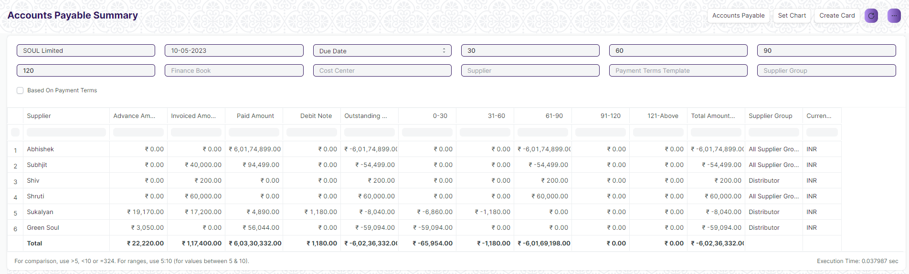

Figure: Accounts Payable Summary Screen

**Input Filters**

|  |  |  |  |  |  |  |
| --- | --- | --- | --- | --- | --- | --- |
| **ID** | **Input Fields** | **Field Type** | **Mandatory** | **Validation/ Action** | **Remarks** | **R/N/D** |
| 1 | Company | Link Field |  |  | Default Company will be fetched |  |
| 2 | Posting Date | Date |  |  | Today’s date will be auto-fetched |  |
| 3 | Ageing Based On | Dropdown |  |  | Options: Posting Date, Due Date, Supplier Invoice Date |  |
| 4 | Ageing Range 1 | Number |  | User Input |  |  |
| 5 | Ageing Range 2 | Number |  | User Input |  |  |
| 6 | Ageing Range 3 | Number |  | User Input |  |  |
| 7 | Ageing Range 4 | Number |  | User Input |  |  |
| 8 | Finance Book | Link Field |  |  |  |  |
| 9 | Cost Center | Link Field |  |  |  |  |
| 10 | Supplier | Link Field |  |  |  |  |
| 11 | Payment Terms Template | Link Field |  |  |  |  |
| 12 | Supplier Group | Link Field |  |  |  |  |
| 13 | Based On Payment Terms | Checkbox |  | If checked, a column payment terms will appear |  |  |

**Actions**

* User will enter the search fields such as Date, Supplier Group,Payment Terms Template etc. as per requirement
* A user can add or remove the headers with the help of Add Column or Remove Column button.

**Report Fields**

|  |  |  |
| --- | --- | --- |
| **ID** | **Column Name** | **Description** |
|  | Supplier | This displays the supplier name |
|  | Advance Amount | This displays the advance amount |
|  | Invoice Amount | This displays the invoice amount for the supplier |
|  | Paid Amount | This shows the paid amount |
|  | Debit Note | This shows the debit note if any |
|  | Outstanding Amount | This shows the outstanding amount for the transaction |
|  | 0-30 | The 0-30 days interval represents the outstanding payable balances that are due within the next 30 days. |
|  | 31-60 | The 31-41 days interval represents the outstanding payable balances that are due within the next 40 days. |
|  | 61-90 | The 61-90 days interval represents the outstanding payable balances that are due within the next 90 days. |
|  | 91-120 | The 91-120 days interval represents the outstanding payable balances that are due within the next 120 days. |
|  | 121-Above | This interval represents the outstanding payable balances that are due within the next 120 and above days. |
|  | Total Amount | This represents the amount summation link to each supplier |
|  | Supplier Group | Supplier Group of the transaction is shown here |
|  | Currency | Currency in which the transaction has occurred is show here |

**User: Roles & Permission**

The following table describes the users and their roles and permissions for the screens :

|  |  |  |  |  |  |  |  |  |
| --- | --- | --- | --- | --- | --- | --- | --- | --- |
| **ID** | **Role** | **Read** | **Write** | **Create** | **Delete** | **Submit** | **Cancel** | **Amend** |
| 1 | Accountant Admin | Yes | Yes | NA | NA | NA | NA | NA |
| 2 | Account Manager | Yes | Yes | NA | NA | NA | NA | NA |
| 3 | Account User | Yes | Yes | NA | NA | NA | NA | NA |

## Reports

### Trial Balance for Party

**General Description**

|  |  |
| --- | --- |
| **Description** | It is common to review the trial balance for employees, students, and suppliers. This information can be easily accessed for all individuals or for specific individuals. |
| **Navigation** | Home > Accounts > Reports > Trial Balance for Party |
| **Pre-requisites** | Company  Account  Party Type  Party  Fiscal Year |
| **Existing Screen Name** | Trial Balance for Party |
| **New Screen Name** | NA |

**Screenshot**

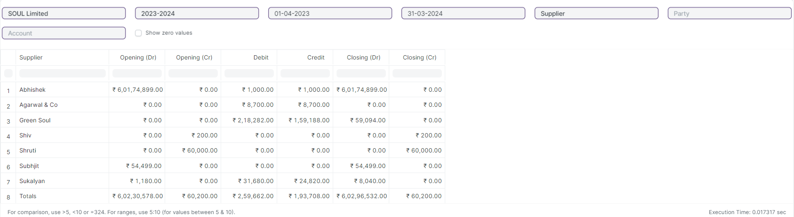

Figure: Trial Balance for Party Report

**Input Filters**

|  |  |  |  |  |  |  |
| --- | --- | --- | --- | --- | --- | --- |
| **ID** | **Field Label** | **Field Type** | **Validation/Action** | **Mandatory** | **Remarks** | **R/N/D** |
|  | Company | Link Field | Fetched from Company master screen |  |  |  |
|  | Fiscal Year | Link Field | Fetched from Fiscal Year master screen |  |  |  |
|  | From Date | Date | From Date should be less than To Date |  |  |  |
|  | To Date | Date | To Date should be greater than From Date |  |  |  |
|  | Party Type | Link Field | Fetched from Party Type master screen |  |  |  |
|  | Party | Link Field | Fetched from selected Party Type |  |  |  |
|  | Account | Link Field | Fetched from Account master screen |  |  |  |
|  | Show Zero Values | Check box |  |  | It display parties that have a zero balance in the report. |  |

**Actions**

* User will enter the search fields such as: Account, Voucher No, etc. Based on that input, the report will be shown.
* User can add or remove the headers with the help of Add Column or Remove Column button.

**Report Fields**

|  |  |  |
| --- | --- | --- |
| **ID** | **Column Fields** | **Description** |
|  | Party Type | Categorization of parties involved in transactions, such as Student, suppliers etc. |
|  | Opening (Dr) | Opening (Dr) represent the opening debit balances |
|  | Opening (Cr) | Opening (Cr) represent the opening credit balances |
|  | Debit | Debit represent the total debit transactions during the period |
|  | Credit | Credit represent the total credit transactions during the period |
|  | Closing (Dr) | Closing (Dr) represents the closing debit balance |
|  | Closing (Cr) | Closing (Cr) represents the closing credit balance |

**User: Roles & Permission**

The following table describes the users and their roles and permissions for the screens :

|  |  |  |  |  |  |  |  |  |
| --- | --- | --- | --- | --- | --- | --- | --- | --- |
| **ID** | **Role** | **Read** | **Write** | **Create** | **Delete** | **Submit** | **Cancel** | **Amend** |
|  | Account User | Yes | No | NA | NA | NA | NA | NA |
|  | Account Manager | Yes | No | NA | NA | NA | NA | NA |
|  | Account Admin | Yes | Yes | NA | NA | NA | NA | NA |

### Tax Detail

**General Description**

|  |  |
| --- | --- |
| **Description** | Tax Details report provides an overview of all the taxes applied to transactions.This report shows the Item Tax Template, Taxes and Charges Template and Tax Category linked to various voucher types in the application. |
| **Navigation** | Home > Accounts > Reports > Tax Detail |
| **Pre-requisites** | Company  Fiscal Year  Account |
| **Existing Screen Name** | Tax Detail |
| **New Screen Name** | NA |

**Screenshot**

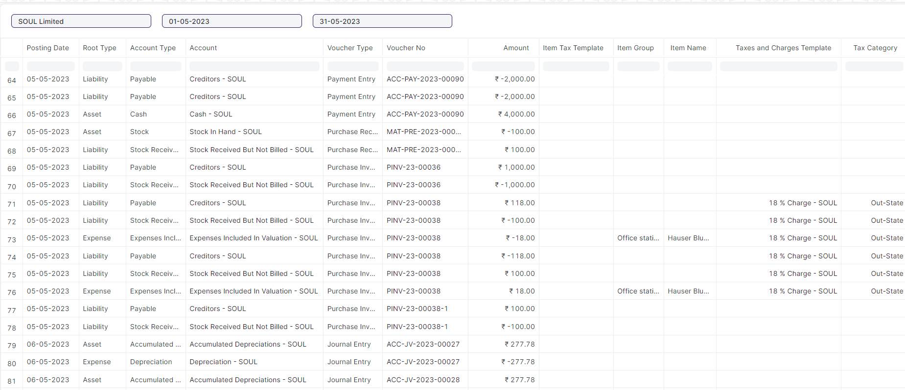

Figure: Tax Category Report

**Input Filters**

|  |  |  |  |  |  |  |
| --- | --- | --- | --- | --- | --- | --- |
| **ID** | **Field Label** | **Field Type** | **Validation/Action** | **Mandatory** | **Remarks** | **R/N/D** |
|  | Company | Link Field | Fetched from Company master screen |  |  |  |
|  | From Date | Date | From Date should be less than To Date |  |  |  |
|  | To Date | Date | To Date should be greater than From Date |  |  |  |

**Actions**

* User will enter the search fields such as: Account, Voucher No, etc. Based on that input, the report will be shown.
* User can add or remove the headers with the help of Add Column or Remove Column button.

**Report Fields**

|  |  |  |
| --- | --- | --- |
| **ID** | **Column Fields** | **Description** |
|  | Posting Date | Date of the transaction |
|  | Root Type | Account Root types are mainly classified as income, expense, asset, or liability. |
|  | Account Type | Account type of that account. |
|  | Account | Name of the Account. |
|  | Voucher Type | Different Types of Vouchers like Purchase Receipt, Stock Entry, etc. |
|  | Voucher No | Voucher no. is based on the voucher type. |
|  | Amount | Voucher amount. |
|  | Item Tax Template | Item Tax Template is a predefined tax template applied to items. |
|  | Item Group | Item Group is a grouping of similar items. |
|  | Item Name | Item Name is the name of the item. |
|  | Taxes and Charges Template | Taxes and Charges Template is a predefined tax template applied to transactions. |
|  | Tax Category | Tax Category is a predefined tax category assigned to taxes. |

**User: Roles & Permission**

The following table describes the users and their roles and permissions for the screens :

|  |  |  |  |  |  |  |  |  |
| --- | --- | --- | --- | --- | --- | --- | --- | --- |
| **ID** | **Role** | **Read** | **Write** | **Create** | **Delete** | **Submit** | **Cancel** | **Amend** |
|  | Account User | Yes | No | NA | NA | NA | NA | NA |
|  | Account Manager | Yes | No | NA | NA | NA | NA | NA |
|  | Account Admin | Yes | Yes | NA | NA | NA | NA | NA |

## Financial Statement

### Trial Balance

**General Description**

|  |  |
| --- | --- |
| **Description** | A Trial Balance is an accounting report which lists account balances for all Accounts for any given reporting period. A company prepares a trial balance periodically, usually at the end of every reporting period. The general purpose of producing a trial balance is to ensure the entries in a company's bookkeeping system are mathematically correct. The totals of Debit and Credit columns must be same for any given period, to ensure the entries are correct. |
| **Navigation** | Home > Accounts > Financial Statements> Trial Balance |
| **Pre-requisites** | Account  Company  Fiscal Year |
| **Existing Screen Name** | Trial Balance |
| **New Screen Name** | NA |

**Screenshot**

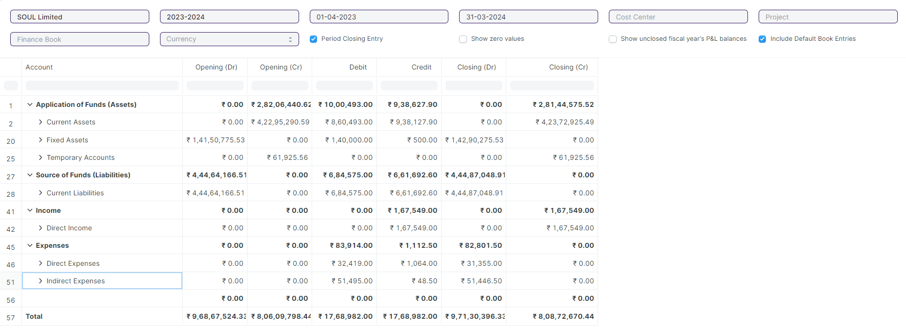

Figure: Trial Balance Report

**Input Filters**

|  |  |  |  |  |  |  |
| --- | --- | --- | --- | --- | --- | --- |
| **ID** | **Field Label** | **Field Type** | **Validation/Action** | **Mandatory** | **Remarks** | **R/N/D** |
|  | Company | Link Field | Fetched from Company master screen |  |  |  |
|  | Fiscal Year | Link Field | Fetched from Fiscal Year master screen |  |  |  |
|  | From Date | Date | From Date should be less than To Date |  |  |  |
|  | To Date | Date | To Date should be greater than From Date |  |  |  |
|  | Cost Center | Link Field | Fetched from Cost Center master screen |  |  |  |
|  | Project | Link Field | Fetched from Project master screen |  |  |  |
|  | Finance Book | Link Field | Fetched from Finance Book master screen |  |  |  |
|  | Currency | Link Field | Fetched from Currency master screen |  |  |  |
|  | Period Closing Entry | Checkbox |  |  | It shows the closing balances as per the period closing entries |  |
|  | Show Zero Values | Checkbox |  |  | It display parties that have a zero balance in the report. |  |
|  | Show unclosed fiscal year's P&L balances | Checkbox |  |  | It displays the profit and loss balances of unclosed fiscal years. |  |
|  | Include Default Book Entries | Checkbox |  |  | It includes predefined transactions used for opening balances of ledger accounts, such as banks, cash, and accounts payable/receivable. |  |

**Actions**

* User will enter the search fields such as: Account, Voucher No, etc. Based on that input, the report will be shown.
* User can add or remove the headers with the help of Add Column or Remove Column button.

**Report Fields**

|  |  |  |
| --- | --- | --- |
| **ID** | **Column Fields** | **Description** |
|  | Account | Account refers to the ledger accounts |
|  | Opening (Dr) | Opening (Dr) represent the opening debit balances |
|  | Opening (Cr) | Opening (Cr) represents the opening credit balances |
|  | Debit | Debit represents the total debit transactions during the period |
|  | Credit | Credit represents the total credit transactions during the period |
|  | Closing (Dr) | Closing (Dr) represents the closing debit balance |
|  | Closing (Cr) | Closing (Cr) represents the closing credit balance |

**User: Roles & Permission**

The following table describes the users and their roles and permissions for the screens :

|  |  |  |  |  |  |  |  |  |
| --- | --- | --- | --- | --- | --- | --- | --- | --- |
| **ID** | **Role** | **Read** | **Write** | **Create** | **Delete** | **Submit** | **Cancel** | **Amend** |
|  | Account User | Yes | No | NA | NA | NA | NA | NA |
|  | Account Manager | Yes | No | NA | NA | NA | NA | NA |
|  | Account Admin | Yes | Yes | NA | NA | NA | NA | NA |

### Balance Sheet

**General Description**

|  |  |
| --- | --- |
| **Description** | A Balance Sheet is the financial statement of a company which states assets, liabilities and equity at a particular point in time.  The Balance Sheet gives more flexibility to analyse your financial position. You can run the report across multiple year to compare values. You can check values for a specific Finance Book or Cost Center. You can also choose any other currency to display the balances. |
| **Navigation** | Home > Accounts > Financial Statements> Balance Sheet |
| **Pre-requisites** | Company  Fiscal Year  Account |
| **Existing Screen Name** | Balance Sheet |
| **New Screen Name** | NA |

**Screenshot**

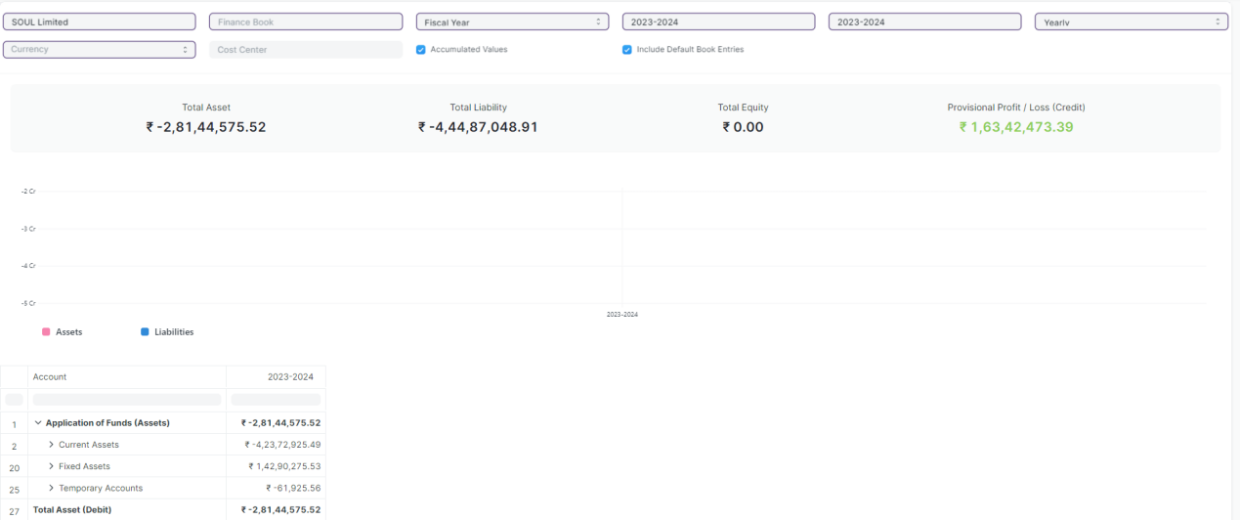

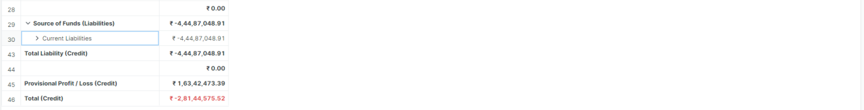

Figure: Balance Sheet Report

**Input Filters**

|  |  |  |  |  |  |  |
| --- | --- | --- | --- | --- | --- | --- |
| **ID** | **Field Label** | **Field Type** | **Validation/Action** | **Mandatory** | **Remarks** | **R/N/D** |
| 1. 1 | Company | Link Field | Fetched from Company master screen |  |  |  |
| 1. 2 | Finance Book | Link Field | Fetched from Finance Book master screen |  |  |  |
| 1. 3 | Filter Based On | Drop Down | Fiscal Year/Date Range |  |  |  |
| 1. 4 | Start Year | Link Field | Fetched from Fiscal Year master screen |  | Display depends on If Filter based on Fiscal Year |  |
| 1. 5 | End Year | Link Field | Fetched from Fiscal Year master screen |  | Display depends on If Filter based on Fiscal Year |  |
| 1. 6 | Start Date | Date | Start Date should be less than End Date |  | Display depends on If Filter based on Date Range |  |
| 1. 7 | End Date | Date | End Date should be greater than Start Date |  | Display depends on If Filter based on Date Range |  |
| 1. 8 | Periodicity | Dropdown | Monthly/Quarterly/Half-Yearly/Yearly |  |  |  |
| 1. 9 | Currency | Link Field | Fetched from Currency master screen |  |  |  |
| 1. 10 | Cost Center | Link Field | Fetched from Cost Center master screen |  |  |  |
| 1. 11 | Accumulated Values in Group Company | Checkbox |  |  |  |  |
| 1. 12 | Include Default Book Entries | Checkbox |  |  | It includes predefined transactions used for opening balances of ledger accounts, such as banks, cash, and accounts payable/receivable. |  |

**Actions**

* User will enter the search fields such as: Account, Voucher No, etc. Based on that input, the report will be shown.
* User can add or remove the headers with the help of Add Column or Remove Column button.

**Report Fields**

|  |  |  |
| --- | --- | --- |
| **ID** | **Column Fields** | **Description** |
|  | Account | Name of the Account |
|  | Amount | Amount based on the Amount |

**User: Roles & Permission**

The following table describes the users and their roles and permissions for the screens :

|  |  |  |  |  |  |  |  |  |
| --- | --- | --- | --- | --- | --- | --- | --- | --- |
| **ID** | **Role** | **Read** | **Write** | **Create** | **Delete** | **Submit** | **Cancel** | **Amend** |
|  | Account User | Yes | No | NA | NA | NA | NA | NA |
|  | Account Manager | Yes | No | NA | NA | NA | NA | NA |
|  | Account Admin | Yes | Yes | NA | NA | NA | NA | NA |

### Profit and Loss Statement

**General Description**

|  |  |
| --- | --- |
| **Description** | A Profit and Loss Statement is a financial statement which summarizes all the revenues and expenses in a given period. The report is also known as P&L Statement.  you can run the report across multiple year / period to compare the values. You can also check values for a specific Finance Book, Project or Cost Center. You can also choose any other currency to display the balances. If you are running the report to see quarterly / monthly balances, you can choose whether you want to show accumulated balances or only for each period. |
| **Navigation** | Home > Accounts > Financial Statements> Profit and Loss Statement |
| **Pre-requisites** | Company  Fiscal Year  Account |
| **Existing Screen Name** | Profit and Loss Statement |
| **New Screen Name** | NA |

**Screenshot**

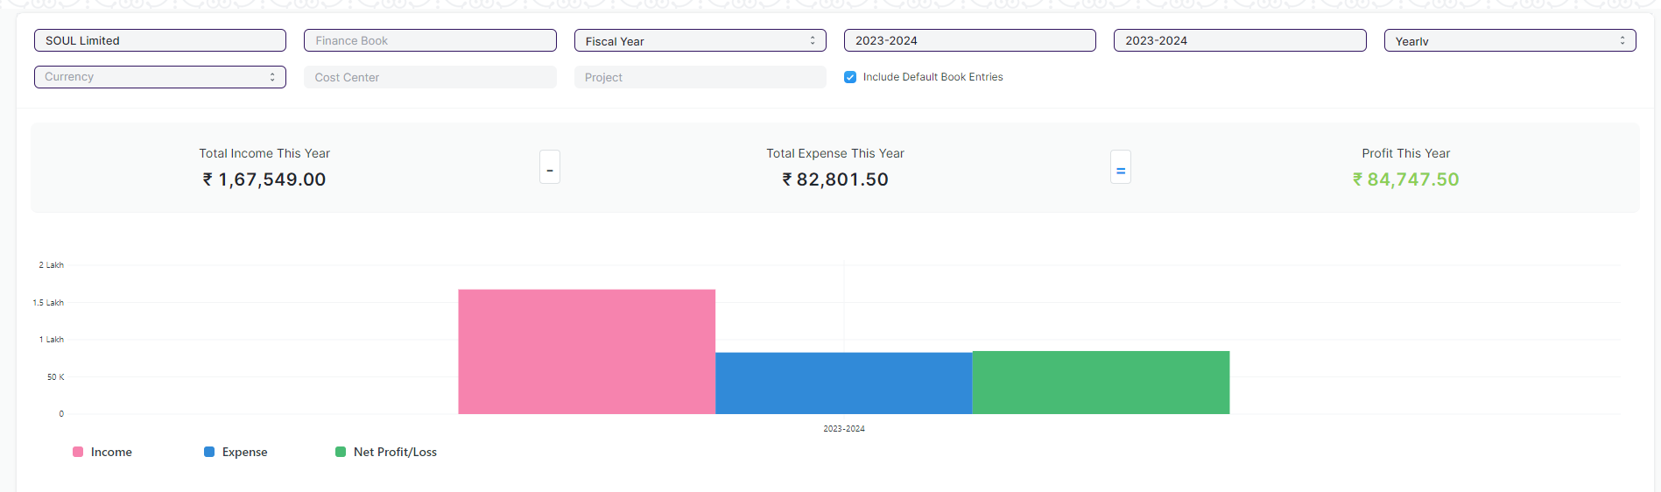

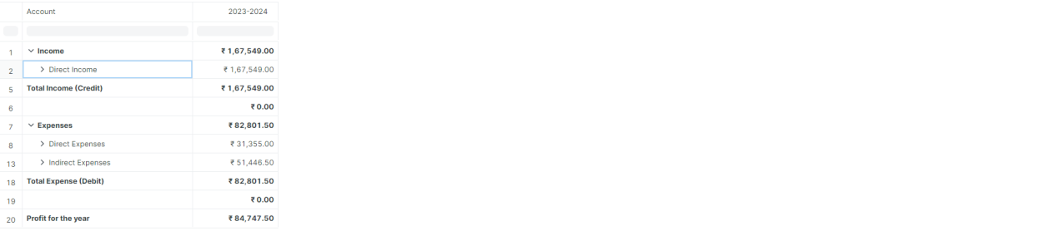

Figure: Profit and Loss Statement Report

**Input Filters**

|  |  |  |  |  |  |  |
| --- | --- | --- | --- | --- | --- | --- |
| **ID** | **Field Label** | **Field Type** | **Validation/Action** | **Mandatory** | **Remarks** | **R/N/D** |
|  | Company | Link Field | Fetched from Company master screen |  |  |  |
|  | Finance Book | Link Field | Fetched from Finance Book master screen |  |  |  |
|  | Filter Based On | Drop Down | Fiscal Year/Date Range |  |  |  |
|  | Start Year | Link Field | Fetched from Fiscal Year master screen |  | Display depends on If Filter based on Fiscal Year |  |
|  | End Year | Link Field | Fetched from Fiscal Year master screen |  | Display depends on If Filter based on Fiscal Year |  |
|  | Start Date | Date | Start Date should be less than End Date |  | Display depends on If Filter based on Date Range |  |
|  | End Date | Date | End Date should be greater than Start Date |  | Display depends on If Filter based on Date Range |  |
|  | Periodicity | Dropdown | Monthly/Quarterly/Half-Yearly/Yearly |  |  |  |
|  | Currency | Link Field | Fetched from Currency master screen |  |  |  |
|  | Cost Center | Link Field | Fetched from Cost Center master screen |  |  |  |
|  | Project | Link Field | Fetched from Project master screen |  |  |  |
|  | Include Default Book Entries |  |  |  | It includes predefined transactions used for opening balances of ledger accounts, such as banks, cash, and accounts payable/receivable. |  |

**Actions**

* User will enter the search fields such as: Account, Voucher No, etc. Based on that input, the report will be shown.
* User can add or remove the headers with the help of Add Column or Remove Column button.

**Report Fields**

|  |  |  |
| --- | --- | --- |
| **ID** | **Column Fields** | **Description** |
|  | Account | Name of the Account |
|  | Amount | Amount based on the Amount |

**User: Roles & Permission**

The following table describes the users and their roles and permissions for the screens :

|  |  |  |  |  |  |  |  |  |
| --- | --- | --- | --- | --- | --- | --- | --- | --- |
| **ID** | **Role** | **Read** | **Write** | **Create** | **Delete** | **Submit** | **Cancel** | **Amend** |
|  | Account User | Yes | No | NA | NA | NA | NA | NA |
|  | Account Manager | Yes | No | NA | NA | NA | NA | NA |
|  | Account Admin | Yes | Yes | NA | NA | NA | NA | NA |

### Cash Flow

**General Description**

|  |  |
| --- | --- |
| **Description** | A Cash Flow is a financial statement which shows the incoming and outgoing of cash or cash-equivalents for a company. It is used to analyse the liquidity position of the company. |
| **Navigation** | Home > Accounts > Financial Statements> Cash Flow |
| **Pre-requisites** | Company  Fiscal Year  Account |
| **Existing Screen Name** | Cash Flow |
| **New Screen Name** | NA |

**Screenshot**

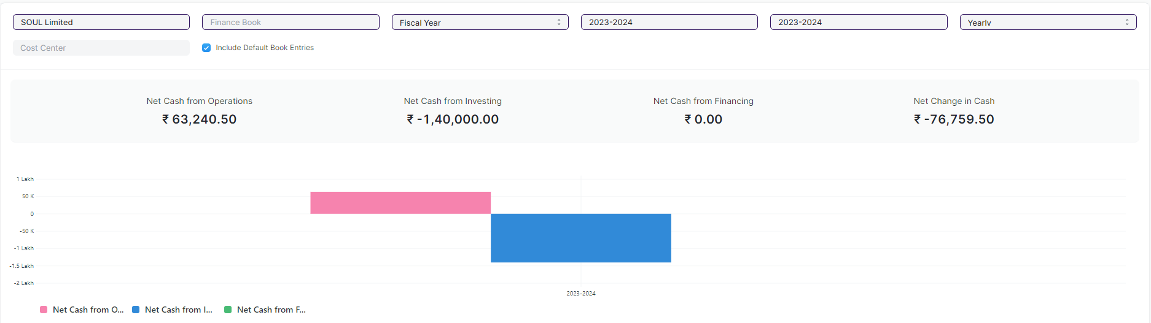

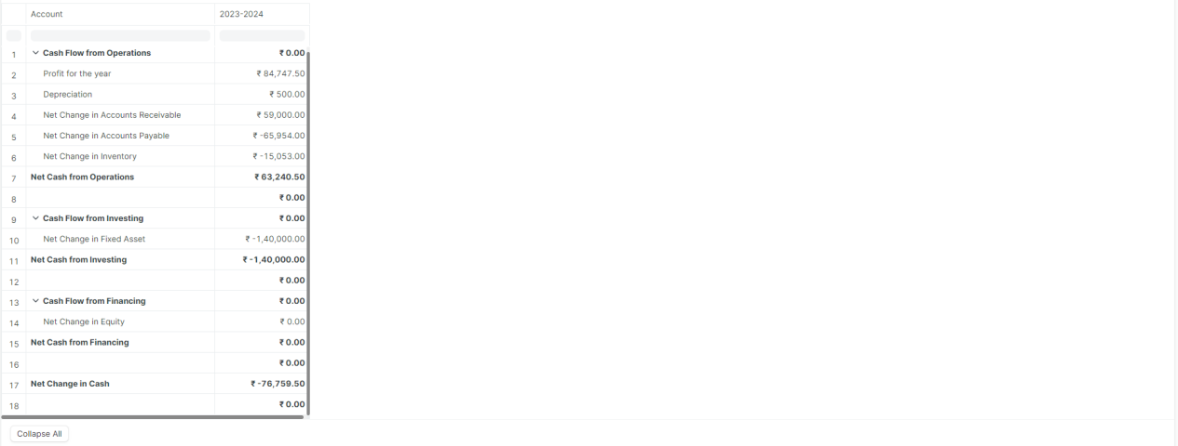

Figure: Cash Flow Report

**Input Filters**

|  |  |  |  |  |  |  |
| --- | --- | --- | --- | --- | --- | --- |
| **ID** | **Field Label** | **Field Type** | **Validation/Action** | **Mandatory** | **Remarks** | **R/N/D** |
| 1. 1 | Company | Link Field | Fetched from Company master screen |  |  |  |
| 1. 2 | Finance Book | Link Field | Fetched from Finance Book master screen |  |  |  |
| 1. 3 | Filter Based On | Drop Down | Fiscal Year/Date Range |  |  |  |
| 1. 4 | Start Year | Link Field | Fetched from Fiscal Year master screen |  | Display depends on If Filter based on Fiscal Year |  |
| 1. 5 | End Year | Link Field | Fetched from Fiscal Year master screen |  | Display depends on If Filter based on Fiscal Year |  |
| 1. 6 | Start Date | Date | Start Date should be less than End Date |  | Display depends on If Filter based on Date Range |  |
| 1. 7 | End Date | Date | End Date should be greater than Start Date |  | Display depends on If Filter based on Date Range |  |
| 1. 8 | Periodicity | Dropdown | Monthly/Quarterly/Half-Yearly/Yearly |  |  |  |
| 1. 9 | Cost Center | Link Field | Fetched from Cost Center master screen |  |  |  |
| 1. 10 | Include Default Book Entries | Checkbox |  |  | It includes predefined transactions used for opening balances of ledger accounts, such as banks, cash, and accounts payable/receivable. |  |

**Actions**

* User will enter the search fields such as: Account, Voucher No, etc. Based on that input, the report will be shown.
* User can add or remove the headers with the help of Add Column or Remove Column button.

**Report Fields**

|  |  |  |
| --- | --- | --- |
| **ID** | **Column Fields** | **Description** |
|  | Account | Name of the Account |
|  | Amount | Amount based on the Amount |

**User: Roles & Permission**

The following table describes the users and their roles and permissions for the screens :

|  |  |  |  |  |  |  |  |  |
| --- | --- | --- | --- | --- | --- | --- | --- | --- |
| **ID** | **Role** | **Read** | **Write** | **Create** | **Delete** | **Submit** | **Cancel** | **Amend** |
|  | Account User | Yes | No | NA | NA | NA | NA | NA |
|  | Account Manager | Yes | No | NA | NA | NA | NA | NA |
|  | Account Admin | Yes | Yes | NA | NA | NA | NA | NA |

### Consolidated Financial Statement

**General Description**

|  |  |
| --- | --- |
| **Description** | The report shows a consolidated view of Balance Sheet, Profit and Loss Statement and Cash Flow for a group company, by merging financial statements of all the subsidary companies. It shows balances for all individual company and as well as accumulated balances for a group company. |
| **Navigation** | Home > Accounts > Financial Statements> Consolidated Financial Statement |
| **Pre-requisites** | Company  Fiscal Year  Account |
| **Existing Screen Name** | Cash Flow |
| **New Screen Name** | NA |

**Screenshot**

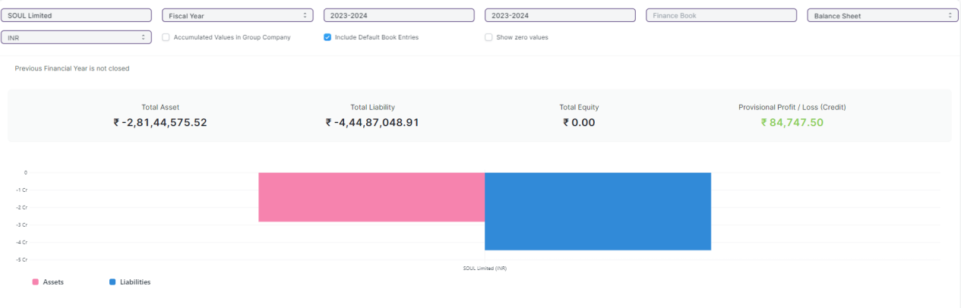

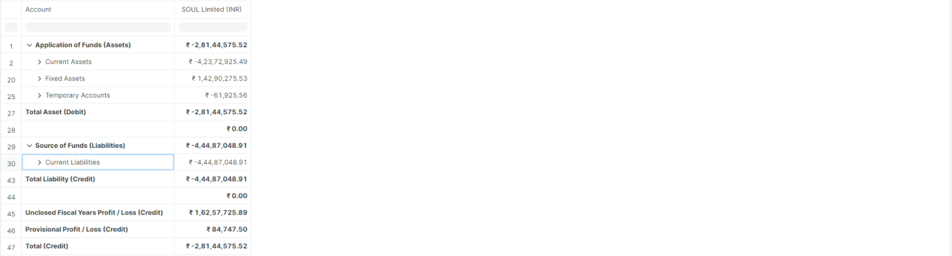

Figure: Consolidated Financial Statement Report

**Input Filters**

|  |  |  |  |  |  |  |
| --- | --- | --- | --- | --- | --- | --- |
| **ID** | **Field Label** | **Field Type** | **Validation/Action** | **Mandatory** | **Remarks** | **R/N/D** |
|  | Company | Link Field | Fetched from Company master screen |  |  |  |
|  | Filter Based On | Drop Down | Fiscal Year/Date Range |  |  |  |
|  | Start Year | Link Field | Fetched from Fiscal Year master screen |  | Display depends on If Filter based on Fiscal Year |  |
|  | End Year | Link Field | Fetched from Fiscal Year master screen |  | Display depends on If Filter based on Fiscal Year |  |
|  | Start Date | Date | Start Date should be less than End Date |  | Display depends on If Filter based on Date Range |  |
|  | End Date | Date | End Date should be greater than Start Date |  | Display depends on If Filter based on Date Range |  |
|  | Finance Book | Link Field | Fetched from Finance Book master screen |  |  |  |
|  | Report | Dropdown | Profit and Loss Statement/Balance Sheet/Cash Flow |  |  |  |
|  | Currency | Link Field | Fetched from Currency master screen |  |  |  |
|  | Accumulated Values in Group Company | Checkbox |  |  |  |  |
|  | Include Default Book Entries | Checkbox |  |  | It includes predefined transactions used for opening balances of ledger accounts, such as banks, cash, and accounts payable/receivable. |  |
|  | Show zero values | Checkbox |  |  | "Show Zero Values" option allows you to display parties that have a zero balance in the report. |  |

**Actions**

* User will enter the search fields such as: Account, Voucher No, etc. Based on that input, the report will be shown.
* User can add or remove the headers with the help of Add Column or Remove Column button.

**Report Fields**

|  |  |  |
| --- | --- | --- |
| **ID** | **Column Fields** | **Description** |
|  | Account | Name of the Account |
|  | Amount | Amount based on the Account |

**User: Roles & Permission**

The following table describes the users and their roles and permissions for the screens :

|  |  |  |  |  |  |  |  |  |
| --- | --- | --- | --- | --- | --- | --- | --- | --- |
| **ID** | **Role** | **Read** | **Write** | **Create** | **Delete** | **Submit** | **Cancel** | **Amend** |
|  | Account User | Yes | No | NA | NA | NA | NA | NA |
|  | Account Manager | Yes | No | NA | NA | NA | NA | NA |
|  | Account Admin | Yes | Yes | NA | NA | NA | NA | NA |

## Bank Statement

### Bank Reconciliation Tool

**General Description**

The following table describes overall information about this screen:

|  |  |  |
| --- | --- | --- |
| **Description** | | 1. Once all your bank transactions are imported into the application, you can reconcile them with your existing vouchers. 2. The final goal of Bank Reconciliation is to make the difference amount zero (green) by either matching to an existing voucher or creating a new voucher. |
| **Navigation** | Home > Accounts > Bank Statement > Bank Reconciliation Tool | |
| **Pre-requisites** | The system should have records in the following screen   1. Payment Entries 2. Bank Statement | |
| **Existing Screen Name** | Bank Reconciliation Tool | |
| **New Screen Name** | No change | |

**Screenshot**

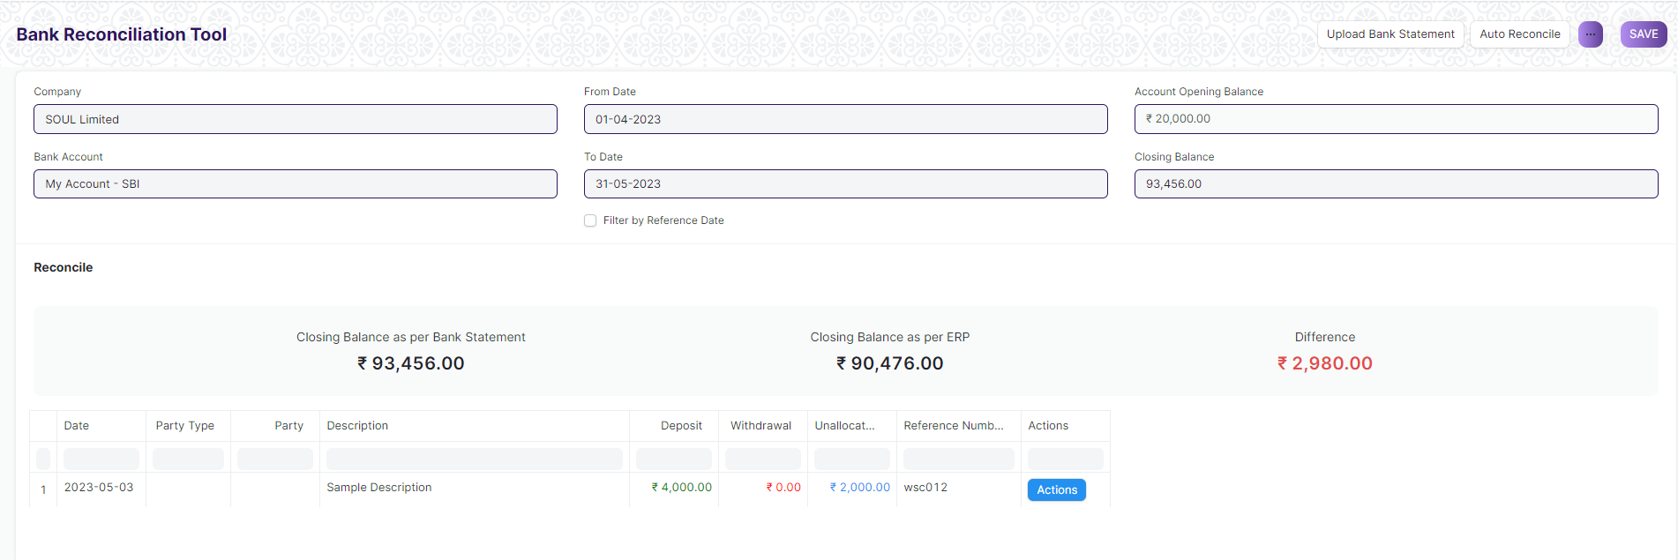

Figure: Bank Reconciliation Tool Screen

**Field List**

The following table describes the UI fields present in this screen :

|  |  |  |  |  |  |  |
| --- | --- | --- | --- | --- | --- | --- |
| **ID** | **Field Name** | **Field Type** | **Mandatory** | **Validation/ Action** | **Remarks** | **R/N/D** |
| 1 | Company | Link Field |  | Link Fields to Master Screen Company | Default company name will be fetched |  |
| 2 | Bank Account | Link Field |  | Link Fields to Master Screen Bank Account | Default bank account name will be fetched |  |
| 3 | From Date | Date |  |  |  |  |
| 4 | To Date | Date |  | To Date shall be greater than From date |  |  |
| 5 | From Reference Date | Date |  |  |  |  |
| 6 | To Reference Date | Date |  | To Reference Date shall be greater than From Reference Date |  |  |
| 7 | Filter by Reference Date | Checkbox |  | If checked fields ‘From Reference Date’ and ‘ To Reference Date’ will be displayed instead of ‘From Date’ and ‘To Date’ and vice versa |  |  |
| 8 | Account Opening Balance | Currency |  |  |  |  |
| 10 | Closing Balance | Currency |  |  | Enter the closing balance as per bank statement |  |
| 11 | Reconciliation Tool Cards | HTML |  |  | Displays the ‘Closing Balance as per Bank Statement’ , ‘Closing Balance as per ERP’ and the difference |  |
| 12 | Bank Transactions | HTML |  | For all the bank transactions which are present in the Bank Statement but do not have a clearance date, click on the Actions Button to Match/ Create Vouchers |  |  |
| 13 | Upload Bank Statement Button | | | Make sure you have at least the date, the debit/credit and the currency on every row of your bank statement | Download a bank statement from your bank's website |  |
| 14 | Auto Reconcile Button | | |  | Click on ‘Auto Reconcile’ button to reconcile against matching references |  |

**User: Roles & Permission**

The following table describes the users and their roles and permissions for the screens :

|  |  |  |  |  |  |  |  |  |
| --- | --- | --- | --- | --- | --- | --- | --- | --- |
| **ID** | **Role** | **Read** | **Write** | **Create** | **Delete** | **Submit** | **Cancel** | **Amend** |
| 1 | Account User | No | No | No | No | NA | NA | NA |
| 2 | Account Manager | Yes | Yes | Yes | Yes | NA | NA | NA |
| 3 | Accountant Admin | Yes | Yes | Yes | Yes | NA | NA | NA |

### Bank Clearance

**General Description**

The following table describes overall information about this screen:

|  |  |  |
| --- | --- | --- |
| **Description** | | 1. This feature is used to manually update clearance date with respect to payment entries which are not reconciled 2. You can also use this feature to update or rectify clearance date of reconciled transactions |
| **Navigation** | Home > Accounts > Bank Statement > Bank Clearance | |
| **Pre-requisites** | The system should have records in the following screen   1. Account 2. Account Currency | |
| **Existing Screen Name** | Bank Clearance | |
| **New Screen Name** | No change | |

**Screenshot**

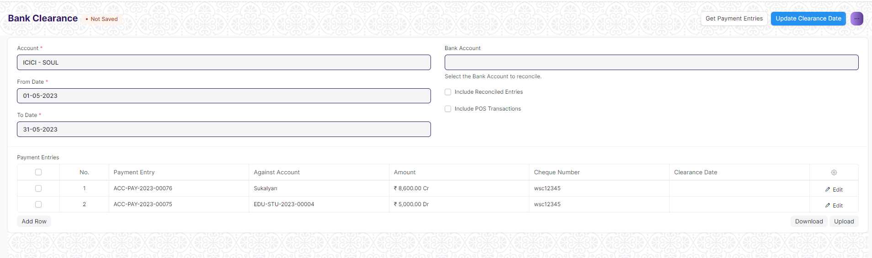

Figure: Bank Clearance Screen

**Field List**

The following table describes the UI fields present in this screen :

|  |  |  |  |  |  |  |
| --- | --- | --- | --- | --- | --- | --- |
| **ID** | **Field Name** | **Field Type** | **Mandatory** | **Validation/ Action** | **Remarks** | **R/N/D** |
| 1 | Account | Link Field | Yes | Link Fields to Master Screen Account | Default account name will be fetched |  |
| 2 | Account Currency | Link Field |  | Link Fields to Master Screen Currency | This field is hidden |  |
| 3 | From Date | Date | Yes |  |  |  |
| 4 | To Date | Date | Yes | To Date shall be greater than From date |  |  |
| 5 | Bank Account | Link Field |  | Link Fields to Master Screen Bank Account |  |  |
| 6 | Include Reconciled Entries | Checkbox |  | If checked reconciled entries will be fetched |  |  |
| 7 | Include POS Transactions | Checkbox |  | If checked POS Transactions will fetch |  |  |
| 8 | Payment Entries | Table |  | Description of the Table is given below | Once clearance date is updated the entires disappear from the table |  |
| 9 | Get Payment Entries Button | | | Payment Entries table is filled with relevant data once clicked |  |  |
| 10 | Update Clearance Date Button | | | Set the clearance date for the relevant payment entries and then click on this button to update clearance date |  |  |

|  |  |  |  |  |  |  |  |
| --- | --- | --- | --- | --- | --- | --- | --- |
| **Payment Entries(Bank Clearance Detail)** | | | | | | | |
| **ID** | **Field Name** | **Field Type** | **Mandatory** | **Validation / Action** | | **Remarks** | **R/N/D** |
| 1 | Payment Document | Link Field |  | Links to Doctype List | Data fetches on click “Get Payment Entries” button | |  |
| 2 | Payment Entry | Dynamic Link Field |  | Links to Doctype selected in Payment Document | Data fetches on click “Get Payment Entries” button | |  |
| 3 | Against Account | Data |  |  | Data fetches on click “Get Payment Entries” button | |  |
| 4 | Amount | Data |  |  | Data fetches on click “Get Payment Entries” button | |  |
| 5 | Posting Date | Date |  |  | Data fetches on click “Get Payment Entries” button | |  |
| 6 | Cheque Number | Data |  |  | Data fetches on click “Get Payment Entries” button | |  |
| 7 | Cheque Date | Date |  |  | Data fetches on click “Get Payment Entries” button | |  |
| 8 | Clearance Date | Date |  |  | Enter clearance date and click on “update clearance date” button | |  |

**User: Roles & Permission**

The following table describes the users and their roles and permissions for the screens :

|  |  |  |  |  |  |  |  |  |
| --- | --- | --- | --- | --- | --- | --- | --- | --- |
| **ID** | **Role** | **Read** | **Write** | **Create** | **Delete** | **Submit** | **Cancel** | **Amend** |
| 1 | Account User | No | No | No | No | NA | NA | NA |
| 2 | Account Manager | Yes | Yes | Yes | Yes | NA | NA | NA |
| 3 | Accountant Admin | Yes | Yes | Yes | Yes | NA | NA | NA |

### Bank Reconciliation Statement

**General Description**

The following table describes overall information about this screen:

|  |  |
| --- | --- |
| Description | The Bank Reconciliation Report provides the difference between the bank balance shown in an organization's bank statement, as provided by the bank against the amount shown in the companies Chart of Accounts. |
| Navigation | Home > Accounts > Bank Statement > Bank Reconciliation Statement |
| Pre-requisites | The system should have records in the following screen   1. GL Entries 2. Payment Entries |
| Existing Screen Name | Bank Reconciliation Statement |
| New Screen Name | No change |

**Screenshot**

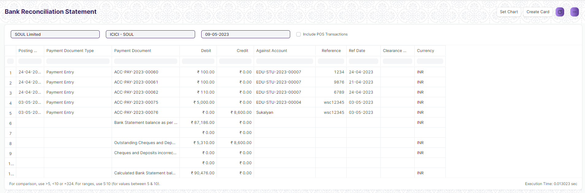

Figure: Bank Reconciliation Statement Screen

**Input Filters**

|  |  |  |  |  |  |  |
| --- | --- | --- | --- | --- | --- | --- |
| **ID** | **Input Fields** | **Field Type** | **Mandatory** | **Validation/ Action** | **Remarks** | **R/N/D** |
|  | Company | Link Field |  |  | Default Company will be fetched |  |
|  | Bank Account | Link Field |  |  | Default Bank Account will be fetched |  |
|  | Date | Date |  |  | Today’s date will be auto-fetched |  |

**Actions**

* User will enter the search fields such as Date and Bank Account as per requirement
* A user can add or remove the headers with the help of Add Column or Remove Column button.

**Report Fields**

|  |  |  |
| --- | --- | --- |
| **ID** | **Column Name** | **Description** |
|  | Posting Date | This displays the posting date of the transaction |
|  | Payment Document Type | This displays the type of voucher associated to the payment |
|  | Payment Document | This shows the primary key of the payment voucher |
|  | Debit | This shows the credit amount |
|  | Credit | This shows the debit amount |
|  | Against Account | This shows the party against which the amount was charged |
|  | Reference | This shows the reference number against transactions, if any |
|  | Ref Date | This shows the reference date against transactions, if any |
|  | Clearance Date | It shows the clearance date of the transactions, if any |
|  | Currency | It shows the currency such as INR, USD, etc. |

**User: Roles & Permission**

The following table describes the users and their roles and permissions for the screens :

|  |  |  |  |  |  |  |  |  |
| --- | --- | --- | --- | --- | --- | --- | --- | --- |
| **ID** | **Role** | **Read** | **Write** | **Create** | **Delete** | **Submit** | **Cancel** | **Amend** |
| 1 | Accountant Admin | Yes | Yes | NA | NA | NA | NA | NA |
| 2 | Account Manager | Yes | Yes | NA | NA | NA | NA | NA |
| 3 | Account User | Yes | Yes | NA | NA | NA | NA | NA |

### Cost Center

**General Description**

The following table describes overall information about this screen:

|  |  |  |
| --- | --- | --- |
| **Description** | | A Cost Center is a part of an organization where costs or income can be charged. |
| **Navigation** | Home > Accounts > Cost Center > Chart of Cost Centers | |
| **Pre-requisites** | The system should have records in the following screen   1. Company | |
| **Existing Screen Name** | Cost Center | |
| **New Screen Name** | No change | |

**Screenshot**

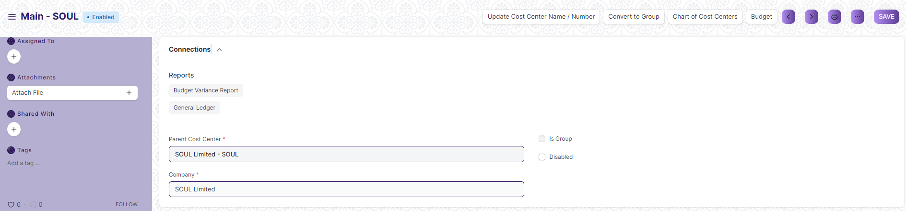

Figure: Cost Center Screen

**Field List**

The following table describes the UI fields present in this screen :

|  |  |  |  |  |  |  |
| --- | --- | --- | --- | --- | --- | --- |
| **ID** | **Field Name** | **Field Type** | **Mandatory** | **Validation/ Action** | **Remarks** | **R/N/D** |
| 1 | Cost Center Name | Data | Yes |  |  |  |
| 2 | Cost Center Number | Data |  |  |  |  |
| 3 | Parent Cost Center | Link | Yes |  |  |  |
| 4 | Company | Link | Yes | Link Fields to Master Screen Company | Default company name will be fetched |  |
| 5 | Is Group | Checkbox |  | If checked will create a group which can is visible under tree view |  |  |
| 6 | Disabled | Checkbox |  | If checked the cost center will be disabled |  |  |
| 7 | Update Cost Center Name / Number Button | | | On click you can update two fields i.e. Cost Center Name and Cost Center Number | Click this button to update cost center name or number |  |
| 8 | Convert to Group Button | | | Cost Center with existing transactions cannot be converted to group | Click this button to activate is group checkbox and make it a group which will be reflected under Chart of Cost Centers(tree view) |  |
| 9 | Chart of Cost Centers Button | | |  | This will open the tree view of cost centers |  |
| 10 | Budget Button | | |  | This will open the Budget screen of the application |  |

**User: Roles & Permission**

The following table describes the users and their roles and permissions for the screens :

|  |  |  |  |  |  |  |  |  |
| --- | --- | --- | --- | --- | --- | --- | --- | --- |
| **ID** | **Role** | **Read** | **Write** | **Create** | **Delete** | **Submit** | **Cancel** | **Amend** |
| 1 | Account User | No | No | No | No | NA | NA | NA |
| 2 | Account Manager | Yes | Yes | Yes | Yes | NA | NA | NA |
| 3 | Accountant Admin | Yes | Yes | Yes | Yes | NA | NA | NA |

### Accounting Dimension

**General Description**

The following table describes overall information about this screen:

|  |  |  |
| --- | --- | --- |
| **Description** | | 1. Dimensional accounting means tagging each transaction with appropriate dimensions like Branch, Business Unit, etc. This allows you to maintain each segment separately, thereby limiting the overall maintenance on GL accounts and your Chart of Accounts remains pure. 2. Cost Center is treated as dimensions by default in the application. On setting a field in Accounting Dimension, that field will be added in transactions reports where applicable. 3. In the application you can create conFigureurable accounting dimensions and use them in transactions and reports. |
| **Navigation** | Home > Accounts > Cost Center > Accounting Dimension | |
| **Pre-requisites** | The system should have records in the following screen   1. Reference Document Type | |
| **Existing Screen Name** | Accounting Dimension | |
| **New Screen Name** | No change | |

**Screenshot**

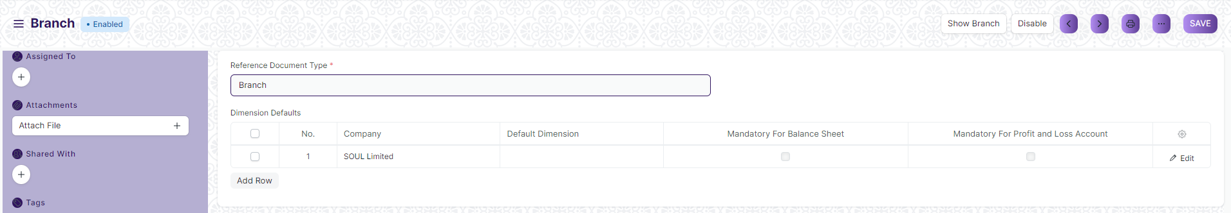

Figure: Accounting Dimension Screen

**Field List**

The following table describes the UI fields present in this screen :

|  |  |  |  |  |  |  |
| --- | --- | --- | --- | --- | --- | --- |
| **ID** | **Field Name** | **Field Type** | **Mandatory** | **Validation/ Action** | **Remarks** | **R/N/D** |
| 1 | Reference Document Type | Link | Yes |  | The Doc-type whose values are required as accounting dimension |  |
| 2 | Dimension Name | Data |  | Same as Reference Document Type |  |  |
| 3 | Fieldname | Data |  |  |  |  |
| 4 | Dimension Defaults | Table |  |  | Description of the table is given below |  |
| 5 | Disable | Checkbox |  | Disables the accounting dimension if checked |  |  |
|  | Show ““Reference Document Type”” button | | |  |  |  |
|  | Enable/Disable button | | |  |  |  |

|  |  |  |  |  |  |  |  |
| --- | --- | --- | --- | --- | --- | --- | --- |
| **Dimension Default (Accounting Dimension Detail)** | | | | | | | |
| **ID** | **Field Name** | **Field Type** | **Mandatory** | **Validation / Action** | | **Remarks** | **R/N/D** |
| 1 | Company | Link Field |  | This will fetch the default company of the application |  | |  |
| 2 | Reference Document | Link Field |  | This field is hidden |  | |  |
| 3 | Default Dimension | Dynamic Link Field |  |  | This is where you can mention company specific default dimensions.This dimension will be automatically fetched in the transaction against that specific company. | |  |
| 4 | Mandatory For Balance Sheet | Checkbox |  |  | Check "Mandatory" checkbox if you want the dimension to be mandatory in the transactions | |  |
| 5 | Mandatory For Profit and Loss Account | Checkbox |  |  | Check "Mandatory" checkbox if you want the dimension to be mandatory in the transactions | |  |

**User: Roles & Permission**

The following table describes the users and their roles and permissions for the screens :

|  |  |  |  |  |  |  |  |  |
| --- | --- | --- | --- | --- | --- | --- | --- | --- |
| **ID** | **Role** | **Read** | **Write** | **Create** | **Delete** | **Submit** | **Cancel** | **Amend** |
| 1 | Account User | No | No | No | No | NA | NA | NA |
| 2 | Account Manager | Yes | Yes | Yes | Yes | NA | NA | NA |
| 3 | Accountant Admin | Yes | Yes | Yes | Yes | NA | NA | NA |

## Taxes

### Tax Category

**General Description**

The Following table describe overall information about this screen:

|  |  |
| --- | --- |
| **Description :** | A Tax Category allows applying one or more Tax Rules to transactions based on various criteria. |
| **Navigation :** | Home > Accounts > Taxes > Tax Category |
| **Pre-requisites :** | NA |
| **Existing Screen Name** | Tax Category |
| **New Screen Name** | No change |

**Tax Category Screenshot**

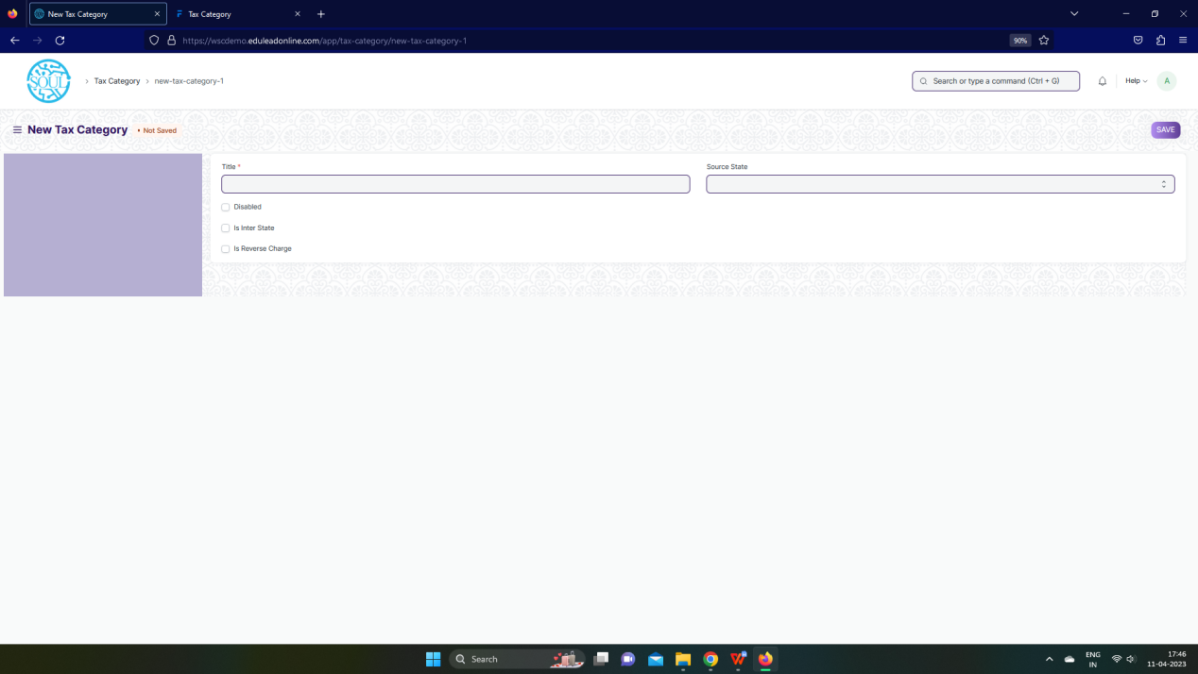Figure: Tax Category Screen

**UI Fields**

The “Tax Category” screen shall consist of the following fields:

|  |  |  |  |  |  |  |
| --- | --- | --- | --- | --- | --- | --- |
| **ID** | **Field Label** | **Field Type** | **Validation/ Action** | **Mandatory** | **Remarks** | **R/N/D** |
| 1 | Title | Text Field | User Input | Yes |  |  |
| 2 | Disabled | Checkbox | User Input |  |  |  |
| 3 | Is Inter State | Checkbox | User Input |  |  |  |
| 4 | Is Reverse Charge | Checkbox | User Input |  |  |  |
| 5 | Source State | Select | Andaman and Nicobar Islands/  Andhra Pradesh/  Arunachal Pradesh/  Assam/  Bihar/  Chandigarh/  Chhattisgarh/  Dadra and Nagar Haveli and Daman and Diu/  Delhi/  Goa/  Gujarat/  Haryana/  Himachal Pradesh/  Jammu and Kashmir/  Jharkhand/  Karnataka/  Kerala/  Ladakh/  Lakshadweep Islands/  Madhya Pradesh/  Maharashtra/  Manipur/  Meghalaya/  Mizoram/  Nagaland/  Odisha/  Other Territory/  Pondicherry/  Punjab/  Rajasthan/  Sikkim/  Tamil Nadu/  Telangana/  Tripura/  Uttar Pradesh/  Uttarakhand/  West Bengal |  |  |  |

**Users: Roles and Permissions**

The following table describes the users and their roles and permissions for the screens :

|  |  |  |  |  |  |  |  |  |
| --- | --- | --- | --- | --- | --- | --- | --- | --- |
| **ID** | **Role** | **Read** | **Write** | **Create** | **Delete** | **Submit** | **Cancel** | **Amend** |
| 1 | Account User | Yes | Yes | Yes | Yes | NA | NA | NA |
| 2 | Account Manager | Yes | Yes | Yes | Yes | NA | NA | NA |
| 3 | Accountant Admin | Yes | Yes | Yes | Yes | NA | NA | NA |

### Item Tax Template

**General Description**

The Following table describe overall information about this screen:

|  |  |
| --- | --- |
| **Description :** | Item Tax Template is useful for item wise taxation |
| **Navigation :** | Home > Accounts > Taxes > Item Tax Template |
| **Pre-requisites :** | NA |
| **Existing Screen Name** | Item Tax Template |
| **New Screen Name** | No change |

**Item Tax Template Screenshot**

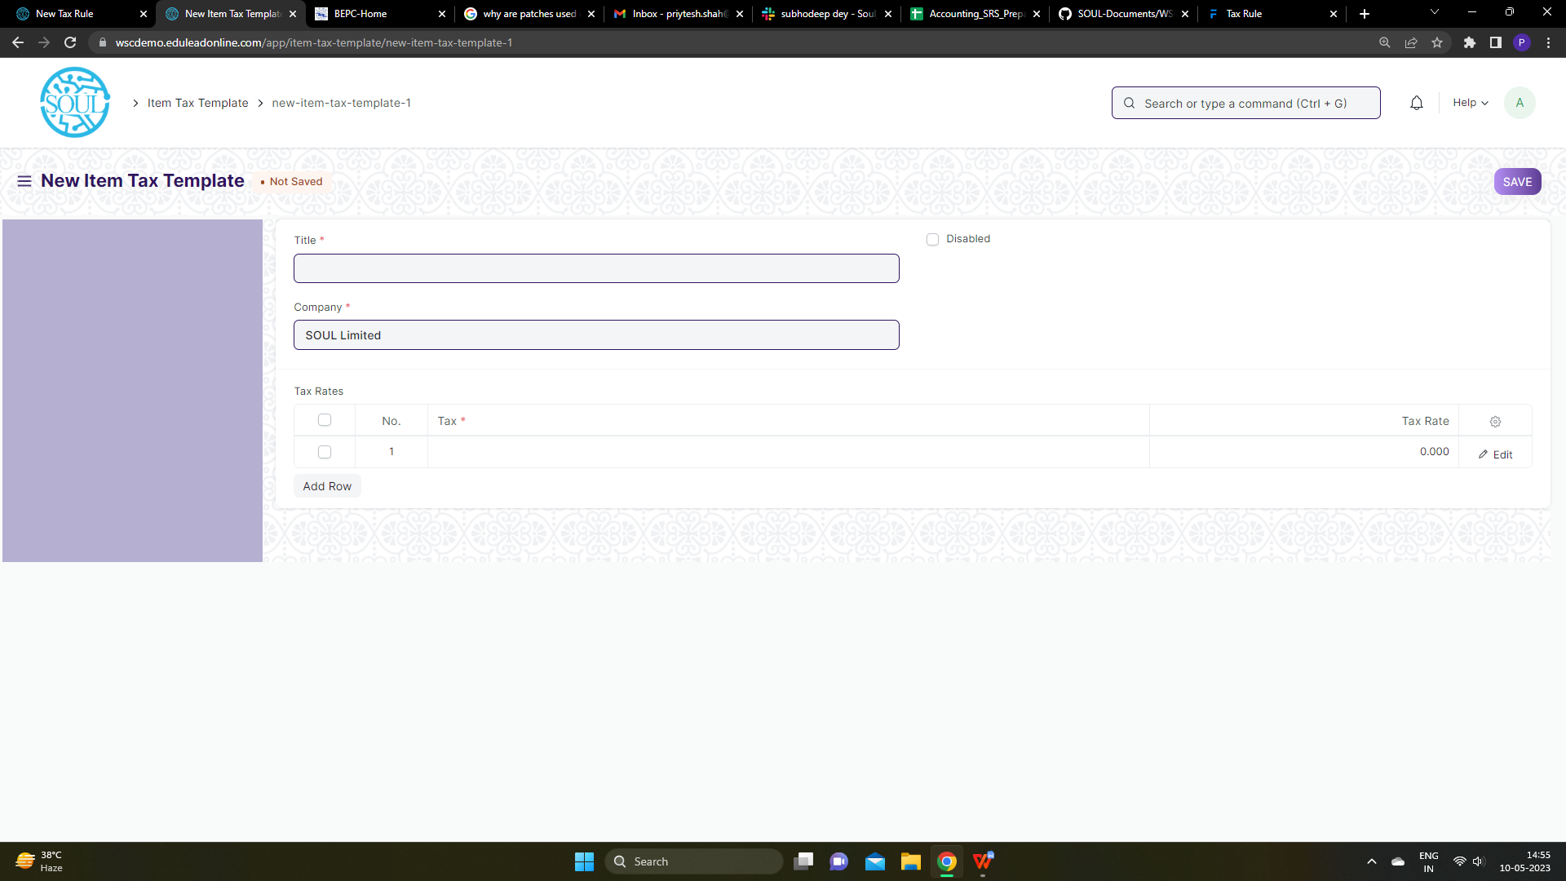Figure: Item Tax Template Screen

**UI Fields**

The “Item Tax Template” screen shall consist of the following fields:

|  |  |  |  |  |  |  |
| --- | --- | --- | --- | --- | --- | --- |
| **ID** | **Field Label** | **Field Type** | **Validation/ Action** | **Mandatory** | **Remarks** | **R/N/D** |
| 1 | Title | Text Field | User Input | Yes |  |  |
| 2 | Company | Link | Fetched from Company screen | Yes |  |  |
| 3 | Disabled | Checkbox | User Input |  |  |  |
| 4 | Tax Rates | Table |  | Yes | These table is describe below |  |

|  |  |  |  |  |  |  |
| --- | --- | --- | --- | --- | --- | --- |
| **Tax Rates (Child Table)** | | | | | | |
| **ID** | **Field Label** | **Field Type** | **Validation/ Action** | **Mandatory** | **Remarks** | **R/N/D** |
| 1 | Tax | Link | Fetched from Accounts screen | Yes |  |  |
| 2 | Tax Rate | Float | User Input |  |  |  |

**Users: Roles and Permissions**

The following table describes the users and their roles and permissions for the screens :

|  |  |  |  |  |  |  |  |  |
| --- | --- | --- | --- | --- | --- | --- | --- | --- |
| **ID** | **Role** | **Read** | **Write** | **Create** | **Delete** | **Submit** | **Cancel** | **Amend** |
| 1 | Account User | Yes | Yes | Yes | Yes | NA | NA | NA |
| 2 | Account Manager | Yes | Yes | Yes | Yes | NA | NA | NA |
| 3 | Accountant Admin | Yes | Yes | Yes | Yes | NA | NA | NA |

### Purchase Taxes and Charges Template

**General Description**

The Following table describe overall information about this screen:

|  |  |
| --- | --- |
| **Description :** | Purchase Taxes and Charges may be applied to any item you buy. |
| **Navigation :** | Home > Accounts > Taxes > Purchase Taxes and Charge Template |
| **Pre-requisites :** | 1. Company 2. Tax Category 3. Account |
| **Existing Screen Name** | Purchase Taxes and Charges Template |
| **New Screen Name** | No change |

**Purchase Taxes and Charges Template Screenshot**

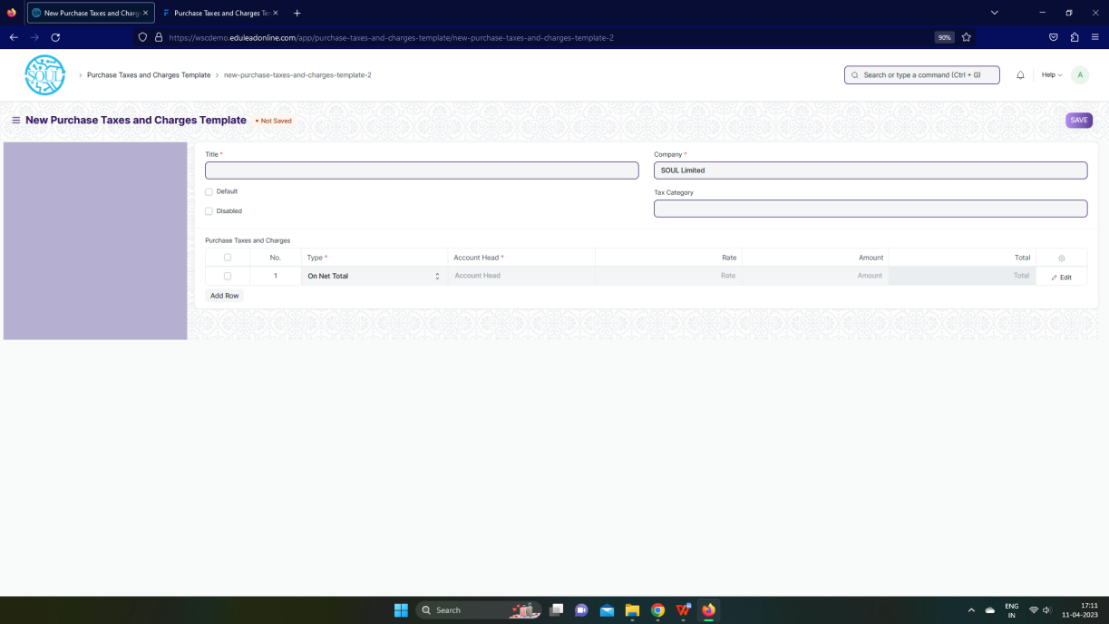

Figure: Purchase Taxes and Charges Template Screen

**UI Fields**

The “Purchase Taxes and Charges Template” screen shall consist of the following fields:

|  |  |  |  |  |  |  |
| --- | --- | --- | --- | --- | --- | --- |
| **ID** | **Field Label** | **Field Type** | **Validation/ Action** | **Mandatory** | **Remarks** | **R/N/D** |
| 1 | Title | Text Field | User Input | Yes |  |  |
| 2 | Default | Checkbox | User Input |  |  |  |
| 3 | Disabled | Checkbox | User Input |  |  |  |
| 4 | Company | Link | Fetched from Company screen | Yes |  |  |
| 5 | Tax Category | Link | Fetched from Tax Category screen |  |  |  |
| 6 | Purchase Taxes and Charges | Table |  |  | These table is describe below |  |
|  | **Purchase Taxes and Charges (Child Table)** | | | | | |
| **ID** | **Field Label** | **Field Type** | **Validation/ Action** | **Mandatory** | **Remarks** | **R/N/D** |
| 1 | Consider Tax or Charge for | Dropdown | Valuation and Total / Valuation / Total | Yes |  |  |
| 2 | Add or Deduct | Dropdown | Add / Deduct | Yes |  |  |
| 3 | Type | Dropdown | Actual / On Net Total / On previous row amount / On previous row Total / On Item Quantity | Yes |  |  |
| 4 | Is this Tax included in Basic Rate? | Checkbox | User Input |  |  |  |
| 5 | Considered In Paid Amount | Checkbox | User Input |  |  |  |
| 6 | Account Head | Link | Fetched from Account screen | Yes |  |  |
| 7 | Description | Small Text Field | User Input | Yes |  |  |
| 8 | Rate | Float | User Input |  |  |  |
| 9 | Address | Link | Fetched from Account screen |  |  |  |
| 10 | Article | Link | Fetched from Account screen |  |  |  |
| 11 | Cost Center | Link | Fetched from Account screen |  |  |  |
| 12 | About Us Team Member | Link | Fetched from Account screen |  |  |  |
| 13 | Account Currency | Link | Fetched from Account screen |  |  |  |
| 14 | Amount | Currency | Calculated on the basis of user input of rate |  |  |  |
| 15 | Tax Amount After Discount Amount | Currency | Calculated on the basis of user input of rate |  |  |  |
| 16 | Total | Currency | Calculated on the basis of user input of rate |  |  |  |
| 17 | Amount (Company Currency) | Currency | Calculated on the basis of user input of rate |  |  |  |
| 18 | Total (Company Currency) | Currency | Calculated on the basis of user input of rate |  |  |  |
| 19 | Tax Amount After Discount Amount | Currency | Calculated on the basis of user input of rate |  |  |  |

**Users: Roles and Permissions**

The following table describes the users and their roles and permissions for the screens :

|  |  |  |  |  |  |  |  |  |
| --- | --- | --- | --- | --- | --- | --- | --- | --- |
| **ID** | **Role** | **Read** | **Write** | **Create** | **Delete** | **Submit** | **Cancel** | **Amend** |
| 1 | Account User | Yes | Yes | Yes | Yes | NA | NA | NA |
| 2 | Account Manager | Yes | Yes | Yes | Yes | NA | NA | NA |
| 3 | Accountant Admin | Yes | Yes | Yes | Yes | NA | NA | NA |

### Tax Rule

**General Description**

The Following table describe overall information about this screen:

|  |  |
| --- | --- |
| **Description :** | A Tax Rule automatically applies taxes to transactions based on preset rules. |
| **Navigation :** | Home > Accounts > Taxes > Purchase Taxes and Charge Template |
| **Pre-requisites :** | 1. Company 2. Tax Category 3. Account |
| **Existing Screen Name** | Tax rule |
| **New Screen Name** | No change |

**Tax Rule Screenshot**

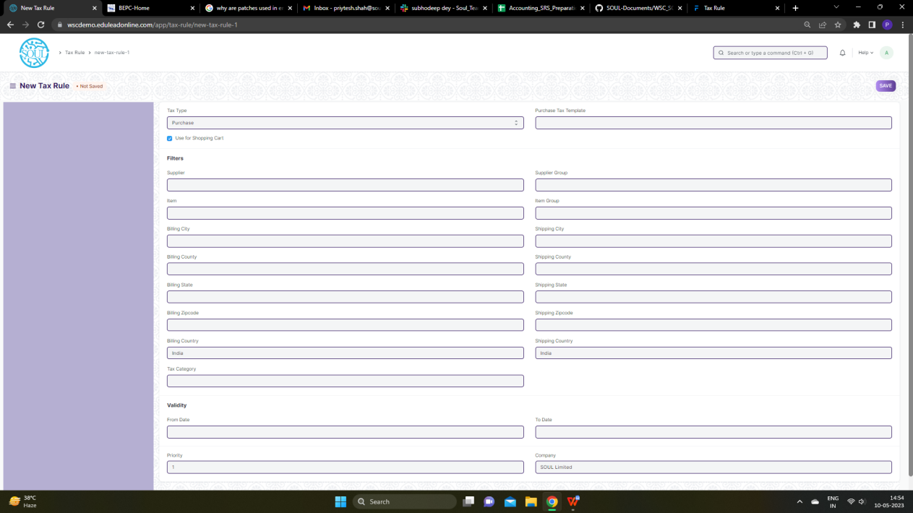

Figure: Tax Rule Screen

**UI Fields**

The “Tax Rule” screen shall consist of the following fields:

|  |  |  |  |  |  |  |
| --- | --- | --- | --- | --- | --- | --- |
| **ID** | **Field Label** | **Field Type** | **Validation/ Action** | **Mandatory** | **Remarks** | **R/N/D** |
| 1 | Tax Type | Dropdown | Sales / Purchase |  |  |  |
| 2 | Use for Shopping Cart | Checkbox | User Input |  |  |  |
| 3 | Sales Tax Template | Link | Fetched from Sales Tax Template screen |  |  |  |
| 4 | Purchase Tax Template | Link | Fetched from Purchase Tax Template screen |  |  |  |
| 5 | Customer | Link | Fetched from Customer screen |  |  |  |
| 6 | Supplier | Link | Fetched from Supplier screen |  |  |  |
| 7 | Item | Link | Fetched from Item screen |  |  |  |
| 8 | Billing City | Text field | User Input |  |  |  |
| 9 | Billing County | Text field | User Input |  |  |  |
| 10 | Billing State | Text field | User Input |  |  |  |
| 11 | Billing Zipcode | Text field | User Input |  |  |  |
| 12 | Billing Country | Link | Fetched from Country screen |  |  |  |
| 13 | Tax Category | Link | Fetched from Tax Category screen |  |  |  |
| 14 | Customer Group | Link | Fetched from Supplier Group screen |  |  |  |
| 15 | Supplier Group | Link | Fetched from Supplier Group screen |  |  |  |
| 16 | Item Group | Link | Fetched from Item Group screen |  |  |  |
| 17 | Shipping City | Text field | User Input |  |  |  |
| 18 | Shipping County | Text field | User Input |  |  |  |
| 19 | Shipping State | Text field | User Input |  |  |  |
| 20 | Shipping Zipcode | Text field | User Input |  |  |  |
| 21 | Shipping Country | Link | Fetched from Country screen |  |  |  |
| 22 | From Date | Date | User Input |  |  |  |
| 23 | To Date | Date | User Input |  |  |  |
| 24 | Priority | Int | User Input |  |  |  |
| 25 | Company | Link | Fetched from Company screen |  |  |  |

**Users: Roles and Permissions**

The following table describes the users and their roles and permissions for the screens :

|  |  |  |  |  |  |  |  |  |
| --- | --- | --- | --- | --- | --- | --- | --- | --- |
| **ID** | **Role** | **Read** | **Write** | **Create** | **Delete** | **Submit** | **Cancel** | **Amend** |
| 1 | Account User | Yes | Yes | Yes | Yes | NA | NA | NA |
| 2 | Account Manager | Yes | Yes | Yes | Yes | NA | NA | NA |
| 3 | Accountant Admin | Yes | Yes | Yes | Yes | NA | NA | NA |

### Tax Withholding Category

**General Description**

The Following table describe overall information about this screen:

|  |  |
| --- | --- |
| **Description :** | Tax Withholding Category is Tax Deducted at Source. |
| **Navigation :** | Home > Accounts > Taxes > Tax Withholding Category |
| **Pre-requisites :** | 1. Supplier 2. Customer |
| **Existing Screen Name** | Tax Withholding Category |
| **New Screen Name** | No change |

**Tax Withholding Category Screenshot**

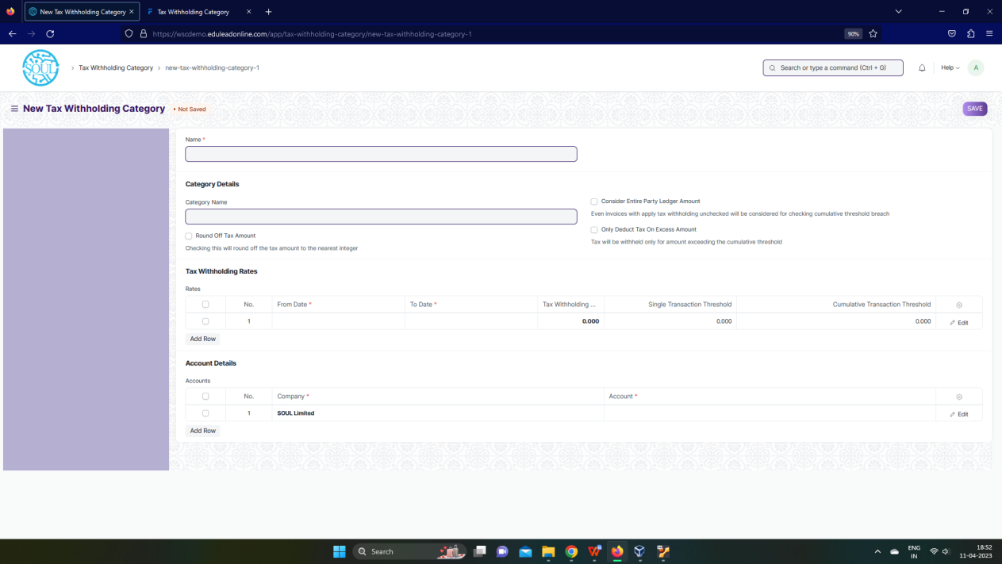

Figure: Tax Withholding Category Screen

**UI Fields**

The “Tax Withholding Category” screen shall consist of the following fields:

|  |  |  |  |  |  |  |
| --- | --- | --- | --- | --- | --- | --- |
| **ID** | **Field Label** | **Field Type** | **Validation/ Action** | **Mandatory** | **Remarks** | **R/N/D** |
| 1 | Category Name | Text Field | User Input |  |  |  |
| 2 | Round Off Tax Amount | Checkbox | User Input |  |  |  |
| 3 | Consider Entire Party Ledger Amount | Checkbox | User Input |  |  |  |
| 4 | Only Deduct Tax On Excess Amount | Checkbox | User Input |  |  |  |
| 5 | Rates | Table |  | Yes | These table is describe below |  |
| 6 | Accounts | Table |  | Yes | These table is describe below |  |
|  | **Rates (Child Table)** | | | | | |
| **ID** | **Field Label** | **Field Type** | **Validation/ Action** | **Mandatory** | **Remarks** | **R/N/D** |
| 1 | From Date | Date | User Input | Yes |  |  |
| 2 | To Date | Date | User Input | Yes |  |  |
| 3 | Tax Withholding Rate | Float | User Input | Yes |  |  |
| 4 | Single Transaction Threshold | Float | User Input |  |  |  |
| 5 | Cumulative Transaction Threshold | Float | User Input |  |  |  |
| 6 | Due Date Based On | Dropdown | Day(s) after invoice date /  Day(s) after the end of the invoice month /  Month(s) after the end of the invoice month |  |  |  |
| 7 | Credit Days | Int | User Input |  |  |  |
| 8 | Credit Months | Int | User Input |  |  |  |
| 9 | Discount Type | Dropdown | Percentage /  Amount |  |  |  |
| 10 | Discount | Float | User Input |  |  |  |
| 11 | Discount Validity Based On | Dropdown | Day(s) after invoice date /  Day(s) after the end of the invoice month /  Month(s) after the end of the invoice month |  |  |  |
| 12 | Discount Validity | Int | User Input |  |  |  |

|  |  |  |  |  |  |  |
| --- | --- | --- | --- | --- | --- | --- |
| **Accounts (Child Table)** | | | | | | |
| **ID** | **Field** Label | **Field** Type | **Validation/ Action** | **Mandatory** | **Remarks** | **R/N/D** |
| 1 | Company | Link | Fetched from Company screen | Yes |  |  |
| 2 | Account | Link | Fetched from Account screen | Yes |  |  |

**Users: Roles and Permissions**

The following table describes the users and their roles and permissions for the screens :

|  |  |  |  |  |  |  |  |  |
| --- | --- | --- | --- | --- | --- | --- | --- | --- |
| **ID** | **Role** | **Read** | **Write** | **Create** | **Delete** | **Submit** | **Cancel** | **Amend** |
| 1 | Account User | Yes | Yes | Yes | Yes | NA | NA | NA |
| 2 | Account Manager | Yes | Yes | Yes | Yes | NA | NA | NA |
| 3 | Accountant Admin | Yes | Yes | Yes | Yes | NA | NA | NA |

## SLCM

### Fee Structure

**General Description**

The following table describes overall information about this screen:

|  |  |
| --- | --- |
| **Description** | A Fee Structure is a template that can be used while making Fees records or generating them via the Fee Schedule. |
| **Navigation** | Home > Admission > Fees > Fee Structure |
| **Pre-requisites** | 1. Fee Type 2. Programs 3. Program Grade 4. Fee Type 5. Student Category 6. Semester 7. Academic Year 8. Academic Term |
| **Existing Screen Name** | Fee Structure |
| **New Screen Name** | None |

**Screenshot**

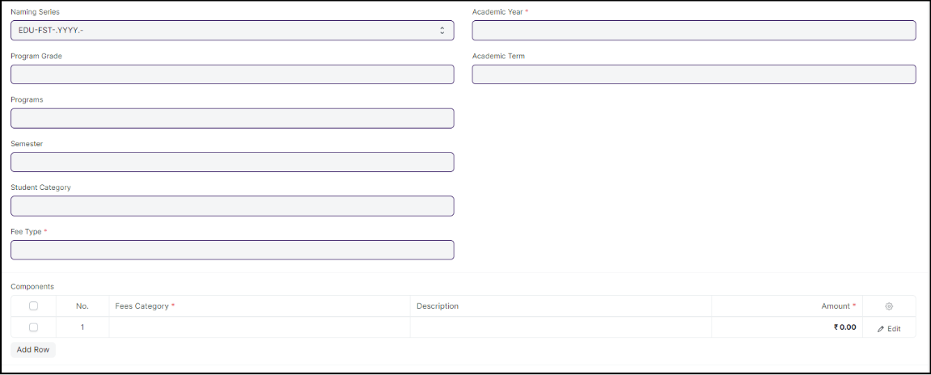

Figure :Fee Structure screen

**Field List**

The following table describes the UI fields present in this screen :

|  |  |  |  |  |  |  |
| --- | --- | --- | --- | --- | --- | --- |
| **ID** | **Field Name** | **Field Type** | **Mandatory** | **Validation/Action** | **Remarks** | **R/N/D** |
| 1 | Program Grade | Link Field |  | Linked to Program Grade |  | (R) Course Grade |
| 2 | Programs | Link Field |  | Linked to Programs Screen |  | (R) Course |
| 3 | Semester | Link Field |  | Linked to Semester Screen |  |  |
| 4 | Student Category | Link Field |  | Linked to Student Category Screen |  |  |
| 5 | Fee Type | Link Field | Yes | Linked to Fee Type Screen |  |  |
| 6 | Exam Type | Link Field |  | Linked to Exam Type Screen |  |  |
| 7 | Academic Year | Link Field | Yes | |  | | --- | | Linked to Academic Year Screen | |  |  |
| 8 | Academic Term | Link Field |  | Linked to Academic Term Screen |  |  |
| 9 | **Components** | Table |  | Description of the table is given below |  |  |
| 10 | Total Amount | Currency |  |  |  |  |
| 11 | Company | Link Field |  | Linked to Cost Center Screen |  |  |
| 12 | Cost Center | Link Field |  |  |  |  |
| 13 | Create Fee Schedule | Button |  | Redirects to Fee Schedule Screen |  |  |

|  |  |  |  |  |  |  |
| --- | --- | --- | --- | --- | --- | --- |
| **Component** | | | | | | |
| **ID** | **Field Name** | **Field Type** | **Mandatory** | **Validation/ Action** | **Remarks** | **R/N/D** |
| 1 | Fees Category | Link Field | Yes | Link Fields to master screen Fee Category |  |  |
| 2 | Description | Long Text |  |  |  |  |
| 3 | Amount | Currency | Yes |  |  |  |
| 4 | Waiver Type | Dropdown |  | Amount  Percentage |  |  |
| 5 | Percentage | Float |  |  |  |  |
| 6 | Waiver Amount | Currency |  |  |  |  |
| 7 | Total waiver Amount | Currency |  |  |  |  |
| 8 | Receivable Account | Link Field | Yes | Link Fields to Account Screen |  |  |
| 9 | Income Account | Link Field | Yes | Link Fields to Account Screen |  |  |
| 10 | Company | Link Field |  | Link Fields to Company Screen |  |  |
| 11 | Grand Fee Amount | Currency |  |  |  |  |
| 12 | Outstanding Fees | Currency |  |  |  |  |

**Users: Roles and Permissions**

The following table describes the users and their roles and permissions for the screens :

|  |  |  |  |  |  |  |  |  |
| --- | --- | --- | --- | --- | --- | --- | --- | --- |
| **ID** | **Role** | **Read** | **Write** | **Create** | **Delete** | **Submit** | **Cancel** | **Amend** |
| 1 | Account User | Yes | Yes | Yes | Yes | No | No | No |
| 2 | Account Manager | Yes | Yes | Yes | No | Yes | No | No |
| 3 | Accountant Admin | Yes | Yes | Yes | Yes | Yes | Yes | Yes |

### Fee Schedule

**General Description**

The following table describes overall information about this screen:

|  |  |
| --- | --- |
| **Description** | Fee Schedule would help in defining a time-line for the Fee payment of the students, based on the Student Group. |
| **Navigation** | Home > Admission > Fees > Fee Schedule |
| **Pre-requisites** | Fee Structure |
| **Existing Screen Name** | Fee Schedule |
| **New Screen Name** | None |

**Screenshot**

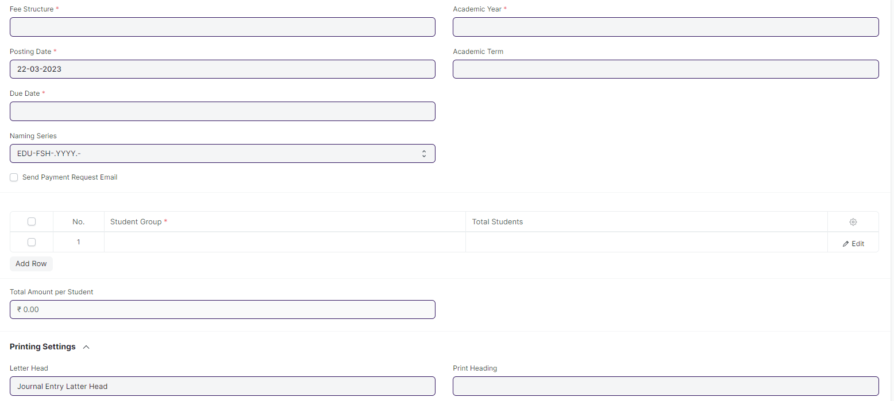 Figure: Fee Schedule

**Field List**

The following table describes the UI fields present in this screen :

|  |  |  |  |  |  |  |
| --- | --- | --- | --- | --- | --- | --- |
| **ID** | **Field Name** | **Field Type** | **Mandatory** | **Action / Validation** | **Remarks** | **R/N/D** |
| 1 | Fee Structure | Link Field | Yes | Link Fielded to Fee Structure Screen |  |  |
| 2 | Posting Date | Date | Yes |  |  |  |
| 3 | Due Date | Date | Yes |  |  |  |
| 4 | Fee Creation Status | Dropdown |  | In Process  Failed  Successful |  |  |
| 5 | Send Payment Request Email | Checkbox |  | If checked mail will be triggered form payment request |  |  |
| 7 | Student Category | Link Field |  | Links to Student Category screen |  |  |
| 8 | Programs | Link Field |  | Links to Programs Screen |  | ( R ) Course |
| 9 | Program | Link Field |  | Links to Semester Screen |  | (R) Semester |
| 10 | Academic Year | Link Field | Yes | Links to Academic Year |  |  |
| 11 | Academic Term | Link Field |  | Links to Academic Term |  |  |
| 13 | Currency | Link Field |  | Links to Currency Screen |  |  |
| 14 | **Student Group** | Table | Yes | 1. filtered will be applied on the basis of inputted semester and academic term 2. Description of the table given below |  |  |
| 16 | **Fee Components** | Table |  | Description of the table given below |  |  |
| 19 | Total Amount per Student | Currency |  |  |  |  |
| 20 | Grand Total | Currency |  |  |  |  |
| 21 | In Words | Text |  |  |  |  |
| 23 | Letter Head | Link Field |  | Links to the Letter head screen |  |  |
| 25 | Print Heading | Link Field |  | Links to Print Heading Screen |  |  |
| 27 | Receivable Account | Link Field |  | Links to Receivable Account |  |  |
| 28 | Income Account | Link Field |  | Links to Income Account |  |  |
| 30 | Institution | Link Field |  | Links to Company Screen |  |  |
| 32 | Cost Center | Link Field |  | Links to Cost Center Screen |  |  |
| 33 | View Fee Records | Button |  | Redirects to Fees List |  |  |
| 34 | Accounting Ledger | Button |  | Redirects to Accounting Ledger Report |  |  |

|  |  |  |  |  |  |  |
| --- | --- | --- | --- | --- | --- | --- |
| **Fee Components** | | | | | | |
| **ID** | **Field Name** | **Field Type** | **Mandatory** | **Validation/Action** | **Remarks** | **R/N/D** |
| 1 | Fees Category | Link Field | Yes | Link Fields to master screen Fee Category and auto fetch from Fee Structure |  |  |
| 2 | Description | Long Text |  | auto fetch from Fee Structure |  |  |
| 3 | Amount | Currency | Yes | auto fetch from Fee Structure |  |  |
| 4 | Waiver Type | Dropdown |  | Amount  Percentage |  |  |
| 5 | Percentage | Float |  | auto fetch from Fee Structure |  |  |
| 6 | Waiver Amount | Currency |  |  |  |  |
| 7 | Total waiver Amount | Currency |  |  |  |  |
| 8 | Receivable Account | Link Field | Yes | Link Fields to Account Screen and auto fetch from Fee Structure |  |  |
| 9 | Income Account | Link Field | Yes | Link Fields to Account Screen and auto fetch from Fee Structure |  |  |
| 10 | Company | Link Field |  | Link Fields to Company Screen and auto fetch from Fee Structure |  |  |
| 11 | Grand Fee Amount | Currency |  |  |  |  |
| 12 | Outstanding Fees | Currency |  |  |  |  |

**Users: Roles and Permissions**

The following table describes the users and their roles and permissions for the screens :

|  |  |  |  |  |  |  |  |  |
| --- | --- | --- | --- | --- | --- | --- | --- | --- |
| **ID** | **Role** | **Read** | **Write** | **Create** | **Delete** | **Submit** | **Cancel** | **Amend** |
| 1 | Account User | Yes | Yes | Yes | Yes | No | No | No |
| 2 | Account Manager | Yes | Yes | Yes | No | Yes | No | No |
| 3 | Accountant Admin | Yes | Yes | Yes | Yes | Yes | Yes | Yes |

### 

### Fees

**General Description**

The following table describes overall information about this screen:

|  |  |
| --- | --- |
| **Description** | In this form, Fee Records of the students can be maintained. |
| **Navigation** | Home > Admission > Fees > Fees |
| **Pre-requisites** | Fee Structure  Fee Schedule |
| **Existing Screen Name** | Fees |
| **New Screen Name** | None |

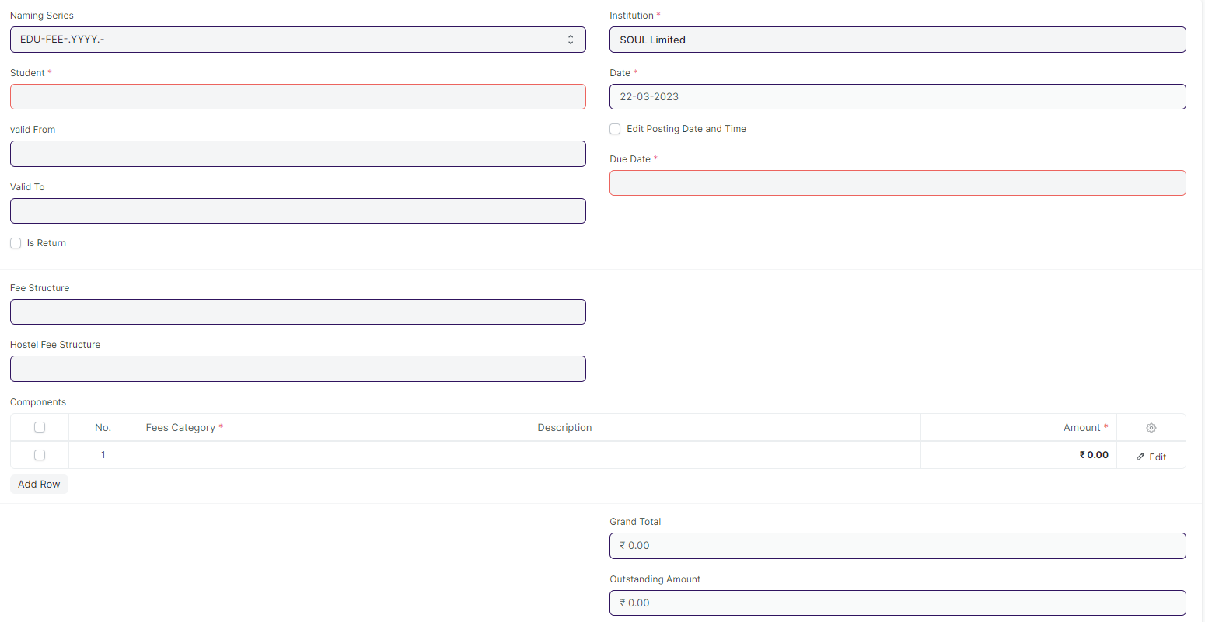**Screenshot**

Figure:Fees

**Field List**

The following table describes the UI fields present in this screen :

|  |  |  |  |  |  |  |
| --- | --- | --- | --- | --- | --- | --- |
| **ID** | **Field Name** | **Field Type** | **Mandatory** | **Action / Validation** | **Remarks** | **R/N/D** |
| 1 | Student | Link Field |  | Link Field to Student Screen |  |  |
| 2 | Student Name | Text | Yes | Student Name auto fetched when student id is entered |  |  |
| 3 | Roll No | Text |  | Roll No auto fetched when student id is entered |  |  |
| 4 | Registration Number | Text |  | Registration Number auto fetched when student id is entered |  |  |
| 5 | Fee Schedule | Link Field |  | Link Field to Fee Schedule Screen |  |  |
| 8 | Valid From | Date |  |  |  |  |
| 9 | Valid To | Date |  | Valid to date should be greater then Valid from date |  |  |
| 11 | Return Issued | Checkbox |  |  |  |  |
| 13 | Institution | Link Field | Yes | Link Fielded to Company Screen |  |  |
| 14 | Date | Date | Yes |  |  |  |
| 15 | Posting Time | Time |  |  |  |  |
| 16 | Edit Posting Date and Time | Checkbox |  |  |  |  |
| 17 | Due Date | Date | Yes |  |  |  |
| 19 | Program Enrollment | Link Field |  | Link Field to Program Enrollment Screen |  | (R) Course Enrollment |
| 20 | Programs | Link Field | Yes | Link Field to Programs Screen |  | (R) Course |
| 21 | Semester | Link Field | Yes | Link Field to Semester Screen |  |  |
| 22 | Student Batch | Link Field |  | Link Field to Student Batch Screen |  |  |
| 23 | Student Email | Text |  | Auto fetched when student id is entered |  |  |
| 25 | Student Category | Link Field |  | Link Fielded to Student Category Screen |  |  |
| 26 | Academic Term | Link Field |  | Link Fielded to Academic Term Screen |  |  |
| 27 | Academic Year | Link Field |  | Link Fielded to Academic Year Screen |  |  |
| 29 | Currency | Link Field |  | Link Fielded to Currency Screen |  |  |
| 30 | Fee Structure | Link Field |  | Link Fielded to Fee Structure Screen and filtered applied according to the Programs, Semester and Academic Term. |  |  |
| 31 | Hostel Fee Structure | Link Field |  | Link Fielded to Hostel Fee Structure Screen |  |  |
| 32 | **Components** | Table | Yes |  |  |  |
| 34 | Grand Total | Currency |  |  |  |  |
| 35 | In Words | Text |  |  |  |  |
| 36 | Outstanding Amount | Currency |  |  |  |  |
| 38 | Waiver Type | Drop down |  | Amount  Percentage |  |  |
| 39 | Percentage | Text |  |  |  |  |
| 40 | Amount | Currency |  |  |  |  |
| 41 | Waiver Amount | Currency |  |  |  |  |
| 43 | Letter Head | Link Field |  | Link Fielded to Letter Head Screen |  |  |
| 46 | Print Heading | Link Field |  | Link Fielded to Print Heading Screen |  |  |
| 47 | Cost Center | Link Field |  | Link Fielded to Cost Center |  |  |
| 48 | View | Button |  | Clicking this button shows a dropdown , containing 3 options:   1. Accounting Ledger 2. Payments 3. General Ledger w/ Cancellation | 1. Accounting : Links to Accounting Ledger Report Page 2. Payments: Links to Payment Entry Page 3. Links to General Ledger Report Page |  |
| 49 | Create | Button |  | Clicking this button shows a dropdown , containing 2 options:   1. Payment Request 2. Payment | 1. Payment Request: Redirects to payment request page where after submissions a payment request is created 2. Payment: Leads to Payment Entry Page where after saving and submitting a payment entry is generated |  |

|  |  |  |  |  |  |  |
| --- | --- | --- | --- | --- | --- | --- |
| **Fee Components** | | | | | | |
| **ID** | **Field Name** | **Field Type** | **Mandatory** | **Validation/Action** | **Remarks** | **R/N/D** |
| 1 | Fees Category | Link Field | Yes | Link Fields to master screen Fee Category and auto fetch from Fee Structure |  |  |
| 2 | Description | Long Text |  | auto fetch from Fee Structure |  |  |
| 3 | Amount | Currency | Yes | auto fetch from Fee Structure |  |  |
| 4 | Waiver Type | Dropdown |  | Amount  Percentage |  |  |
| 5 | Percentage | Float |  | auto fetch from Fee Structure |  |  |
| 6 | Waiver Amount | Currency |  |  |  |  |
| 7 | Total waiver Amount | Currency |  |  |  |  |
| 8 | Receivable Account | Link Field | Yes | Link Fields to Account Screen and auto fetch from Fee Structure |  |  |
| 9 | Income Account | Link Field | Yes | Link Fields to Account Screen and auto fetch from Fee Structure |  |  |
| 10 | Company | Link Field |  | Link Fields to Company Screen and auto fetch from Fee Structure |  |  |
| 11 | Grand Fee Amount | Currency |  |  |  |  |
| 12 | Outstanding Fees | Currency |  |  |  |  |

**Users: Roles and Permissions**

The following table describes the users and their roles and permissions for the screens :

|  |  |  |  |  |  |  |  |  |
| --- | --- | --- | --- | --- | --- | --- | --- | --- |
| **ID** | **Role** | **Read** | **Write** | **Create** | **Delete** | **Submit** | **Cancel** | **Amend** |
| 1 | Account User | Yes | Yes | Yes | Yes | No | No | No |
| 2 | Account Manager | Yes | Yes | Yes | No | Yes | No | No |
| 3 | Accountant Admin | Yes | Yes | Yes | Yes | Yes | Yes | Yes |
| 4 | Student | Yes | Yes | No | No | No | No | No |

### Program Enrollment

**General Description**

The following table describes overall information about this screen:

|  |  |
| --- | --- |
| **Description** | 1. Program Enrollment is the record of enrollment of a student in a given program and chosen courses for a particular Academic Term. 2. To ensure that students are associated with a particular program in the system, their Program Enrollment must be created. The mandatory course in that program is automatically filled in the Enrolled Courses table while the elective or optional courses can be selected manually. 3. If the student has applied online for the admission in a particular Program and the application is approved, then the Program Enrollment can be created from within the Student Applicant record via clicking on the Enroll button. |
| **Navigation** | Home > Education > Admission > Program Enrollment |
| **Pre-requisites** | Student  Fee Structure  Student Batch |
| **Existing Screen Name** | Program Enrollment |
| **New Screen Name** | Course Enrollment |

**Screenshot**

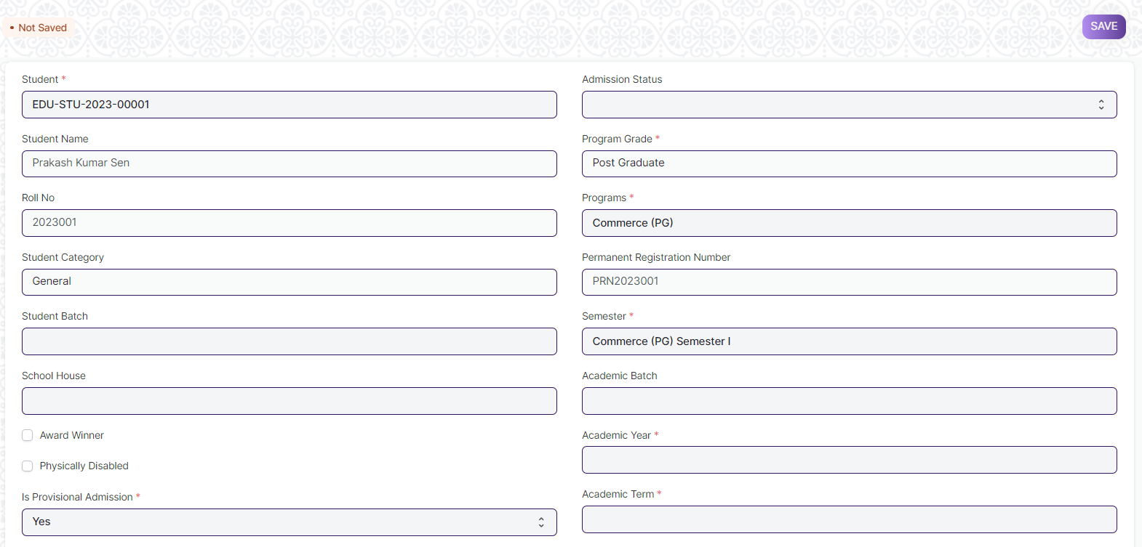 Figure: Program Enrollment

**Field List:**

The following table describes the UI fields present in this screen :

|  |  |  |  |  |  |  |
| --- | --- | --- | --- | --- | --- | --- |
| **ID** | **Field Name** | **Field Type** | **Mandatory** | **Validation / Action** | **Remarks** | **R/N/D** |
| 1 | Student | Link Field | Yes | Link Fields to master screen Student, auto fetched when clicked enrolled button from student or student Applicant screen. |  |  |
| 2 | Student Name | Read Only |  | Auto fetched when student id is inputted. |  |  |
| 3 | Roll No | Text |  |  |  |  |
| 4 | Gender | Link Field |  | Link Fields to master screen Gender, auto fetched when clicked enrolled connection button from student screen or enroll button from student applicant screen. |  |  |
| 5 | Student Category | Link Field |  | Link Fields to master screen Student Category, auto fetched when clicked enrolled connection button from student screen or enroll button from student applicant screen |  |  |
| 6 | Student Batch | Link Field |  | Link Fields to master screen Student Batch Name |  |  |
| 7 | School House | Link Field |  | Link Fields to master screen School House |  |  |
| 8 | Physically Disabled | Checkbox |  |  |  |  |
| 9 | Is Provisional Admission | Dropdown | Yes | Yes  No |  |  |
| 10 | Admission Status | Dropdown |  | Provisional Admission  Admitted |  |  |
| 11 | Program Grade | Link Field |  | Link Fields to master screen Program Grade |  | (R) Course Grade |
| 12 | Programs | Link Field |  | Link Fields to master screen Programs and filtered on the basis of program grade |  | (R) Courses |
| 13 | Permanent Registration Number | Text |  |  |  |  |
| 14 | Program | Link Field | Yes | Link Fields to master screen Semester and filtered on the basis of programs |  | (R) Semester |
| 15 | Academic Batch | Text |  |  |  | (D) |
| 16 | Academic Year | Link Field | Yes | Link Fields to master screen Academic Year auto fetched when clicked enrolled connection button from student screen. And enroll button form student applicant screen. |  |  |
| 17 | Academic Term | Link Field |  | Link Fields to master screen Academic Term |  |  |
| 18 | Year End Date | Date |  |  |  |  |
| 19 | Enrollment Date | Date | Yes |  |  |  |
| 20 | Seat Reservation Type | Link Field |  | Link Fields to master screen Seat Reservation Type and fetched on the basis student category wise seat reservation |  |  |
| 21 | Available seats | Number |  | Auto fetched from Student admission screen child table Reservation distribution table. |  |  |
| 22 | Boarding Student | Checkbox |  |  |  |  |
|  |  |  |  |  |  |  |
| 23 | **Courses** | Table |  | Description of the table is given below as programmed Enrolled Courses |  | (R) Modules |
|  |  |  |  |  |  |  |
| 25 | Vehicle/Bus Number |  |  |  |  |  |
| 26 | Due Date | Date |  |  |  |  |
| 27 | **Fee Structure Item** | Table |  | 1. Once program enrollment record submitted for a particular student then in back-end the fees record for that particular student will created and then the student need to pay their fees from the Fees screen.   2. Description of this table is given below. |  |  |
| 28 | Image | Attach Image |  | 1. On attachment a dialogue box will be popup where user can attach the images, take the picture with the help camera. 2. If photos or images attached then the size will be maximum 200 kb. |  |  |
| 29 | **Academic Calendar** | Table |  | Description of this table is given below. |  |  |
| 30 | Voucher No. | Text Field |  |  |  |  |
| 31 | Company | Text Field |  |  |  |  |
| 32 | Submit | | | On submit the record the course enrollment auto created and student will be enrolled on those courses which are present in **course** child table |  |  |

|  |  |  |  |  |  |  |
| --- | --- | --- | --- | --- | --- | --- |
| **Program Enrollment Course** | | | | | | |
| **ID** | **Field Name** | **Field Type** | **Validation/Action** | **Mandatory** | **Remarks** | **R/N/D** |
| 1 | Course | Link Field |  | Yes | Link Fields to master screen Course, and those courses will be visible which are linked with inputted semester | (R) Module |
| 2 | Course Code | Text |  |  |  | (R) Module Code |
| 3 | Course Name | Text |  |  |  | (R) Module Name |
| 4 | Instructor | Link Field |  |  | Link Fields to master screen Instructor | (R) Trainer |
| 5 | Credit Allocation | Button |  |  |  | (D) |

|  |  |  |  |  |  |  |
| --- | --- | --- | --- | --- | --- | --- |
| **Fee Structure Item** | | | | | | |
| **ID** | **Field Name** | **Field Type** | **Validation/Action** | **Mandatory** | **Remarks** | **R/N/D** |
| 1 | Student Category | Link Field |  |  | Link Fields to master screen Student Category |  |
| 2 | Fee Structure | Link Field |  | Yes | Link Fields to master screen Fee Structure |  |
| 3 | Amount | Currency |  |  |  |  |
| 4 | Due Date | Date |  | Yes |  |  |

|  |  |  |  |  |  |  |
| --- | --- | --- | --- | --- | --- | --- |
| **Academic Calendar** | | | | | | |
| **ID** | **Field Name** | **Field Type** | **Validation/Action** | **Mandatory** | **Remarks** | **R/N/D** |
| 1 | Academic Events | Link Field |  | Yes | Link Fields to master screen Academic Events, events will fetch w.r.t Academeic Calendar Template |  |
| 2 | Start Date | Date |  | Yes | Start date will fetch w.r.t Academeic Calendar Template |  |
| 3 | End Date | Date |  | Yes | End date will fetch w.r.t Academeic Calendar Template |  |
| 4 | Duration | Number |  |  | Duration will fetch w.r.t Academeic Calendar Template |  |

**Users: Roles and Permissions**

The following table describes the users and their roles and permissions for the screens :

|  |  |  |  |  |  |  |  |  |
| --- | --- | --- | --- | --- | --- | --- | --- | --- |
| **ID** | **Role** | **Read** | **Write** | **Create** | **Delete** | **Submit** | **Cancel** | **Amend** |
| 1 | Admin | Yes | Yes | Yes | Yes | Yes | Yes | Yes |
| 2 | Instructor | Yes | No | No | No | No | No | No |
| 3 | Student | Yes | No | No | No | No | No | No |

### Student Re registration Tool

**General Description**

The following table describes overall information about this screen:

|  |  |
| --- | --- |
| **Description** | Student Re registration tool mainly help for enrolling the students into their next semester bulk wise only after the enrollment of first semester. |
| **Navigation** | | Home > Admission > Tools > Student Re registration |
| **Pre-requisites** | 1. Program Enrollment up-to first semester 2. Semester 3. Academic Year 4. Academic Term 5. Student Batch |

**Screenshot**

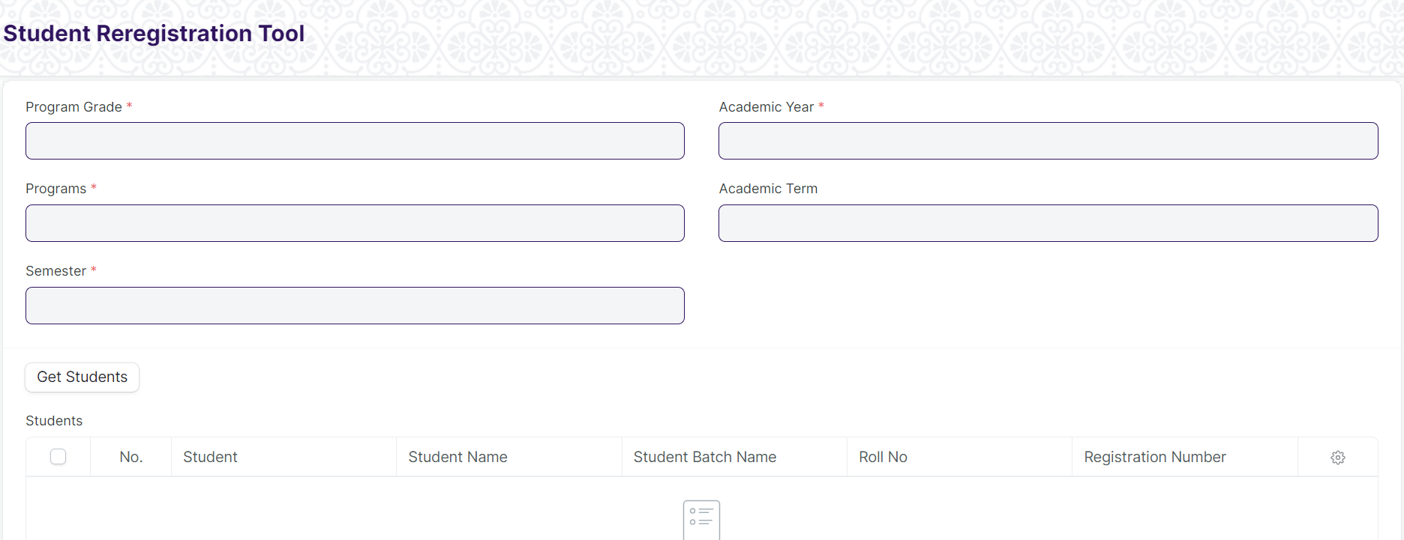

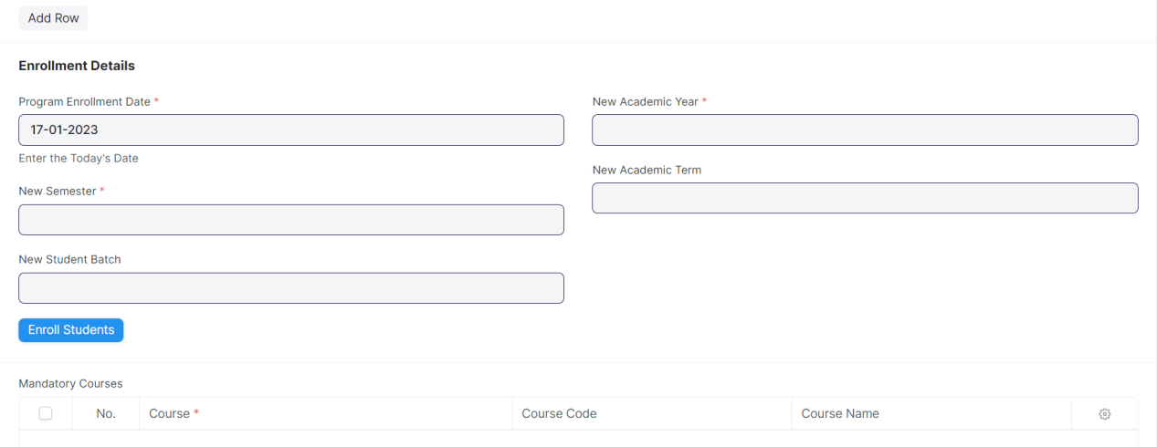

Figure: Student Re registration Tool Screen

**Field List**

The following table describes the UI fields present in this screen :

|  |  |  |  |  |  |  |
| --- | --- | --- | --- | --- | --- | --- |
| **ID** | **Field Name** | **Field Type** | **Mandatory** | **Validation / Action** | **Remarks** | **R/N/D** |
| 1 | Program Grade | Link Field | Yes | Linked to Program Grade Screen |  | (R) Course Grade |
| 2 | Programs | Link Field | Yes | Linked to Programs Screen |  | (R) Course |
| 3 | Program | Link Field | Yes | Linked to Semester Screen |  | (R) Semester |
| 4 | Student Batch | Link Field |  |  |  |  |
| 5 | Academic Year | Link Field | Yes | Linked to Academic Year Screen |  |  |
| 6 | Academic Term | Link Field | Yes | Linked to Academic Term Screen |  |  |
| 7 | Get Students | Button |  |  |  |  |
| 8 | Students | Table |  | **Auto Generated the student List** |  |  |
| 9 | Program Enrollment Date | Date | Yes | Need to give the today’s date |  | (R) Course enrollment |
| 10 | New Semester | Link Field | Yes | Linked to Semester Screen |  |  |
| 11 | New Student Batch | Link Field | Yes |  |  |  |
| 12 | Enroll Students | Button |  |  |  |  |
| 13 | New Academic Year | Link Field | Yes | Linked to Academic Year Screen |  |  |
| 14 | New Academic Term | Link Field | Yes | Linked to Academic Term Screen |  |  |
| 15 | Mandatory Courses | Table |  |  |  |  |

|  |  |  |  |  |  |  |
| --- | --- | --- | --- | --- | --- | --- |
| **Students** | | | | | | |
| **ID** | **Field Name** | **Field Type** | **Mandatory** | **Validation / Action** | **Remarks** | **R/N/D** |
| 1 | Student | Link Field |  |  |  |  |
| 2 | Student Name | Text |  |  |  |  |
| 3 | Roll Number | Text |  |  |  |  |

|  |  |  |  |  |  |  |
| --- | --- | --- | --- | --- | --- | --- |
| **Mandatory Courses** | | | | | | |
| **ID** | **Field Name** | **Field Type** | **Mandatory** | **Validation / Action** | **Remarks** | **R/N/D** |
| 19 | Course | Link Field |  |  |  | (R) Module |
| 20 | Course Name | Text |  |  |  | (R) Module Name |

**Users: Roles and Permissions**

The following table describes the users and their roles and permissions for the screens :

|  |  |  |  |  |  |  |  |  |
| --- | --- | --- | --- | --- | --- | --- | --- | --- |
| **ID** | **Role** | **Read** | **Write** | **Create** | **Delete** | **Submit** | **Cancel** | **Amend** |
| 1 | Admin | Yes | Yes | Yes | Yes | NA | NA | NA |

### Fee Waiver

**General Description**

|  |  |
| --- | --- |
| **Description** | Fee waiver refers to an exemption or reduction of a student's fees that they would normally be required to pay in order to enroll in classes or participate in certain activities. |
| **Navigation** |  |
| **Pre-requisites** | Student  Fee Structure  Program  Semester  Academic Year  Academic Term |
| **Existing Screen Name** |  |
| **New Screen Name** |  |

**Screenshot**

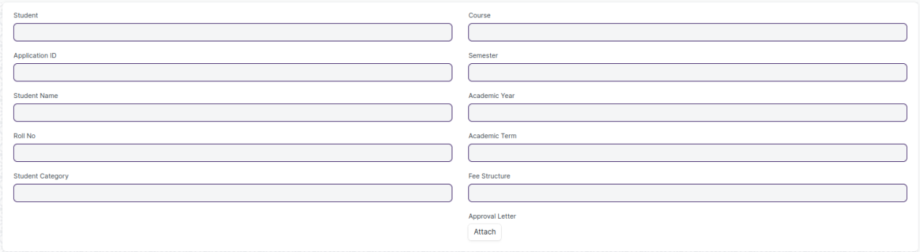

Figure: Fee Waiver Screen

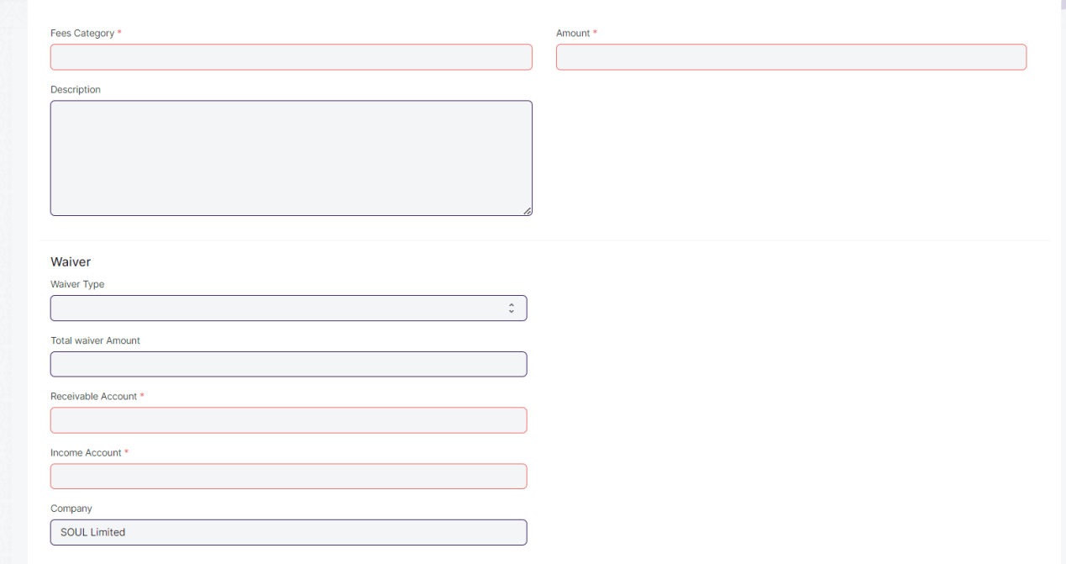

Figure 9 : Fee Components Table

**Field List**

The following table describes the UI fields present in this screen :

|  |  |  |  |  |  |  |
| --- | --- | --- | --- | --- | --- | --- |
| **ID** | **Field Name** | **Field Type** | **Validation/ Action** | **Mandatory** | **Remarks** | **R/N/D** |
|  | Student | Link Field | If the Fee waiver checkbox on the Student screen is checked, then the student's id will be fetched. | Y | Users can search for students based on student id or applicant id | N |
|  | Applicant ID | Link Field | If Applicant ID present in student master screen then it will fetched from student master otherwise it will be blank. |  |  | N |
|  | Student Name | Data | Fetched from student master screen |  |  | N |
|  | Roll No | Data | Fetched from student master screen |  |  | N |
|  | Student Category | Data | Fetched from student master screen |  |  | N |
|  | Course | Link Field | If the student applicant has specified course priority, only that will be displayed and the user must choose from those. If the user has already enrolled in a course, that course will be fetched automatically. Otherwise, all courses will be fetched from the courses master screen and the user will have to choose from those. |  |  | N |
|  | Semester | Link Field | If the student applicant has specified semester, only that will be displayed and the user have to select that semester. If the user has already enrolled in a semester, that semester will be fetched automatically. Otherwise, all semester will be fetched from the semester master screen, filter will be applied based on selected course and the user will have to choose from those. |  |  | N |
|  | Academic Year | Link Field | If the student applicant has specified academic year, only that will be displayed and the user have to select that academic year. If the user has already enrolled in a academic year, that academic year will be fetched automatically. Otherwise, all academic year will be fetched from the academic year master screen, and the user will have to choose from those. |  |  | N |
|  | Academic Term | Link Field | If the student applicant has specified a academic term, only that will be displayed and the user have to select that academic term. If the user has already enrolled in a academic term, that academic term will be fetched automatically. Otherwise, all academic term will be fetched from the academic term master screen, filter will be applied based on selected academic year and the user will have to choose from those. |  |  | N |
|  | Fee Structure | Link Field | Fetched from Fee Structure master screen and filter will be applied based on selected course and semester. | Y |  | N |
|  | Approval letter | Attachment |  |  |  |  |
|  | Fee Components | Table |  | Y | Description of the table is given below. | N |

|  |  |  |  |  |  |  |
| --- | --- | --- | --- | --- | --- | --- |
| **Fee Components** | | | | | | |
| **ID** | **Field Name** | **Field Type** | **Validation/ Action** | **Mandatory** | **Remarks** | **R/N/D** |
|  | Fee Category | Link Field | Fetched from the selected Fee Structure | y |  | N |
|  | Description | Small Text | Fetched from the selected Fee Structure |  |  | N |
|  | Waiver Type | Dropdown | User Input | Y | Dropdown options are: Percentage/Amount | N |
|  | Percentage | Float | User Input |  | If the selected waiver type is percentage, then the field will be displayed and it will be mandatory. | N |
|  | Waiver Amount | Currency | User Input |  | If the selected waiver type is amount, then the field will be displayed and it will be mandatory. | N |
|  | Total Waiver Amount | Currency | The amount of the waiver will be calculated based on the type of waiver selected, either as a fixed amount or as a percentage of the total amount. |  |  | N |
|  | Receivable Account | Link Field | Fetched from the selected Fee Structure | Y |  | N |
|  | Income Account | Link Field | Fetched from the selected Fee Structure | Y |  | N |
|  | Company | Link Field | Fetched from the selected Fee Structure |  |  | N |
|  | Grand Fee Amount | Currency | Fetched from the selected Fee Structure |  |  | N |
|  | Outstanding Fees | Currency | Fetched from the selected Fee Structure, the outstanding fees of the waiver will be calculated based on the type of waiver selected, either as a fixed amount or as a percentage of the total amount. |  |  | N |
|  | Amount | Currency | Fetched from the selected Fee Structure , the amount of the waiver will be calculated based on the type of waiver selected, either as a fixed amount or as a percentage of the total amount. | Y |  | N |

**Note:**

There would be two levels of approval. At the first level approval will be done by Education Admission Department and the first level approval will be done by Education Admission Head.

**User: Roles & Permission**

The following table describes the users and their roles and permissions for the screens :

|  |  |  |  |  |  |  |  |  |
| --- | --- | --- | --- | --- | --- | --- | --- | --- |
| **ID** | **Role** | **Read** | **Write** | **Create** | **Delete** | **Submit** | **Cancel** | **Amend** |
|  | Accountant Admin | Yes | Yes | Yes | Yes | Yes | Yes | Yes |
|  | Account Manager | Yes | Yes | Yes | No | Yes | Yes | Yes |
|  | Account User | Yes | Yes | Yes | No | Yes | Yes | Yes |